MEDIA REFLECTIONS OF CONVENTION CLIMATE CHANGE, FALSE SOLUTIONS AND INDIGENOUS PEOPLES RIGHTS
State level Convention on Climate Change, False Solutions and Indigenous Peoples Rights in Manipur
E-Pao.net
10th November, 2014:

The State level Convention on Climate Change, False Solutions and Indigenous Peoples Rights in Manipur, was organized by Centre for Research and Advocacy, Manipur at Manipur Press Club on 10 November 2014. Ms. Maibam Nganbileima, Lamphel Yaipha Leikai eviction victim, Mr. Mani Khuman, President, All Manipur United Clubs Organization graced as presidium members.
Mr. Jiten Yumnam, Secretary, Centre for Research and Advocacy, Manipur in his key note highlighted the context of deepening climate crisis in Manipur and how aggressive introduction of large scale development projects in Manipur, such as mega dams, oil exploration, creation of industrial zones and other large infrastructure projects such as Road and Railways infrastructure with financing by International Financial Institutions led to violation of indigenous peoples rights in Manipur by destroying their forest, water and land.
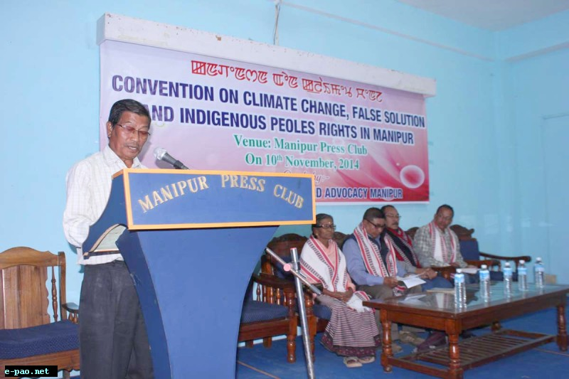
Convention on Climate Change, False Solutions and Indigenous Peoples Rights in Manipur on 10 Nov, 2014
Mr. Phulindro Konsam, Chairman, Committee on Human Rights shared how development decisions and processes, such as new MoUs on mega dams are pursued against the aspirations of indigenous peoples of Manipur. Mega development projects are often anti people, destroyed their forest, water, agriculture land etc and involves human rights violations. All development processes should respect indigenous peoples self determined rights and their right to free, prior and informed consent.
Mr. Achom Brojen of Kongba and Mr. Nahakpam Ibochouba of Langthabal shared the concerns and the failure of the Asian Development Bank loaned Imphal Ring Road plan to consult and take the free, prior and informed consent of affected communities and to take detailed impact assessment due to such large projects. Mr. Gopen, Irabot Foundation elucidated how current day forcible development that benefit multinational corporations with their forced acquisition of agriculture land will undermine food sovereignty of Manipur.
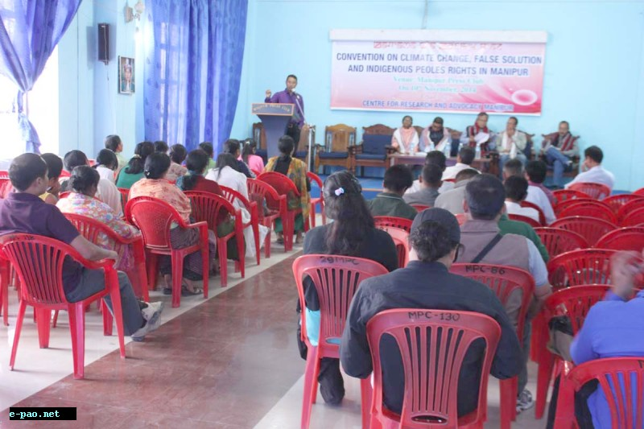
Convention on Climate Change, False Solutions and Indigenous Peoples Rights in Manipur on 10 Nov, 2014
Mr. Oinam Rajen, Secretary, All Loktak Lake Areas Fishermen Union spoke how the commissioning of the 105 MW submerged more than 80,000 acres of prime agriculture land and contributed in deepening climate crisis and how the National Hydroelectric Power Corporation remains unaccountable in Manipur, failing to rehabilitate and compensate those affected by their Loktak Project. Fishing communities were also evicted from Loktak Wetlands by the promulgation of the Manipur Loktak Lake Protection Act, 2006.
Dr. RK Ranjan, Senior environmentalist shared indigenous peoples have intrinsic relationship with our land and resources. Development processes in Manipur are often insensitive to the cultures, traditions and rights of indigenous peoples. Today, Manipur is unpredictable in its climate manifestations due to such insensitivities. Manipur is now forced to depend on outside for its food needs as a result of loss of agriculture land.
Dr. Y. Mani Khuman, President, AMUCO shared how introduction of development process is bereft of peoples participation and how such unsustainable development models contributed in climate crisis. There’s much inconsistence with the conduct of the Government which talks of protecting agriculture land while conscripting agriculture land for corporatization and privatization of our land and resources. Ms. Nganbileima Maibam shared on the fast shrinking wetlands and climate change implications and how communities depending on the wetlands are forcibly and mercilessly evicted.
The participants also adopted the following resolutions:
1) Express concern with worsening climate changes in Manipur, frequent flood, drought, species loss etc and impact on indigenous peoples’ cultures, traditions and their survival.
2) Expresses concern with aggressive pursuance of development processes, especially large scale mega development processes in Manipur with serious climate change implications, viz, mega dams, oil exploration and drilling, etc, which destroyed peoples’ land, forest, wetlands etc.
3) Concerned with Government of Manipur’s MoU’s with corporate bodies for mega dams and to drill oil and gas in Manipur. The colossal forest area submergence of these mega dams, including 27,000 hectares, by the planned 1500 MW Tipaimukh dam etc will aggravate climate crisis.
4) Express concern with the increased agriculture land grabbing by mega projects such as the Film Institute, Sports University, Trans Asian Highway and railway etc. Loss of Agriculture land will deepen climate crisis and undermine food sovereignty of Manipur.
5) Concern with increased investment of International Financial Institutions, viz, Asian Development Bank for mega infrastructure projects such as Imphal Town Ring Road without detailed impact assessment, option assessment and consent of communities.
6) Further concerned with the Manipur State Action Plan on Climate Change that prioritized false solutions to climate change, such as mega dams and REDD+ that will lead to negative impacts on indigenous peoples. All MoUs on Mega dams should be revoked and policies that facilitate such projects, viz, the Manipur Hydro Power Policy, 2012 and Manipur State Action Plan on Climate Change etc should be repealed.
7) The National Hydroelectric Power Corporation should cease all efforts to seek carbon credits and additional profits from the Clean Development Mechanism by classifying the controversial 105 MW Loktak Project in Manipur as clean and renewable energy project.
8) Express concern with the non recognition of indigenous peoples rights in forging out appropriate solutions in really mitigating climate change and in adapting to climate crisis.
9) There should be moratorium on large scale destructive unsustainable development projects in Manipur, primarily mega dams’ construction, oil exploration, large infrastructure projects, which will destroy our forest, wetlands, agriculture land etc. Review Mapithel dam construction.
10) Alternative energies, indigenous peoples’ traditional knowledge and practices such as diversified agriculture; community-based adaptation etc should be promoted in Manipur.
11) The upcoming climate change negotiations in 20 COP at Lima Peru should ensure recognition of indigenous peoples self determined rights and development. The emphasis accorded on Private sector financing as solution to climate crisis in International climate negotiations should end urgently.
12) The process of tackling global climate change has unfortunately been considered as an opportunity for economic benefits. Climate crisis cannot be resolved within the framework of “market solutions.” States should abandon all false solutions to climate changes that negate Indigenous Peoples’ rights.

CRA deplores State’s false solution on climate change
The Imphal Free Press, 11 November 2014
http://ifp.co.in/page/items/23900/cra-deplores-states-false-solution-on-climate-change
IMPHAL, November 10: “Development of the State should include every citizen. There cannot be development for a particular community or individual”, said Oinam Rajen, secretary, All Loktak Lake Areas Fisherman Union at the one day convention held at the Manipur Press Club here today.
The convention was organised by Centre for Research and Advocacy, Manipur on “Climate Change, False Solution and Indigenous Peoples’ Rights in Manipur.
While delivering the keynote address at the convention, Jiten Yumnam, secretary, Centre for Research and Advocacy, Manipur said that the consultation was organised in the context of deepening climate crisis amidst aggressive introduction of large scale development projects in Manipur.
The industrial zones and other development such as mega dams, oil exploration, and large infrastructure projects such as road and railway which involve either submergence or destruction of forest and water will ultimately contribute in climate crisis in Manipur, he added.
During the convention the participants discussed the ongoing aggressive push by the government to promote false solution to climate crisis such as reducing emission and forest degradation and deforestation.
The resolution taken during the convention were concern with worsening climate in Manipur, frequent floods, droughts, species loss etc and impact on the indigenous people’s cultures, tradition and their survival.
The meet also expressed concern over the government of Manipur’s MOUs with corporate bodies for mega dams and to drill oil and gas in Manipur. The colossal forest area submergence of these mega dams, including 27,000 hectares, by the planned 1500 MW Tipaimukh dam will aggravate climate crisis, it maintained.
It further took serious note on the increased agriculture land grabbing by mega projects such as the Film Institute, Sports University, Trans Asian Highway and Railway. Loss of agriculture land will deepen climate crisis and undermine food sovereignty of Manipur, it observed.
The meet also pointed out that increased investment of International Financial Institutions namely Asian Development Bank for mega infrastructure projects such as Imphal Town Ring Road without detailed impact assessment, option assessment and consent of communities is deplorable.
It demanded that all MOUs on mega dams should be revoked and policies that facilitate such projects, namely the Manipur Hydro Power Policy, 2012 and Manipur State Action Plan on Climate Change should be repealed.
The National Hydroelectric Power Corporation should cease all efforts to seek carbon credits and additional profits from the Clean Development Mechanism by classifying the controversial 105 MW Loktak Project in Manipur as clean and renewable energy project, it maintained.
The meet also demanded that the process of tackling global climate has unfortunately been considered as an opportunity for economic benefits. Climate crisis cannot be resolved within the framework of “market solutions” and the State should abandon all false solution to climate change that negates Indigenous Peoples’ rights.
The function was also attended by Phulindro Konsam, chairman, Committee on Human Rights and Dr RK Ranjan, senior environmentalist.

Manipur: Convention on Climate Change held
The North East Today
11 November 2014-11-11
http://www.tntmagazine.in/manipur-convention-on-climate-change-held/
IMPHAL: The State level Convention on Climate Change, False Solutions and Indigenous Peoples Rights in Manipur, was organized by Centre for Research and Advocacy, Manipur at Manipur Press Club here today.
Ms. Maibam Nganbileima, Lamphel Yaipha Leikai eviction victim, Mr.Mani Khuman, President, All Manipur United Clubs Organization graced
as presidium members.
Mr. Jiten Yumnam, Secretary, Centre for Research and Advocacy, Manipur in his key note highlighted the context of deepening climate crisis in Manipur and how aggressive introduction of large scale development projects in Manipur, such as mega dams, oil exploration, creation of industrial zones and other large infrastructure projects such as Road and Railways infrastructure with financing by International Financial Institutions led to violation of indigenous peoples rights in Manipur by destroying their forest, water and land.
Mr. Phulindro Konsam, Chairman, Committee on Human Rights shared how development decisions and processes, such as new MoUs on mega dams are pursued against the aspirations of indigenous peoples of Manipur. Mega development projects are often anti people, destroyed their forest, water, agriculture land etc and involves human rights violations. All development processes should respect indigenous peoples self determined rights and their right to free, prior and informed consent.
Mr. Achom Brojen of Kongba and Mr. Nahakpam Ibochouba of Langthabal shared the concerns and the failure of the Asian Development Bank loaned Imphal Ring Road plan to consult and take the free, prior and informed consent of affected communities and to take detailed impact assessment due to such large projects. Mr. Gopen, Irabot Foundation elucidated how current day forcible development that benefit multinational corporations with their forced acquisition of agriculture land will undermine food sovereignty of Manipur.
Mr. Oinam Rajen, Secretary, All Loktak Lake Areas Fishermen Union spoke how the commissioning of the 105 MW submerged more than 80,000 acres of prime agriculture land and contributed in deepening climate crisis and how the National Hydroelectric Power Corporation remains unaccountable in Manipur, failing to rehabilitate and compensate those affected by their Loktak Project. Fishing communities were also evicted from Loktak Wetlands by the promulgation of the Manipur Loktak Lake Protection Act, 2006.
Dr. RK Ranjan, Senior environmentalist shared indigenous peoples have intrinsic relationship with our land and resources. Development processes in Manipur are often insensitive to the cultures, traditions and rights of indigenous peoples. Today, Manipur is unpredictable in its climate manifestations due to such insensitivities. Manipur is now forced to depend on outside for its food needs as a result of loss of agriculture land.
Dr. Y. Mani Khuman, President, AMUCO shared how introduction of development process is bereft of peoples participation and how such unsustainable development models contributed in climate crisis. There’s much inconsistence with the conduct of the Government which talks of protecting agriculture land while conscripting agriculture land for corporatization and privatization of our land and resources.
Ms. Nganbileima Maibam shared on the fast shrinking wetlands and climate change implications and how communities depending on the wetlands are forcibly and mercilessly evicted. The participants also adopted resolutions among which are the concern with worsening climate changes in Manipur, frequent flood, drought, species loss etc and impact on indigenous peoples’ cultures, traditions and their survival.
Another resolution expresses concern with aggressive pursuance of development processes, especially large scale mega development processes in
Manipur with serious climate change implications, viz, mega dams, oil exploration and drilling, etc, which destroyed peoples’ land, forest, wetlands etc.
One resolution is on the concerned with Government of Manipur’s MoU’s with corporate bodies for mega dams and to drill oil and gas in Manipur. The colossal forest area submergence of these mega dams, including 27,000 hectares, by the planned 1500 MW Tipaimukh dam etc will aggravate climate crisis.
The convention also express concern with the increased agriculture land grabbing by mega projects such as the Film Institute, Sports University, Trans
Asian Highway and railway etc. Loss of Agriculture land will deepen climate crisis and undermine food sovereignty of Manipur.
One of the resolutions said concern with increased investment of InternationalFinancial Institutions, viz, Asian Development Bank for mega infrastructure projects such as Imphal Town Ring Road without detailed impact assessment, option assessment and consent of communities.
Further, the convention also expressed concerned with the Manipur State Action Plan on Climate Change that prioritized false solutions to climate change, such as mega dams and REDD+ that will lead to negative impacts on indigenous peoples. All MoUs on Mega dams should be revoked and policies that facilitate such projects, viz, the Manipur Hydro Power Policy, 2012 and Manipur State Action Plan on Climate Change etc should be
repealed.
The National Hydroelectric Power Corporation should cease all efforts to seek carbon credits and additional profits from the Clean Development Mechanism by classifying the controversial 105 MW Loktak Project in Manipur as clean and renewable energy project.
Express concern with the non recognition of indigenous peoples rights in forging out appropriate solutions in really mitigating climate change and in adapting to climate crisis.
The convention felt that there should be moratorium on large scale destructive unsustainable development projects in Manipur, primarily mega dams’ construction, oil exploration, large infrastructure projects, which will destroy our forest, wetlands, agriculture land etc. Review Mapithel dam construction.
Alternative energies, indigenous peoples’ traditional knowledge and practices such as diversified agriculture; community-based adaptation etc should be promoted in Manipur, the programme added.
The upcoming climate change negotiations in 20 COP at Lima Peru should ensure recognition of indigenous peoples self determined rights and development. The emphasis accorded on Private sector financing as solution to climate crisis in International climate negotiations should end urgently.
The process of tackling global climate change has unfortunately been considered as an opportunity for economic benefits. Climate crisis cannot be resolved within the framework of “market solutions.” States should abandon all false solutions to climate changes that negate Indigenous Peoples’ rights, the convention expressed. (NNN)

Abandoning false solutions to climate changes suggested
The Sangai Express, 11 November 2014
http://www.thesangaiexpress.com/page/items/45086/abandoning-false-solutions-to-climate-changes-suggested
IMPHAL, Nov 10 : Expressing concern over the worsening climate changes in Manipur resulting in frequent flood, drought, loss of species and impact on indigenous peoples' cultures, traditions and their survival, a State level convention on climate change, false solutions and indigenous peoples' rights in Manipur held today at Manipur Press Club resolved that climate crisis cannot be resolved within the framework of "market solutions" while calling for States to abandon all false solutions to climate changes that negate indigenous peoples' rights. The convention was organised by Centre for Research and Advocacy, Manipur.
Phulindro Konsam, chairman, Committee on Human Rights; secretary of All Loktak Lake Area Fishermen's Union, Oinam Rajen; senior environmentalist Dr RK Ranjan, president of AMUCO Mani Khuman, organising secretary of Irabot Foundation, Manipur, Gopen, victim of Lamphel Yaipha Leikai eviction, Maibam Nganbileima and RIMS road victim N Ibochouba were the resource persons of the programme.
Delivering the keynote address, Jiten Yumnam, secretary, Centre for Research and Advocacy, Manipur highlighted the context of deepening climate crisis in Manipur and how aggressive introduction of large scale development projects in Manipur, such as mega dams, oil exploration, creation of industrial zones and other large infrastructure projects such as Road and Railways infrastructure with financing by international financial institutions lead to violation of indigenous peoples rights in Manipur by destroying their forest, water and land. The participants expressed concern over aggressive pursuance of development processes, especially large scale mega development processes in Manipur with serious climate change implications, like mega dams, oil exploration and drilling, etc, which destroy peoples' land, forest, wetlands etc.
The speakers and participants are also concerned with Government of Manipur's MoUs with corporate bodies for mega dams and to drill oil and gas in Manipur. The convention underlined that the colossal forest area submergence of these mega dams, including 27,000 hectares, by the planned 1500 MW Tipaimukh dam etc will aggravate climate crisis. Expressing concern over the increased agriculture land grabbing by mega projects such as the Film Institute, Sports University, Trans Asian Highway and railway etc the convention said that loss of agriculture land will deepen climate crisis and undermine self sufficiency of food.
It also expressed concerned over increased investment of International financial institutions such as Asian Development Bank for mega infrastructure projects like Imphal Ring Road without detailed impact assessment, option assessment and consent of communities. Concerned with the Manipur State Action Plan on Climate Change that prioritize false solutions to climate change, such as mega dams and REDD+ that will lead to negative impacts on indigenous peoples, the convention adopted a resolution that all MoUs on Mega dams be revoked and policies that facilitate such projects, viz, the Manipur Hydro Power Policy, 2012 and Manipur State Action Plan on Climate Change etc be repealed.
The National Hydro Electric Power Corporation should cease all efforts to seek carbon credits and additional profits from the Clean Development Mechanism by classifying the controversial 105 MW Loktak Project in Manipur as clean and renewable energy project, it further adopted.
The convention also expressed serious concern over alleged non recognition of indigenous peoples rights in working out appropriate solutions in really mitigating climate change and in adapting to climate crisis. There should be moratorium on large scale destructive unsustainable development projects in Manipur, primarily mega dams' construction, oil exploration, large infrastructure projects, which will destroy the forest, wetlands, agriculture land etc and to review Mapithel dam construction.
Alternative energies, indigenous peoples' traditional knowledge and practices such as diversified agriculture; community-based adaptation etc should be promoted in Manipur. The upcoming climate change negotiations in 20 COP at Lima Peru should ensure recognition of indigenous peoples self determined rights and development. The emphasis accorded on private sector financing as solution to climate crisis in international climate negotiations should end, it resolved.

