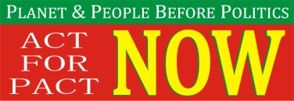
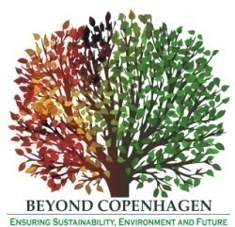
BEYOND COPENHAGEN

CECOEDECON, PAIRVI and Beyond Copenhagen in collaboration with IBON International
cordially invite you to HLPF 2 side event

Improving Governance of the SDGs through Improved Mechanism for Engagement of the Major Groups

1.15 pm, 2nd July 2014, Conference Room No. C, UN HQ

Brief Description of the Context: The HLPF was set up in July 2013 (in pursuance of the outcomes of the Rio+20 meeting) by a resolution of the UNGA (A/67/290, July 2013). The UNGA resolution mandated that it shall provide political leadership, guidance and recommendations for sustainable development. It will also replace the former Commission on Sustainable development. The broader objective of the HLPF is to oversee the implementation of the sustainable development goals and though yet to be institutionalized. The UNGA will convene the HLPF high level forum every four years, and the ECOSOC will convene HLPF for 8 days every year including three days Ministerial Forum.

Theoretically, the HLPF has the broadest engagement mechanism for the MGs who shall be allowed to attend all official meetings of the forum to have access to all official information and documents, to intervene in official meetings, to submit documents and present written and oral contributions, to make recommendations, to organize side events and round tables, in cooperation with Member States and the Secretariat etc. (S.15, UNGA Res. A/67/290). However, in practice, the unique positioning of the HLPF between the UNGA and the ECOSOC might have adverse implications for MGs engagement. The HLPF shall have to be conducted under the rules of procedure of the ECOSOC and the UNGA which though recognize the existence of the CSOs but to a very limited extent. Under the both the ECOSOC and the UNGA; the CSOs/MGs can be only observers, unless mandated specially. It means that the participation of the MGs is subject to the approval of the ECOSOC or the UNGA. The focus of the debate is whether the HLPF Resolution has an overriding effect over the rules of procedures of the ECOSOC or the HLPF? If interpreted in an affirmative manner the participation of MGs is assured, however, determined otherwise, in view of the intergovernmental character of the UN, the role of MGs will remain dependent on the mandate of the ECOSOC/UNGA. The HLPF has not been able to remove this ambiguity and declare an engagement mechanism yet. The speakers will discuss (in view of experience of the UNCSD and principle of non-regression with respect to engagement of the major groups) what MGs engagement mechanism will best suit the interests of the HLPF and will be helpful in effective governance of the SDGs.

For more information, contact: Mr. Ajay Jha (k.ajay.j@gmail.com)

Beyond Copenhagen is a collective of Indian CSOs working with a range of stakeholders, farmers, policymakers, grassroots organizations, and networks on issues of agriculture, food security and environment and sustainable development. The Collective aims at bringing focus on agriculture and food security in climate change negotiations. .
Secretariat: CECOEDECON, Swaraj, F-159-160, Sitapura Industrial Area, Jaipur-302022 (Rajasthan), INDIA
Ph: +91 141 2771488 | Email: cecoedecon@gmail.com | Web: www.cecoedecon.org

