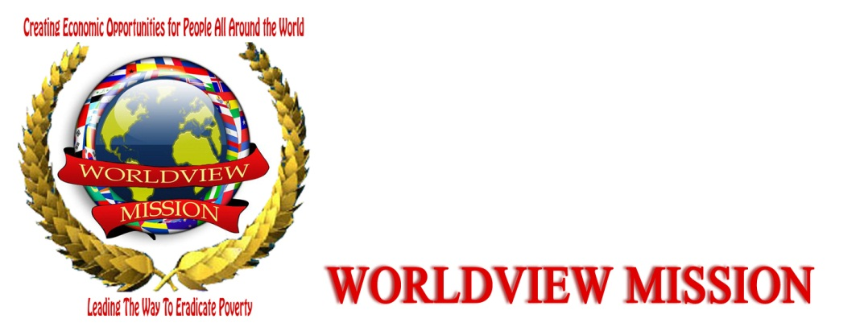
WORLDVIEW MISSION A 501 (C) (3) NGO With Tax-Exempt Status & Member of UN CSO-NET (ECOSOC CIVIL Society Network) NY (WM) Dept NL/EU: Ms. Hélène H. Oord (Chair & Founder / Em:info@worldviewmission.org/ Em: worldview.mission@gmail.com / http://www.worldviewmission.org

Ref: October 11, 2012

For the Attention of:
IREX COMMUNITY SOLUTION PROGRAMME
Community Solutions Team
2121 K St., NW, Suite 700
Washington, DC 20037

RE: RECOMMANDATION FOR RICHARD HAMBA TO BE PART OF YOUR COMMUNITY SOLUTION
PROGRAMM
We hereby wish to recommend Mr. Hamba Richard who is known to our organization and committed to youth activities as country representative Worldview Mission Uganda.
Richard also works with TEENS Uganda (www.teensuganda.org ) a registered not-for-profit organization for young people especially focused to improve their life choices in matters concerning their sexuality, HIV and empowerment.
His work is recommendable contributing to improvement in lifestyles of many young people through promoting youth leadership, decent work, and theatre programmes as part of their behavioral change communication component.
He demonstrates ability to lead community development initiatives at, work with teams and
therefore lead to change. From his participation in this fellowship programme, we are certain that he will be in position to continue supporting development work and share his acquired knowledge and skills with other growing leaders.
It’s against this background that I recommend him for your consideration.
A brief introduction of Worldview Mission
- Worldview Mission is member of United Nations CSO-NET (ECOSOC CIVIL Society Network NGO Branch, New York.
- This Global Organization connected to the United Nations is affiliated with a multitude of organizations in the world that are concerned with ending poverty, with the Statement of United Nations Under-Secretary- General for Communications and Public Information (DPI) Mr. Kiyo Akasaka, to end the poverty by 2015.

Yours sincerely,

Sincerely:
xxxxSignature Signed xx
_________________________________
Hélène H. Oord
Worldview Mission
Chair & Founder
Mob: : +31 (0) 636-108-563
Phn+Fax: +31 (0)107-857-863
Skype: helene.oord21

