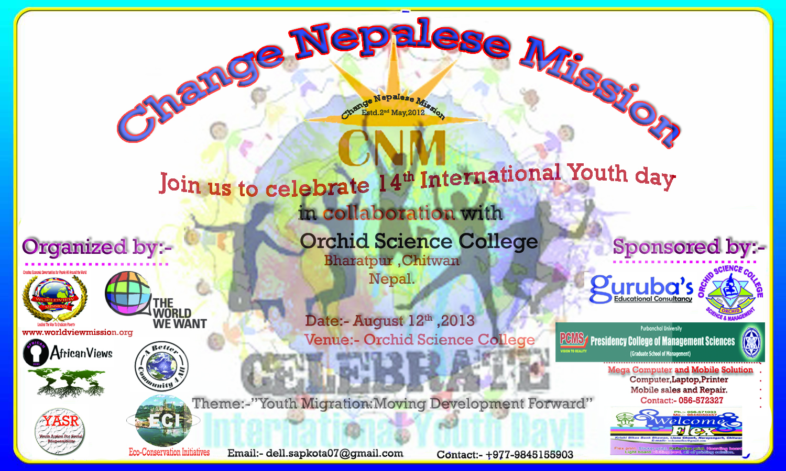

Programe: date August 12th ,

What we do with College Students.
Actually, i am going to celebrate youth day with grade 11 and 12's students (Age 16-19) where they are like newborn baby because they may don't have knowledge about Role of Youth, Who we are, How to be empower etc. so here i have some major points for newborn (youth) to provide fact information to them by interacting with you .

1. When, where,Why International Youth Day is establish?
2. Who are the youth?( Youth range are different according to the nation).
3.What are the major problems of today's youth in modern society?
4.Role ICT(information and communication technology ) for youth.
5. Role of youth in Agriculture, Climate Change
6. Projects Funding

