JOSEPH SENYO KWASHIE
PROFILE
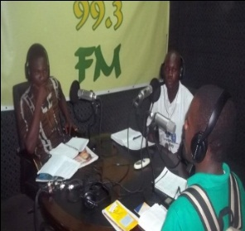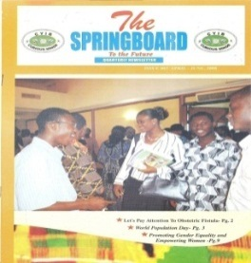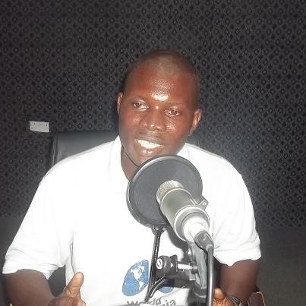
MR. JOSEPH SENYO KWASHIE is the founder of COMMUNITY AND FAMILY AID FOUNDATION-NGO in GHANA, of National in nature working for and pursuing youth and other social humanitarian development agenda for more than half a decade now. The history and work of the organization cannot be complete without the mention of him, known in many cycles as the cradle of NGOs hope. He is well rooted in the work of NGOs with a decades and half experience. Joe-had worked and volunteered for more than 200 civil societies in Ghana and abroad to execute quite a number of projects. He has a fair balance of educational laurels and degrees of recognition from various institutional backgrounds.
As a gentle of the century his contributions to youth and humanity development cannot be under estimated, which have reflected in most organizations he had served in the past such as PPAG,TFAC,NFAID,Young and Wise,GHWA,AYA,DIF,Womens Vision 3000,ROGRAF,WAKE,YOUTH PATH,TRADE WORLD,VYTF,OAU,etc
He is a well gifted persona who takes up any challenges with a prolific writing back ground and specializes in youth activism, training, SRH, Research, development planning, women’s health, and policy reforms. Joseph has been involved in the work of comprehensive youth activism in the areas of Adolescent Sexual Reproductive Health and Rights at the state, district, and national levels, serving as an officer, committee member, delegate, and, most recently, as the National Treasure of the Coalition of Youth Development Organizations in Ghana(COYODOG), leading various project in the health arena. He has been actively involved in special projects including “Operation Youth for Positive Health,” a program to improve the ASRH health needs of young people.
He has also represented, presented, papers, trained, consulted on interest of youth on so many platforms to dialogue and make critical decisions which affect youth total lives such as the 16th ICASA -2011 in Ethiopia 2010, 2nd Global Health workforce Alliance-January 23-31 2011-Thailand, west Africa Regional Youth Leadership Conference on ICPD 10-14 March 2013. He also continues to host quiet a number of programs in the field of MDGs, online, radio discussions, write features, to help the vulnerable have a stand in development. He continue to use direct drama performances to sell out issues to key stakeholders to be informed and to make informed choices which has received high recommendation. Joseph has exceptional communication skills in English, West-Africa, Africa, and International experience in event planning and execution, strong organizational skills. Solutions focused, detailed analyst, team oriented leadership bilingual, Strong and persuasive negotiations and interpersonal skills, with ability to successfully analyze an organization's critical support requirements and identify potential opportunities. Proficient in planning, develop strategies, evaluating projects and making easy good client and people relations.
Indeed he is a product of choice and stronger icon whose participation in any agenda yields the most appreciable results to the latter

