Community and family aid foundation

Annual Report for 2013
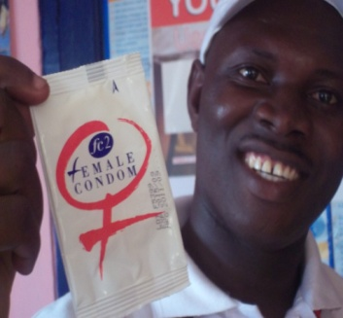13
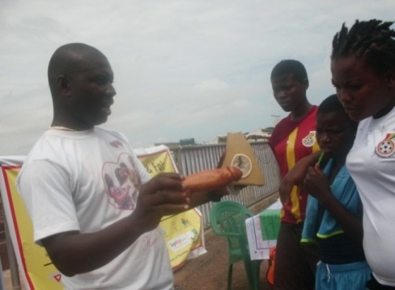
20 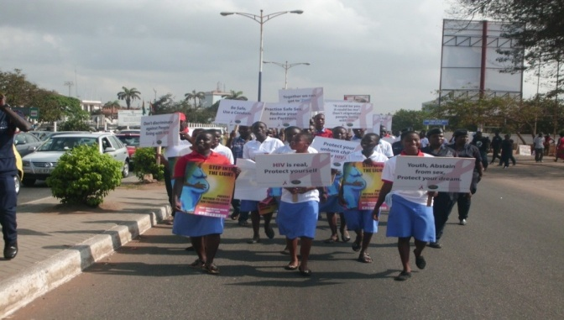
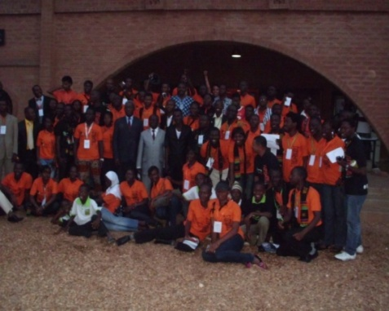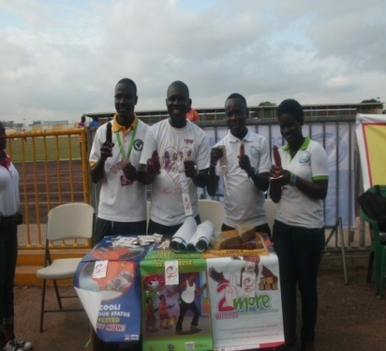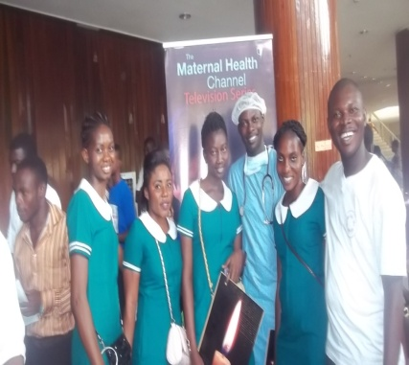
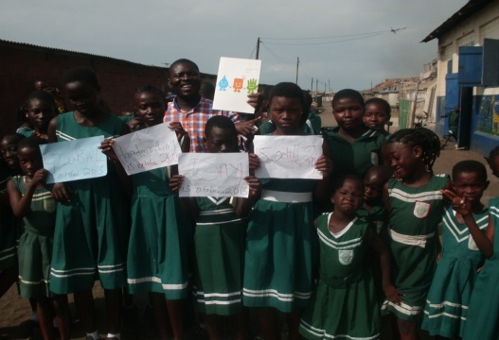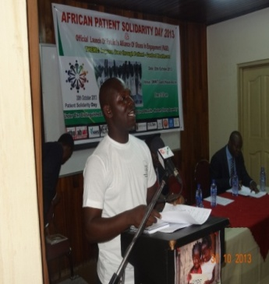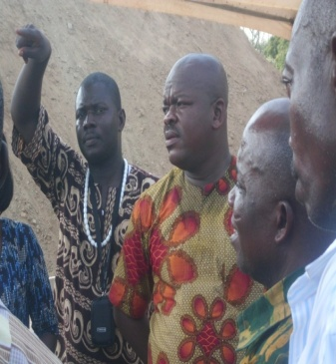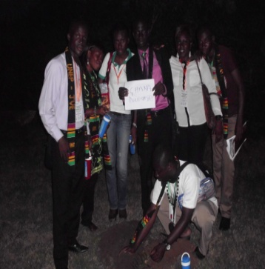

A person is a person through other persons
We care, help us to help
TABLE OF CONTENT

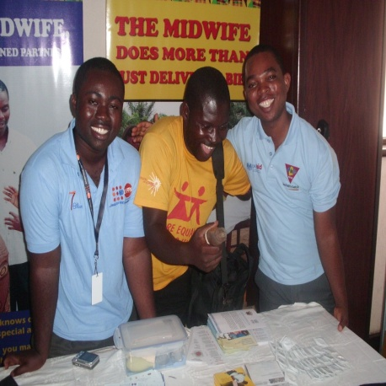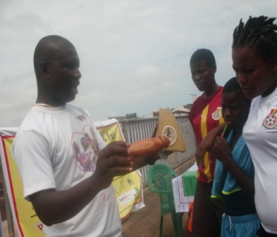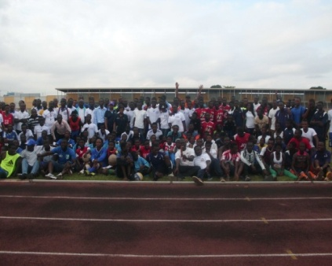

VENERATION

-Acknowledgement
-Message from management

ORGANIZATION PROFILE

-The organization provide profile include
-Mission Statement
-Vision Statement
-Our core values
-Governance and Structure
-Intervention Areas
-Key Target Groups
-Projects under Implementation
-Refer to reports
-CAFAF goes International
Membership of coalition and Network
-Our donors
-Officers
-Contact address

GOVERNANCE STRUCTURE

-The governance structure of the organization remains as fellows:
-The Annual General meeting
-The executive management
-Secretariat
-International offices
-Regional focal points
-Membership
-Beneficiaries
-Communities
-Partners and Collaborations

EXECUTIVE SUMMARY

-The Organization
- Governance and Structure
- Offices of CAFAF
- Membership
- The Secretariat

2013 PROJECTS AND ACTIVITIES OVERVIEW

-Ghana must known HIV and AIDS campaign
-Observation of Global Hand washing Day - 15 Oct
-Operation kick Malaria Away
-Stop TB 2013
-2013 Rubella and Child immunization
- Health for wealth greatest campaign activities.
-Africa Patient Solidarity Day
-Presidential Youth Dialogue 2013
-Climate Change Communication for Change Campaign
-ICT SCH, 4 LIFE PROJECT
-African Patient Solidarity Day 30th October,2013
-Participation in workshops, conference, trainings, consultations etc

ADMINISTRATION

-CAFAF Internal meetings
-Finance and Administration
-Mobilization and Advocacy
-Participation in local Initiatives
-Participation in International Initiatives
-CAFAF welcomes New Volunteers

ON THE MOVE

-Participation in local and in international courses
-CAFAF welcomes 3 new volunteers
-Fund raising, proposal submission
-Up date of CAFAF website
-Appointment of CAFAF members serve on local and international bodies.
-Money matters
-Plan of action for 2014
-Way forward
-Conclusion

ACKNOWLEDGEMENT

Management wishes to take this opportunity to say a sincere thanks to the following bodies and individuals whose contribution help to make our operations absolute. They were behind us through out the storm and their indefatigable inputs must go unnoticed.

- APPLE Project – Mr Jack Dowson
- Daniel Lezu – CAFAF web administrator
- Alex Nii Amah Hayford– Track –Ghana
- Charlotte Amah – ED – women vision
- Elizabeth Korasare – Real opportunities
- Urma Adamu –Society for Youth and Development

NETWORKs
- Nii Kwatelai of Act for change
- Isaac Nii Quartey Owoo of Misshejeloi
- Daniel Nii Boi Boye – JESDAN Hope
- Ezekiel Chebeze – SYDN Ghana
- Rita Naa Dzagble Quaye – GHANET
- Rita Gaglo – No limit charity organization
- Mr Ashie - Christ king of Kings school
- CHF - Solomon
- RIPS – Dr. Dove
- Nola manshall - culture DNA WK
- Elise young – Women Thrive worldwide
- Felicia Sosu – ED – Rural project support Network
- Collins Semah – Act for Change
- Hon. Caryant Zamelo – Marche women
- Mr. Williams Laryear – Himpex Academy
- Madam Josephing Agbo Nettey – DOF
- Joseph Nybuto of Kenya
- Nana Saah of GII
- Rosina Akuorkor – ED Dolly Foundation
- The Ghana Coalition of NGOs in Health
- Ghana HIV and AIDs Network
- Ghana Alliance for clean cook stoves
- Patient Alliance Organization in Engagement – PAGE Ghana
- The Ghana Stop TB Network and NTP
- Helen Sawyers – Oman
- Netright - Ghana
- SWAA –Ghana

The Board members of CAFAF and the countless individuals out there, Management appreciates and values your support to us
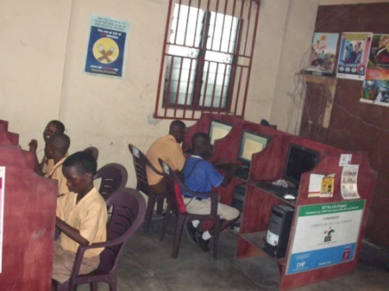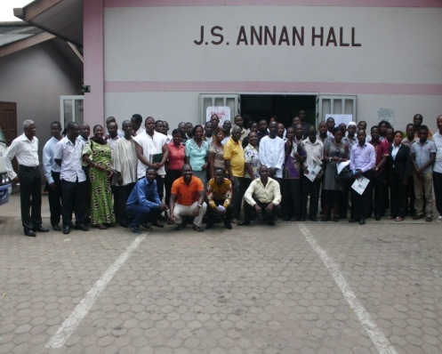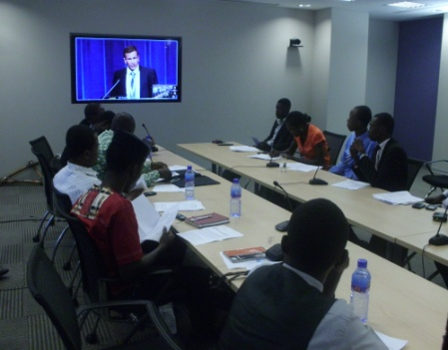

OUR DEAR WELL WISHERS

Management of COMMUNITY AND FAMILY AID FOUNDATION (CAFAF) are happy to once again come your way with our report, a long held tradition depicting steward accounts of our work during the year under review. This practice has been a folklore observed since the inception of the foundation, of which we are extremely proud of it.

In 2013, the foundation witnessed a tremendous turn around in spite of the many challenges our operations encountered. Our activities evolved around five major thematic areas of concern for which reason we tirelessly worked around the clock to achieve. Through out the journey these exposures empowered us and became a spring board for practical learning for reforms.

We witnessed another blowing encounter which has never happen in the history of the foundation before. We received a series of engagement with key stakeholders who reviewed our performance so far. This in the coming year is expected to generate into a solid partnership building to open our growth from a small organization to a bigger one in the near future. We have indeed learnt a lot of lesions from this interaction hoping to take the necessary steps to put in place the necessary structures to help management deliver to the greatest maximum.

Our report reveals our positive stand point of ever ready preparedness to account for our work inline with our laid down policies that under pins the over all operations of the foundation. In 2014, management sincerely wishes to partner with like minded bodies to achieve more results than ever. Our focus are clear cut in suspense to achieve yet another giant fit at the end of which we shall continue to account for our work.

Management takes this indefatigable opportunity to extend our profound gratitude to our allies for the kindest cooperation granted us in the cause of the year. As 2014 unfolds our ability to sail through the tides largely will depend on all, as your contributions to the organization helps to make a difference in the lives of the vulnerable on your behalf.

Kudos, to you all, may 2014 year produce a warmest gesture of love, peace, freedom, joy, power to face and live life to the fullest.

Thanks

ORGANIZATION INFORMATION
COMMUNITY AND FAMILY AID FOUNDATION (NGO) is a Ghanaian National Non-Governmental Organization with a global thinking and acting locally, currently exclusively identified with promoting the empowerment of women, communities, young people to manage issues concerning their development and to advocate for and work towards adolescent and sexual reproductive health, rights and well-being; to advocate for and on behalf of young people, in the area of reproductive health, HIV/AIDS, environmental health education, climate change, and other related issues that affect their total development. Aim at hosting the largest effort of reaching out to youth of Ghana to appreciate and respond to their sexual health rights needs for a bright future and promoting their development toward the nations building.
CAFAF is registered under Registration Act 1963 No 21446 founded in 2006; the organization is also registered under the social welfare system DSW NO 3692. The work of CAFAF has spread over the entire Accra-region, has determined to organize the various programmes for the better livelihood, protection and sustainable development. CAFAF is working in the field of Integrated Rural Development, HIV/AIDS/maternal health, sexual reproductive health, promotion of Traditional Health System and Involvement and Advocacy for the social issues having a definite bearing on the life of people.
CAFAF has come forward with a strong faith that its efforts will uplift the socio economic condition of those people who have been neglected and denied for their rightful share of the society for centuries. The Organization work jointly with the people inviting them to participate actively in solving their own problems, The Organization support their reasonable demand and decision and encourage them to discover and utilize the available natural resources. CAFAF trusts that the spread of education will help them to overcome their deep rooted superstitions and social evils regarding emerging trends.

AT CAFAF We Say: FOR PEOPLE, DEVELOPMENT, AND GENERATIONs

OUR VISION

To see and play a leading role for a better world that promotes both our human and natural resources tapping, to stimulate development resulting in improvement where all are happy and useful
OUR MISSION
CAFAF: exist to create possibilities to improve lives, where our development interventions will live indelible mark on people, communities and underserved populations to fashion a world, where all will be happy and useful including respectively living for others to reflect equal, participatory economy releasing that a person is a person through other persons as a lasting legacy for generations to come for replication.

THE ANNUAL GENERAL MEETING

The Annual General Meeting (AGM) accordingly and by our constitution and policies remains the highest decision making body which looks into the over all operations and mandates of the organization. It is conveyed yearly and when the need arise equally tasked to meet for emergency to under take critical decisions on key issues prevailing at the time. It brings together on one platform both dues and none paying dues members. This kind of encounter is set to review, act, and appraise the general performance of the management of the organization. Aftermath of satisfactory of the works of the management their contract is extended to another period agreed upon. Therefore the AGM is the heart beat of the foundation for which reason their decisions is central in the affairs of the organization.
EXECUTIVE MANAGEMENT
Beyond the operations of the AGM comes the executive management team led by a nucleus constituted set of expertise that are mandated to put the decisions of the AGM into action. They convey a series of meetings during which both financial and narrative activities reports are presented for thorough review by members. Thus, the executive management operates the organization for and on behalf of the members of the AGM. The chairman elected at the bi-annual AGM is expected to play active role and be the mouth piece of the AGM in the administration of the foundation all the time in the day to day running of the foundation.
Additionally, the Executive Director, is expected to expand the administration pattern of the organization and when necessary to make running of the secretariat smooth upon consultation with the chair person in the cause of time. The members of staff and volunteers is unlimited for which reason the Executive Director takes into accounts the available resources,needs,projects,situation vacant before recruiting people into the organization.
THE SECRETARIATE
The Secretariat is managed with the support of core staffs and the chair person of the foundation. The Executive Director supervisors and coordinates all activities that take place from administration to other forms of engagement. Refer to our administrative documents for details. The secretariat is also mandated to venture into other key activities when necessary to the extent of having the power to open offices in other regions should the need be and where the resource for implementation of projects are available to do so.

INTERNATIONAL OFFICES: CAFAF by its constitution is free to operate foreign policy advocacy service across the globe. In this vain management is expected to follow the due processes in securing the necessary permits to operate at such levels. In 2013 quiet a number of people approached the foundation seeking permission to open similar offices outside the country to articulate the mission and vision of the foundation at such levels. Such permission has been granted to a group in Kenya and management is in constant touch with them supporting them to put the necessary structures in place. Outcomes of such engagement will be communicated into our next report in the coming years.
These offices are not to rob shoulders with the mother organization rather play complementary role in making ht voice of people count through policy influence.

REGIONAL FOCAL POINT
CAFAF in the future hopes to operate in other regions in Ghana. As per our constitution management is in consultation with other Networks with possibility of opening office in a region that we are likely to begun implementing activities there. Such offices will be mined by regional representatives with core staff and volunteers where necessary. They will be expected to report to the regional office depending on the type of activities and projects offered on the grounds.

MEMBERSHIP: The organization recognizes two sets of members; they include direct and indirect members.

DIRECT MEMBERS: They are individuals and organizations who have interest in the organization. Such members pay dues and are engaged in most of the activities of the foundation as and when time will allow them. They are given specific tasks and targets to achieve which is supervise by a senior management member. These volunteers’ members also represent the foundation at different levels of interaction and are mandated to raise funds to boost the operations of the foundation.

INDIRECT MEMBERS/INVISIBLE
They are also known as shadow members they do not play active role in the activities of the organization but are expected to contribute resources on regular basis to support the operations of the organization. Management communicates and updates such members from time to time via sending them of reports, plan of actions, up coming events, correspondence to update them. They also have the free hand to come on board subject to official notification of management to perform other tasks if one wishes to do so.

PARTNERSHIP MEMBERS: These are organizations and coalitions who are by the virtue of our constitution are allowed to join the organization after meeting our standard of participation requirement. Such members become franchise members and it allows them to use our tools and resources from time to time to champion our cause in the common interest for mutual development. They are expected to benefit from our free trainings, workshops, consultancy, services, meetings, opportunities where necessary etc.

BENEFICIARIES AND COMMUNITIES: Whatever CAFAF does affect lives and our natural resources directly and indirectly which can be found in communities. Therefore these terms are used interchangeably to depict the nature of people and communities we operate in based on our resources.

BENEFICIARIES: They are our target audience who are reached with our range of interventions from time to time based on identification of their needs and wants.

COMMUNITIES
These are the geographical locations of our activities toward achieving our specific goals and mission. It changes depending on the projects and stakeholders and partnership activities. The entire structure of the organization uses either top to down or bottom to the top .its approach largely rests on the beneficiaries and communities for which reason we do not joke with them at all. The social marketing and donor supports received by the organization are directed to such areas to achieve the needed outcomes at the end of every intervention. Apart from this brief presentation on the governance structure, management has a pictorial view of the structure itself which can be referred to in our cooperate governance policy document .CAFAF have in place the necessary evidence which has been largely used, up dated to operate and conform to best practices and international standard from time to time. In 2014, further steps will be taken to up date and review the policies to correspond with International and local demand standards in the field of NGOs operation.

OUR PROJECTED INTERVENTIONS FOR THE PERIOD

For a period spanning 12 months, the foundation continued with a range roll out of activities bordering on health, climate change, environment, leadership, human rights, energy and participation in both local and international discourse etc. These activities primarily focused on the following but do not limit to:

- Ghana must known HIV and AIDS campaign
- Observation of Global Hand washing Day - 15 Oct
- Operation kick Malaria Away
- Stop TB 2013
- 2013 National Rubella and Child immunization
- Health 4 wealth greatest campaign activities.
- SWAA International female condoms day
- Essential service platform 2013
- Environmental Film Festival of Accra-EFFA 2013
- Alliance for clean cook stoves festival 7th November 2013
- Participation in workshops,conference,trainings,consultations etc

These and many issues bordering on development, social protection, occupied the stage of activities conducted during the period under review. Through these intervention our team of volunteers were able to reach out to the unreached through effective outreach programming. Highlight below were some of the impact and key outcomes obtained. Management equally wishes to state here that all our implemented activities are carried based on extensive consultations with our key stakeholders and it is at this encounter that relevant activities are prioritized for execution for the next year. And so our 2013 activities were planned and agreed with all our partners far ahead in November 2012 two months to close the year.

The issues of policy and the entire organizations mission and vision are taken into consideration before crafting any projects in conformity with our laid down rules and regulations. Again value for money and cost effective ways of managing resources are key pillars of our job demands.
Where necessary project and activities carried out actively and in partnership with our partners have been acknowledged. We owe it as a duty to capture such projects because we have played various crucial roles in terms of investing our energies, skills, expertise, best practices, and attention toward the realization of these projects. No conflict of interest comes in as our partners are aware, could testify including quantifying the value of our contribution to champion such a cause.

We have presented the projects with the relevant pictures to give a fair idea what it is, impact, analysis, methodology, concerns, conclusion to enable our able readers do their own judgment. Management will equally be happy that any one who laid hands on the report makes it a business to share our good works with people and partners from the world over. We still needed more support to get far and shall be happy to hear from you willing to support us.

OUR ACTIVITIES, ACHIEVEMENT, CONCERNS AND CONTRIBUTION TO DEVELOPMENT

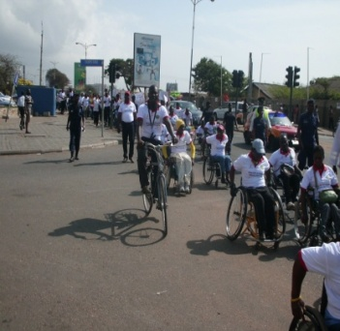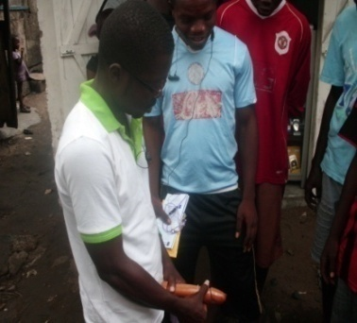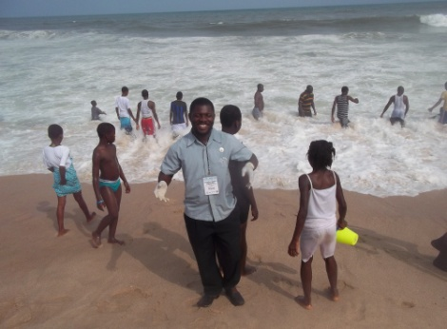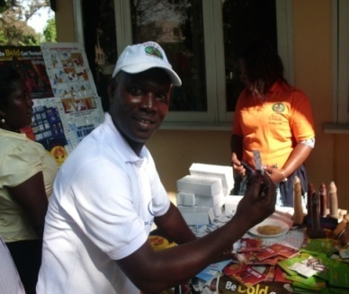
GHANA MUST KNOW HIV AND AIDS 2013 CAMPAIGN

CAFAF in conjunction with the following organizations delivered a comprehensive public HIV and AIDS education and awareness creation in the cause of the year, with Act 4 change, JESDAN Hope For the future, Women’s Vision 3000 etc. The project is a three year strategic plan aimed at reaching out to the infected and affected population.

The intervention employs innovations such as participatory, community simulation approaches to addressing the issues among the general population. Its addresses treatment, care, support, prevention, transmission and technological advancement currently in place to support victims. The access aspect looks at distributing both communication and contraceptives materials to the communities and target population when necessary. The GET IT RIGHT AND SPREAD IT RIGHT message seeks to present accurate information about the pandemic as current knowledge level of most people remains’ low.

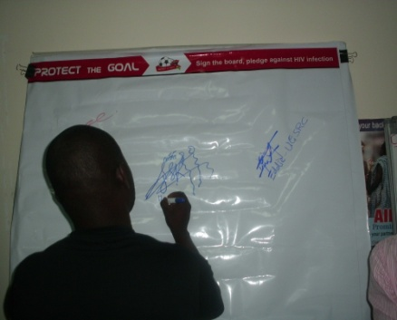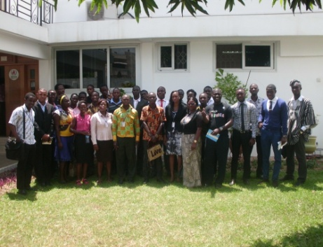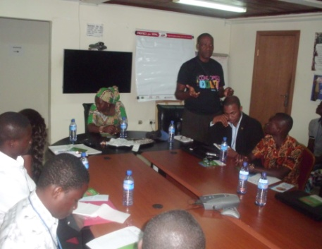
AT CAFAF we are committed to making health care service delivery accessible by the poor
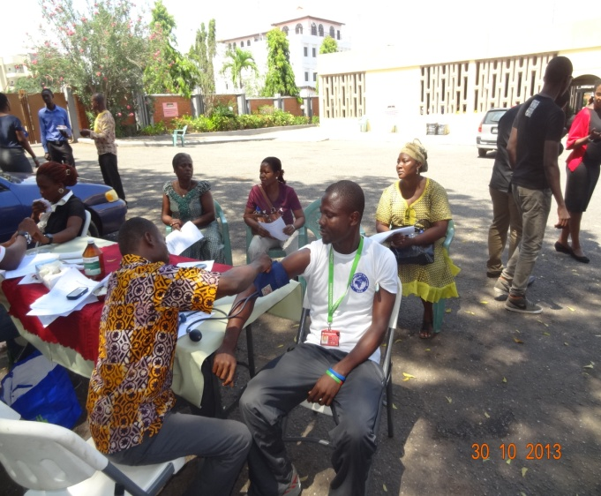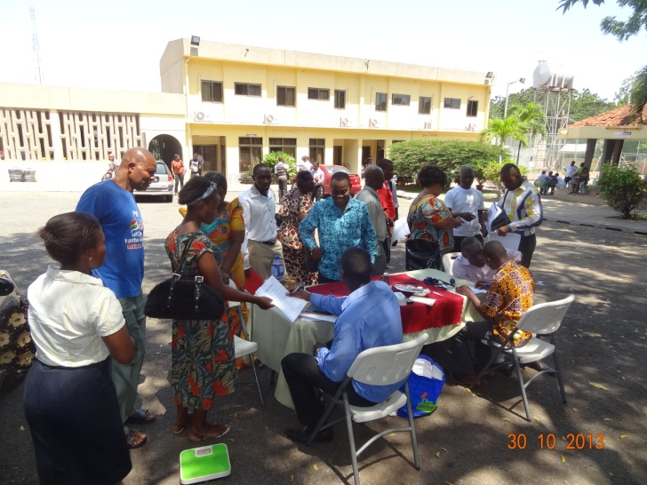

Scene of meetings, public health outreaches to mark the Africa Patient Solidarity Day, 30th October, 2013

Activities continue

Five public outreaches were held in the cause of the year for people in the following communities Sodom and Gomorrah/old FADAMA, march 15th ,2013,, Bubuashie jauary,5th 2013, Agbogbloshie 25th of march 2013, James Town Beach and the Charle Wote Festival show 2013-7-8th September ,2013.
Through these encounter a total number of 15056, audience comprising of males 6333 and females 8723 were reached out to. Following the success of the activities after extensive evaluation, management have reaffirms our commitment to continue with the strategies in 2014. General funding activities was nothing to write home about but the spirit of volunteerism propel management and our partners to pull our little resources together to achieve these enviable results.

We are forever thankful to the following organization for supplying the team with the necessary communication materials for distribution, the Ghana Aid Commission (GAC), the German Technical Cooperation (GIZ), and Ghana Coalition of NGOS in Health for their tremendous support. These partners support greatly helped to make the outreaches quiet interesting which pave way to interact, host group discussion, quizzes, contraceptives use demonstration including conduct of direct counseling and testing by volunteers. With 2014 marking the second phase of the campaign every effort will be pursued to handle planned actions with the necessary attention and administrative acumen.

MPS 2013 BECE SPECIAL CLASSES
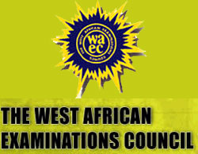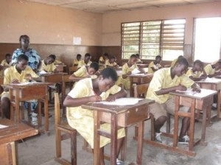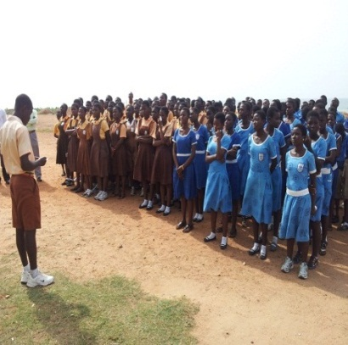

As part of our efforts to champion education in the district, our foundation in partnership with likeminded bodies organized a special encounter with 2013 BECE candidates dubbed “MP’S 2013 BECE SPECIAL CLASSES”. The intent of the programme is to offer hope, show concern, dialogue and offer “winning ways” strategies to prepare the candidates for the tasks ahead. OUR partners the Member of Parliament for Ashiedu-Keteke District-Accra Community and Family Aid Foundation-NGO,THE District Education office School Heads, the OICs ,Sponsors etc
A series of planned extra classes’ lasting ten weeks in April-May, 2013 was organised to reach out to thousands of the candidates in the Ashiedu-Keteke District with support from the Member of Parliament Hon. Nii Lamptey Vanderpuiye /Deputy Minister for Trade and Industry .the project was used to prepare them for the exams ahead. Other side attraction includes the featuring of prominent people to educate the candidates on how to overcome the fears, learn and pass the examination with ease. Key stakeholders such teachers, invigilators, school heads, counsellors, examiners, career coaches, were at hand to offer their expertise, attention and skills free of charge.0ver 2500 candidates benefited from the project with two hundred teachers participating in the teaching along side the senior mentee’s who were occasionally at the various cluster of schools to share real life experiences with the candidates.

SWAA INTERNATIONAL FEMALE CONDOMS DAY
CAFAF joined the Society for Women and Aids in Africa (SWAA) to celebrate the International Female Condom Days on September 2013.As a member of such a vibrant Network work ,CAFAF, officials in conjunction with the network carried out a public out reach at the Agbogbloshie Market here in Accra. The occasion was used to educate the market women on the benefits of using the female condom. Participants had the chance to demonstrate to the women the correct ways of wearing the condom, where to get it, when they are in need of it. Over 2000 pieces of the condom were sold out to the women and were encouraged to be ambassadors to spread the message. It’s their right to negotiate for condom when things are critical and that the condom aside protections equally protect the women from a possible pregnancy, it also prevents them from infections.
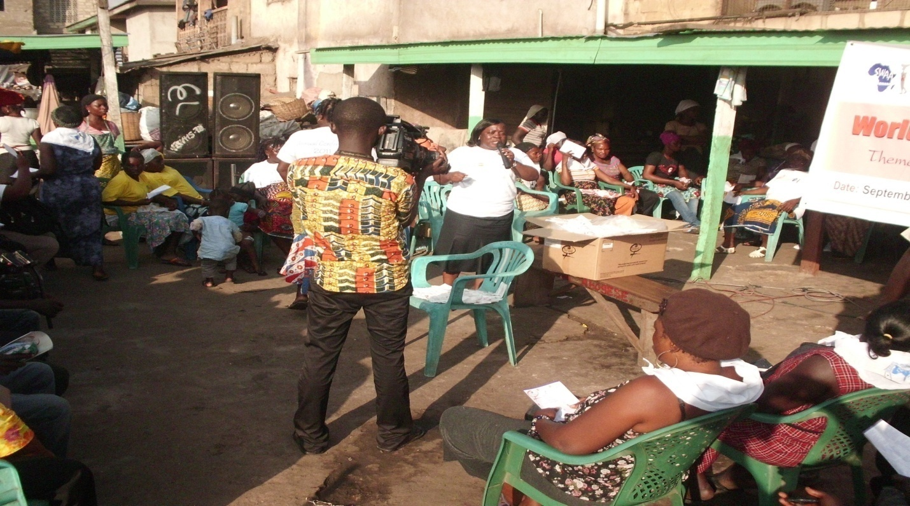
At the end of the programme Joseph Kwashie of CAFAF and Gloria of SWAA were selected to go to TV AFRICA to make a live presentation on the stations 7:00pm News bulletin to remind the public of the day. This was carried out with ease and a final report on the programme was subsequently submitted to SWAA office after words. It also came to light that the entire project have received more support from the Female Health Company and the promoters of the female condom use globally who have selected GHANA to benefit from a special package to that effect. The three years project is targeted at making over 5 million condoms available to women through action focused outreach activities. It is also anticipated that more members of the network will be supported to carry some of the activities in their respective communities to top the outcomes. At CAFAF we are happy to be associated with such a ground breaking intervention aimed at making women’s issues a top priority ,overcome cultural strings, and stimulate women to stand up for their right and demand what is due them to safe guide their health in entirety.

ESSENTIAL SERVICE PLATFORM 2013
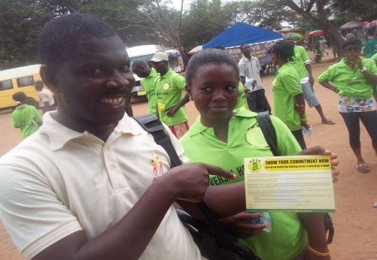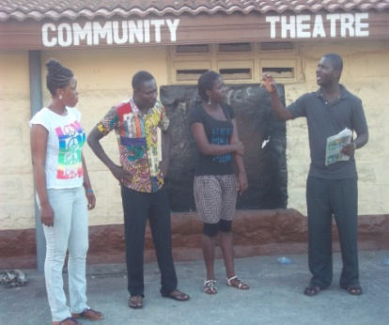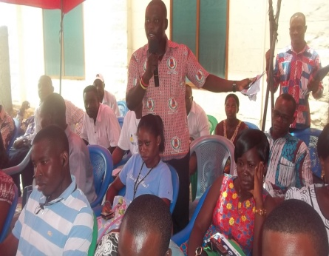
The essential service platform is a network of NGOS pursuing a common agenda of making relevant health issues count by holding respective authorities accountable to live up to their expectation. They represent the voices of the voiceless. During the period under review the organization carried out quiet a number of interventions such as workshops, public, demonstration, press release including symposiums on critical health issues .CAFAF participated actively and in partnership to equally project our concerns.
We did our best and showcase our prowess as far as health system strengthen advocacy is concern in Ghana. These platforms were effectively utilized and we are happy to received positive responses from such actions taken in the cause of the year. We thank our sponsor such as the Oxfam, ISODEC, and Coalition of NGOS in Health and the members of the platform.
ENVIRONMENTAL FILM FESTIVAL OF ACCRA-EFFA 2013
During the year CAFAF, ACT FOR CHANGE and a host of volunteers participated in key activities under taken by the Environmental Film Festival of Accra. The theme for the occasion was HEALTH AND THE ENVIRONMENT, 28th june-5th july,2013.the week long activity was characterize with a night of inspiring environmental cinema,drama,music,and popular entertainment. It featured ACT FOR CHANGE, CAFAF, ALEWA and other under ground artists from the communities. We are happy to have joined them voluntarily and provide the most pressing health challenges, constructively packaging our issues to suite the occasion to receive the need public attention. This led to the total influence of our key stakeholders to be on their toes to address the problem.
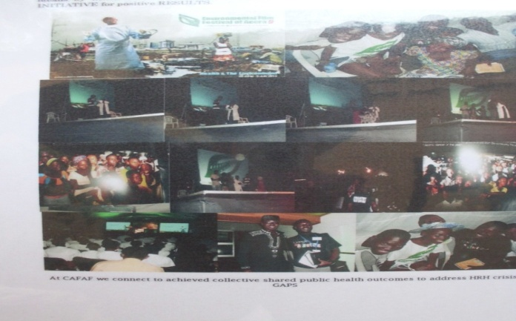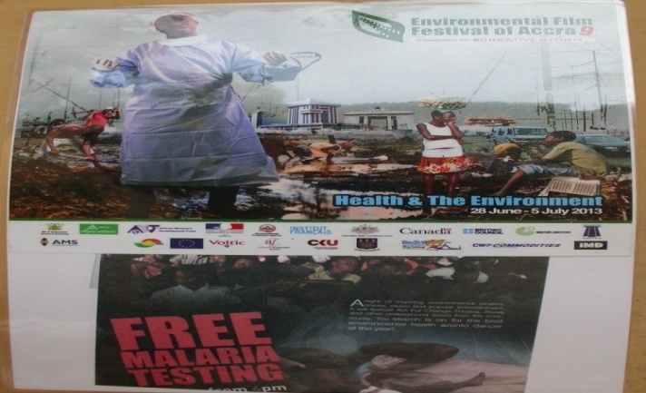Kwashie was featured on at the various scene of the festival through out
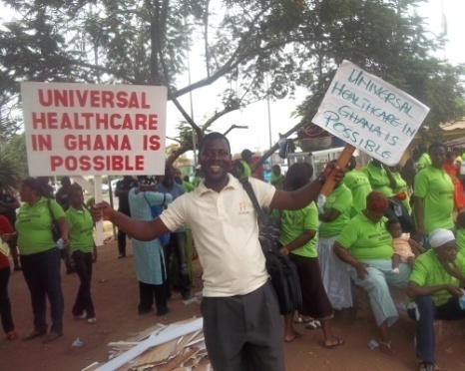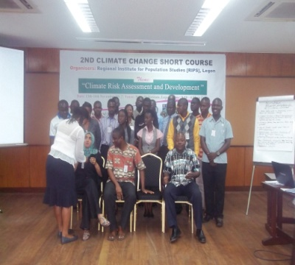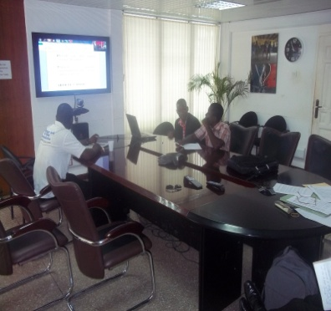
ALLIANCE FOR CLEAN COOK STOVES AND THE WOOD STOVES FESTIVAL
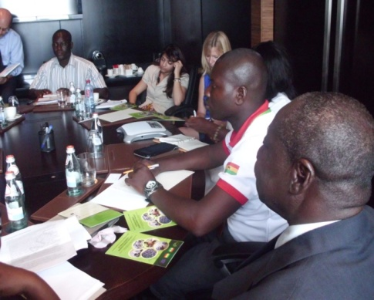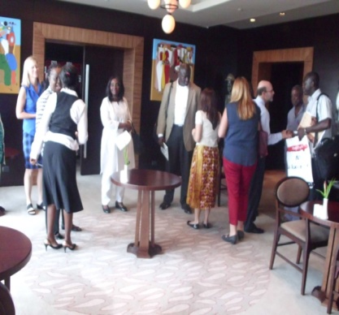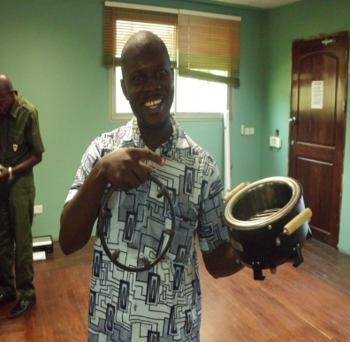
CAFAF is a member of the Ghana Alliance for Clean Cook stoves which is a network of civil society community bringing the issues of renewable energy to the fore. The core mandate is to address access to adequate, affordable and sustainable energy products and services. The intent as well is to bring both manufactures, sellers, consumers, policy makers to understand each other and utilize the platform effectively to negotiate for change.
In the cause of the year quiet a number of activities were held such as conference, regional dialogue ,trainings ,meetings ,election of executives, among others .CAFAF team were invited top feature on these platforms and bring out the issues for discussion from the community. This projected the image of the organization and place us at the decision making table as a vibrant organization to partner with.
As a member of the Alliance we are indeed committed to linking health with energy because access to modem energy not only helps to eradicate poverty and improve the environment and living conditions, it also reduces the disparity between men and women.
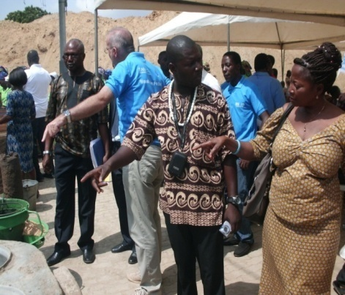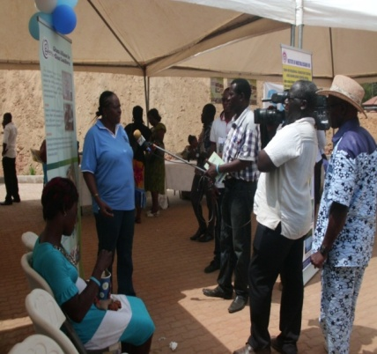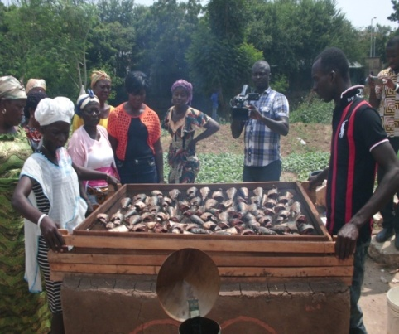
Wood stove festival 2013 at the energy commission office on 8th of November 2013
Kwashie and Madam Faustiana stressing a point to media and members of the public

AFRICA PATIENT SOLIDARITY DAY 2013
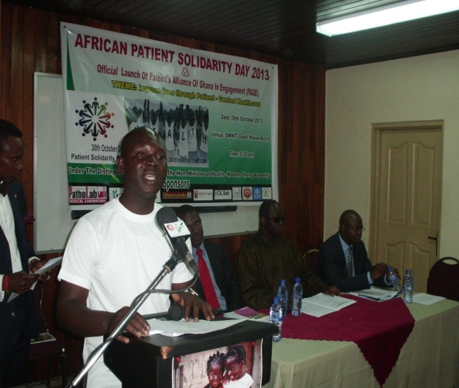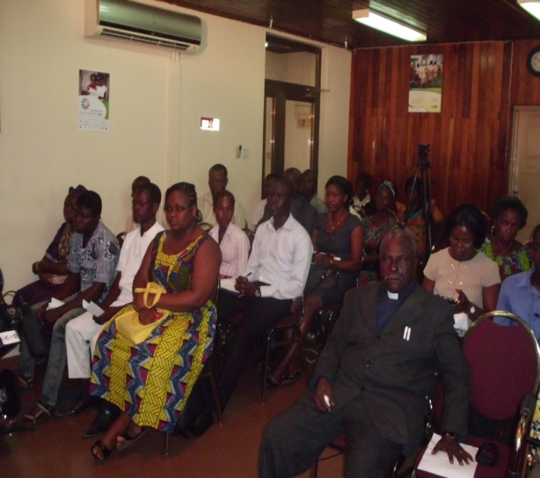
Patient Solidarity Day is an initiative that was conceived by patient advocates in Kenya in 2011 who saw the need to draw attention to patients' rights and build public awareness and support for patient-centered healthcare. Patient Solidarity Day was celebrated in Kenya and Uganda in 2011 and 2012 and is a member-led initiative, supported by the International Alliance of Patients’ Organizations (IAPO).
Health systems in Africa are under pressure and cannot cope if they continue to focus on diseases rather than patients. Healthcare challenges in Africa are complex and multifaceted, with patients facing multiple burdens and problems, including limited resources to adequately address patients’ needs.
The first regional day was marked this year, with activities taking place in 10 countries across Africa. Events included collaborations between a numbers of different partners to highlight the importance of patient-centered healthcare. Patients’ organizations across diseases, including cancer, diabetes, HIV/AIDS, sickle cell, psoriasis and mental health came together, along with other stakeholders such as medical professionals, healthcare providers, policy-makers, regulators and community leaders to consider how patient-centered healthcare can improve health outcomes.
Ghana’s contribution - More than celebration
In Ghana the celebration was led by Patients’ Alliance of Ghana in Engagement (PAGE), in partnership with Concern Health Project, the Community and Family Aid Foundation,Sharecare –Ghana etc on 30th October 2013, with quite a number of civil society organizations, companies and key representatives of government agencies such as the Ministry of Health and Ghana Health Service.
The event was held at the SSNIT Guesthouse in Accra with over 150 representatives in attendance. A side event on the day’s programme was a free health screening exercise for participants offered by Divine Group International to complement our efforts at bringing quality health care to the doorsteps of the vulnerable.
The event commenced with a formal introduction of the chairman, Dr. Sammy Kaba Akoriyea, a representative of the Director-General of Ghana Health Service by Mr. Kwashie, after which Rev. Doku of the Council of Independent Churches of Ghana gave a short prayer to kick-start the programme for the day.
In short but insightful remarks the chairman said history is more than the path drawn by the past; it influences the present and can shape the future. Making reference to Ghana’s health track record, he said following the declaration of the Primary Health Care concept in 1978, Ghana’s priority for health interventions shifted toward primary health programmes and this led to the decline in in-hospital service.
On the day’s celebration, he said “our basic role is to serve each patient with a smile on our face even in the most difficult times. Our role is to serve with professionalism, with good customer care, change our attitude and be positive”. He said he was happy to be associated with Patient Solidarity Day, promising that he would ensure that PAGE’s activities are carried across the length and breadth of the country and beyond.
The welcome address was delivered by the Executive Director of Mental Health Society of Ghana, Mr. Humphrey Kofie. He said although improvements have been made in patient health care services in the country, a lot more needs to be done. There is a gap in our health care system; while attempts are being made to address the teeming challenges, the authorities should treat every health issue as critical.
A Patient’s experience
A patient, Miss Dora Ashong, shared her experience as her perspective on the theme of the celebration. She began by singing a song of worship with the audience to remind all that mental patients are neglected by their parents, families and spouses and even health care providers. The audience was visibly moved by her story.
Why Patient Solidarity Day?
Mr. Joseph Gadagbui, Board Member of Share care Ghana said PAGE found it important to join other stakeholders in health care to put Patient Solidarity Day on the national agenda since marking the day could lead to change.
Is national health insurance improving lives in Ghana?
A representative from the National Health Insurance Authority, Collins Akuamoah-Danso in his address stressed that NHIA’s work is focused on patients, and so within this short period of existence they have done their best in securing better health for all. He acknowledged that they have not been able to meet the expectation of the entire population but said there are plans to address the challenges as they emerge. Celebrating Patient Solidarity Day is a step in the right direction; he said and added that well planned health care delivery builds healthy national resources for peak development.
Solidarity message from WHO Representative
The Resident Representative of WHO, Dr. Patrick Kakore in a solidarity message said that to improve quality of services and reduce the gap between needs and utilization, the patient should be at the centre of our focus in everything we do as a health sector. The adoption of a patient-centered approach in the daily work of health care providers implies recognizing the patient as an equal partner in the process of care.
Keynote address – Hon. Minister of Health
The key note address of the Minister of Health Madam Sherry Ayittey was delivered on her behalf by Dr. Alexander Yaw Arphul, Director of Human Resource for Health Development. The Minister discussed the aim of the Health system in Ghana and their goals to improve the health outcomes of people living in Ghana. She talked about the upcoming MDGs, which will be assessed in 2015. All interventions towards achieving those goals will be evaluated. In line with the health sector’s focus on a patient-centered approach, there have been key programmatic developments in the country. These include key policies around emergency services, the patient charter, the mental health act and the health care quality assurance manual. PAGE has taken the first step to partner with the health sector to bring forth the importance of patient centeredness model in our health care system, THE Minister said. She expressed the hopes that more organizations would show more interest in patient-centeredness.
The chairman said PAGE should be supported in its effort to make the next solidarity day even more successful. He promised the Ghana health Service would have a focal person on PAGE.
The event ended with a closing prayer by Rev. Doku. They health screening which was available on site included blood pressure checks, blood sugar among other important things. The screening was well attended and helpful for the participants.
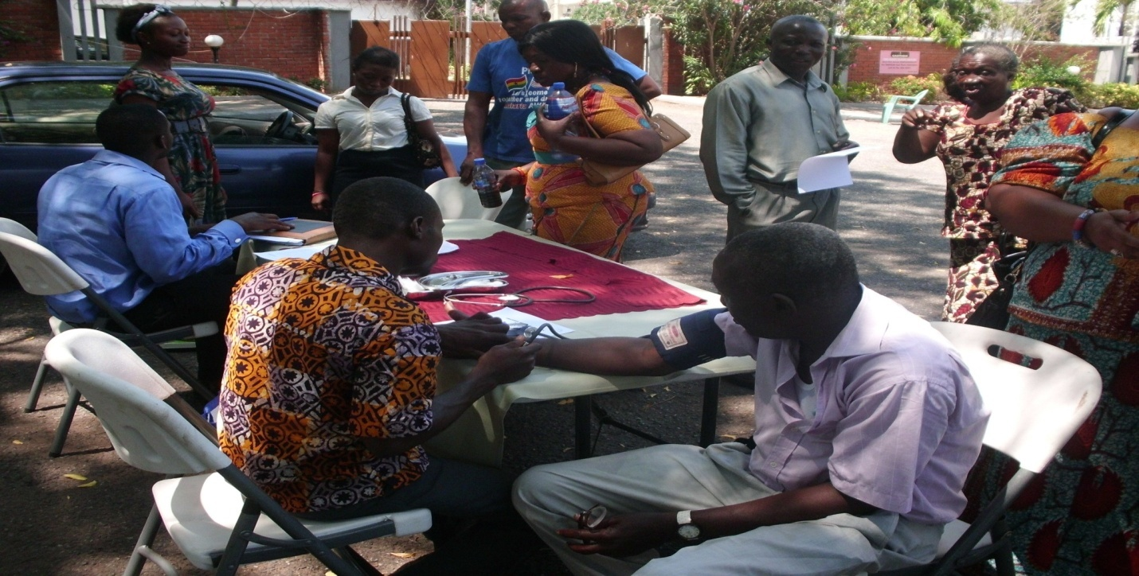
Providing quality health care is our hall mark
“PRESIDENTIAL YOUTH DIALOGUE”
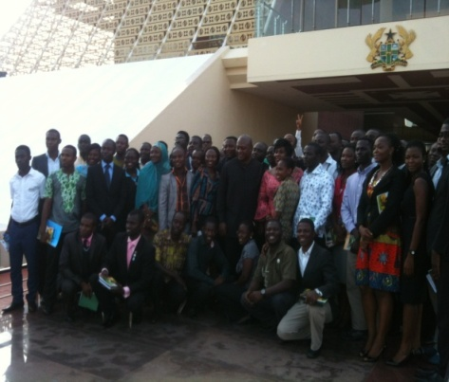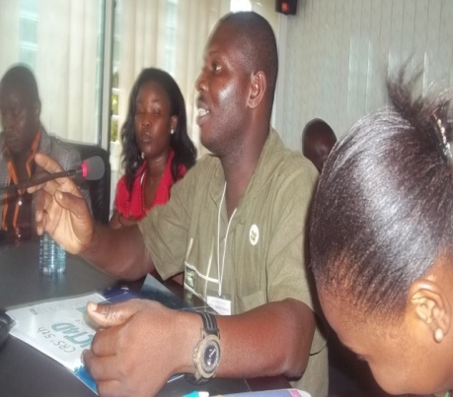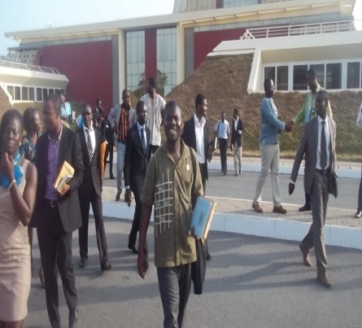
Introduction
Young people constitute a major source of human capital base that hold and drive the socio-economic as well as political development of their countries all over the world. Their intellectual perspectives coupled with their productive abilities when properly harnessed underpin social progress. Historically, the youth of Ghana have played remarkable roles in the development of Ghana right from the pre-independence era. The present generation of Ghanaian youth faces many difficulties that affect their development into responsible adulthood. . Young people are exposed to the trade and use of illicit drugs and arms. They are faced with other challenges such as unemployment and in some cases are used to prosecute violence. Other vices in society, where the youth are most vulnerable include armed robbery, alcohol abuse and sex abuse. Obviously, factors affecting the quality of life of young people youth and their ability to reach their full potentials are now multifaceted and challenging than in the past. Meanwhile, young people are naturally creative and dynamic and must be considered as actors, players and partners in national development. Indeed, they are strategic catalysts for new ideas contributing to peace and human development, as well as to the renewal of the human society, especially in a globalized world.

Even though attempts are being made to engage them in governance processes, factors such doubt for their capacity to engage in any constructive decision making process, the negative stigma of the youth being generally reactionary and unreasonable coupled with other socio-cultural factors hinder the much needed adult-youth partnership towards effective youth development. The Presidential Youth Dialogue is an initiative of His Excellency John D. Mahama facilitated by the National Youth Authority under the esteemed auspices of the Ministry of Youth and Sports. It responds to the need to create a platform for youth representatives to regularly engage with the presidency and share ideas on issues that affect them.

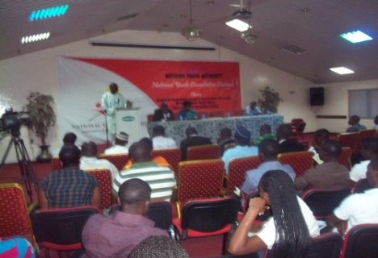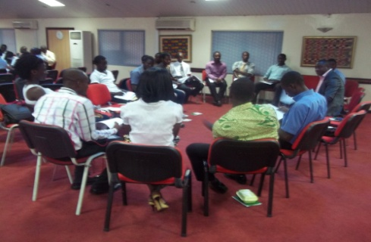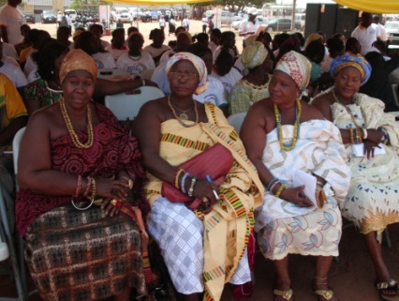

Context and Justification
In his statement to the 67th Session of the General Assembly of the United Nations on 26th September 2012 His Excellency President John Mahama observed that “In Africa, to say that the youth are our future is slightly misleading. Nearly 65% of the continent’s entire population is below the age of 35. Our youth are not only our future; they are also our present.” Ghana’s situation is no different. Ghana has a relatively youthful population with over 60% under age 35.President Mahama clearly identifies with and appeals to the youth as a youthful person himself. Addressing the one week celebration of the late President John Evans Atta Mills, President Mahama extended a hand of partnership to the youth to support him to build a prosperous nation for all. The above are illustrations of the President’s commitment to youth development. In recognition of the need to adopt a holistic and inter-sectoral approach where every sector can play its role towards achieving the desired results, government developed National Youth Policy which was launched by President Mahama in August 2010 when he was the Vice-President.

One key priority area in the National Youth Policy is “Democracy, Governance and Leadership” with the goal of enhancing participation of the youth in the democratic process through both representation and contribution to policy formulation and decision making. Participation of young people in the democratic process comes with many benefits. Effective representation of young people in decision making process improves responsiveness of policies to the needs of the youth. Young people also get to learn from their forebears and through the process build their capacity for leadership and bring to the fore their perspectives on issues. Again, the participation of young people in the democratic process enables them to appreciate democratic governance and respect for human rights as key to sustainable development.

Nature and Scope of the Presidential Youth Leadership and Mentorship Programme

The Presidential Youth Dialogue (PYD) seeks to bring together youth representatives from various youth groups and organizations to the Flagstaff House to interact with the His Excellency the President on a wide range of issues that affect their development. It will also afford government the opportunity to better appreciate the challenges facing the youth and also take feedback on government policies and programmes targeting young people.Youth leaders from the student movement civil societies, National Union of Ghana Students (NUGS), Ghana National Union of Polytechnic Students (GNUPS), Private University Students Association of Ghana (PUSAG), Teacher Trainees Association of Ghana (TTAG), Regional Student Representation Councils of Senior High Schools (RSRCs) and Presidents of Student Representative Councils of Public Universities. Others will include outstanding youth leaders in business and civil society and youth leaders of religious, groups and political parties as well adventure groups such as the Girl guides, Boys scouts, out of school youth, the physically challenged youth amongst others. The operational definition of youth will be as defined in the National Youth Policy, 2010 as persons from the ages of 15 and 35.

Objectives of the Presidential Youth Dialogue
- Create opportunities for the youth for constructive political engagement.
- build a partnership with the youth for national development
- give meaning to the president’s accessibility to citizens
- harness the rich and creative ideas of the youth for national development
- mentor youth leaders for effective leadership
- motivate excelling youth leaders to do more
- mainstream youth development
- promote interaction with the youth and the presidency and government
- create opportunity for networking among youth leaders
- Demystify the presidency and make it more youth friendly
Mode of interaction
Opening statements will be made by the Chief Executive Officer of the National Youth Authority and the Minister for Youth and Sports. The President will then make his opening remarks. Youth representative will then be given the opportunity to ask questions and make comments on issues of concern to them. The president will then respond to the issues accordingly. The issues raised by the youth representatives will consequently be addressed and updates given at the next meeting or through the Ministry of Youth and Sports and the National Youth Authority.
Expected outcomes
- governance better appreciated by participants
- participants influence government policies and programmes in favour of the youth
- participants motivated and inspired as youth leaders
- networking among youth leaders promoted
- ideas of the youth harnessed for national development
Conclusion: Considering the youthful population of Ghana, addressing the needs of the youth is a strategic way of addressing the needs of the citizenry. The importance of addressing challenges facing the youth cannot be over emphasized. As a critical segment of society, enhancing the development of the youth through the right policies and programmes will help harness their full potentials for national development. It is therefore expected that the Presidential Youth Dialogue will help adequately address their concerns and enhance their development.
At CAFAF we are happy to be considered as one of the change makers and youthful think-tanks in Ghana fueling change at all levels of encounter. Our participation in this dialogue underscores the importance authority’s attaches to our view on issues of development. Our representations utilize the platform effectively hoping to play a watch dog role to track the performance and promise made by the president in the cause of time.

Communities climate change dialogue project
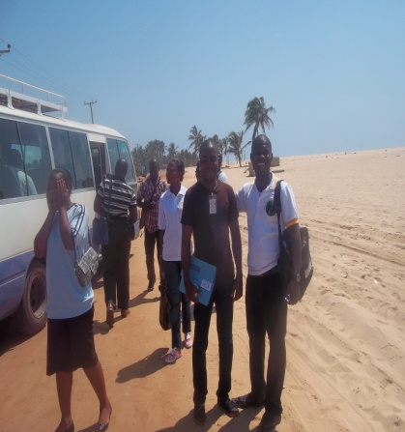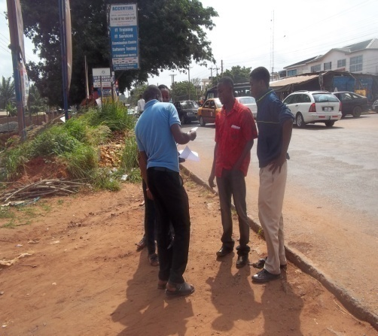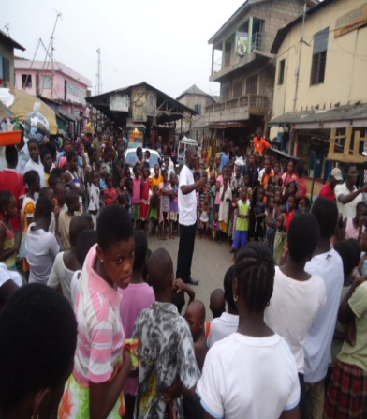
Why we care
Why we care
Evidence of the climate change impact continues to take a centre stage of the media land scope only for the euphoria to vanish into space after few days of public outcry. Both lives and our natural resources have not being spared at all from all angles of judgment. Over here in Ghana various actors have made it their business to drum home the message on climate change exploring various avenues. At both the individual and the national levels, climate change is of serious concern because of the nation's overdependence on climate-sensitive sectors, such as hydro-power generation, agriculture, fisheries and wildlife resources. Projections indicate that temperature will continue to rise, and the survival of coastal communities will be threatened by rising sea level. Reduction in rainfall is already impacting on rain-fed agriculture and hydro-power outages, causing significant decreases in industrial production. The rural poor, especially in the northern regions of Ghana, affected by frequent droughts and annual flooding, are forced to adopt non-sustainable measures such as migration, farming and building in flood plains. These in turn increase their vulnerability and make the fight against poverty increasingly difficult. Increasingly their actions, decisions, and contributions have always being reserved at the top the bottom levels school of thoughts approaches of which have not helped either in tackling the chaos head on. Communities’ participations in climate change discourse have remained minimal for which reason urgency is needed to reverse the trend. To this end, COMMUNITY AND FAMILY AID FOUNDATION-CAFAF having seen the need to employ a more proactive citizen’s government engagement in January, 2012-december 2013 commenced the COMMUNITIES CLIMATE CHANGE DIALOGUE SERIES- which among other things aimed at:
- Meet up-create a platform to learn from communities traditional knowledge used in tackling the prevailing climate change incidence in their fold.
- Education-to engage communities through knowledge exchange on their approaches to addressing climate change
- Awareness-to use evidence gathered in climate change affected communities as a case to demand support to addressing the teaming climate changes needs in those communities.
- Action- to document best practices and traditional knowledge which can be improved to help find lasting solutions to climate change issues in the communities as they unfold.
- Support- to network with key actors in implementing projects with lasting solutions to meeting the climate change incidence.
- Where we are
Community and family aid foundation had since the inception undertaken key activities in the cause of the project delivery factoring key concerns into the project execution. These includes but not limited to :constitution of project management team, stakeholders dialogues series, communities visits to gather evidence of the realities on the ground, meet up –knowledge sharing meetings, reporting on founding, creating of short stories, and managing climate change series, speak up interventions in the communities, climate change solutions shows etc.
These activities as modest as they are helped in going to the levels of the communities, to understand the issues, gender dimensions, approaches, traditional actions, beliefs and practices. The relationship with these communities pave way for them, to open up, as the project team proactively dispatched a team whose efforts have helped to generated useful information to shape future projects and interactions with equally important communities we are yet to reach out to them.
For two years there have been persistent interactions with community folks through the organization of follow up visits witnessing the impacts of climate change. Through this meetings, concerns and immediate actions employed by them to remedy the canker wear shared with our team. These efforts enabled or fostered equal participation by communities making them feel part of the solutions to the problems.
The impact of climate change as measured on the national scale are real but are dotted across the length and breadth of the country with most communities feeling the impact at different degrees daily. However, the urgency needed to respond to the teaming the needs of the communities and affected population cannot be traced. The intervention and support of civil societies, opinions leaders need a new reflection and approaches to addressing the problem. Failure will results in inseparable damage and the economic impact will be felt more than before. The slow pace of actions are the government al levels coupled with the absence of effective stakeholders participation had being a major set to the fight against climate change. Change goes with effective communication and the use of the negotiation table, thus, climate change is no more one man business affairs. All actors need to come on board and we at COMMUNITY AND FAMILY AID FOUNDATION is here to show the way to the top noting the crucial role communities’ participation plays in successful disposal of any serious project.

We need to move the next stage of helping communities to help themselves, therefore wish to call on all interested individuals including climate change activist to contact us, so that we can both work hand in hand in mobilizing resources to implement the next face of our project to make change happen in 2014 -2015 and beyond. Because what had be done earlier on was just the phase of the project we seek to put smiles on the faces of community folks to find lasting solutions to climate change which cannot BE ignored in any development discourse either.

ICT SCH, 4 LIFE PROJECT

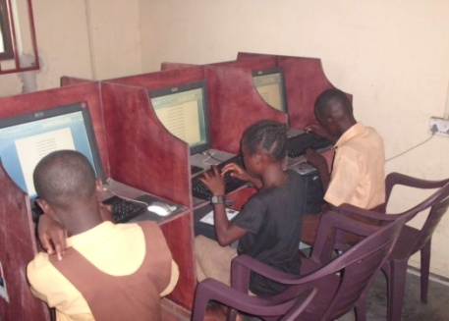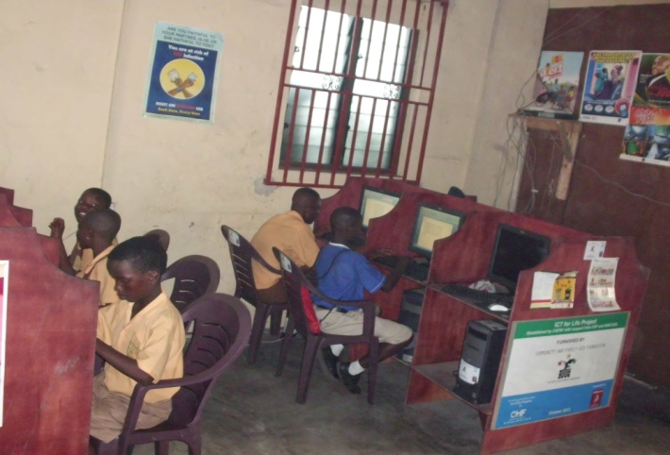

The CHF/Global communities cum CAFAF funded ICT School 4 Life project in the James Town community was continued in the cause of the year. Target beneficiaries continue to receive the free ICT skills training especially school children and youth in the community. A total number of 795 children received a range of specific needs tuition during the period which comprises of 335 males and females 460.

Two major quarterly reports were produced and submitted to the funders.CHF with a follow up visit by CHF officials to the facilities. The project could not continue aftermath because of the malfunction of the equipment due to effect of the sea breeze. The machines have since been submitted for repairs of which the cost of payment had become headache to management.

The joint support received from the Australian Embassy through the DAP fund response was negative and so there is currently no funds in yet to support the running of the project at the moment. If the fund was timely released it could have helped to commissioned the next phase of the project. This fund will help to meet some of the logistical needs of the project. The project will see the light of the day in 2014 as plans are far advanced to bring other interested parties on board to keep the dreams of the projects on going at all cost.

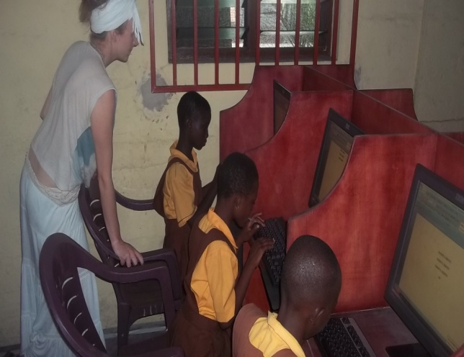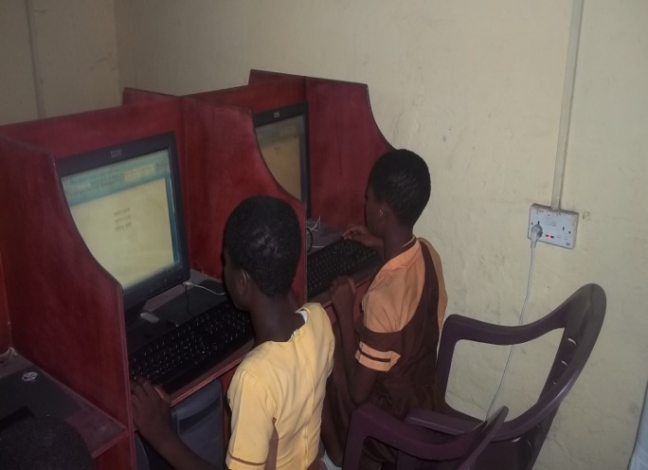

At CAFAF we promise to deliver, bridging the ICT gap has been a long cherished agenda on our spring board. This came to pass in the year 2013 after winning $ 2000 from CHF and this is how far we put the support to good use. Volunteers were at hand to support every step of he way in fulfilling this noble dream.

GLOBAL HANDWASHING DAY 2013

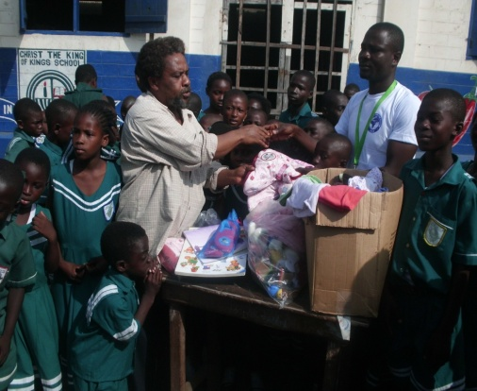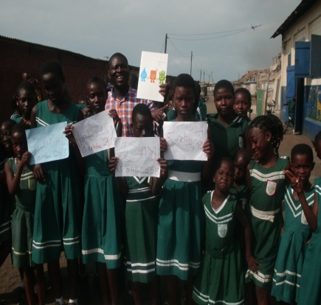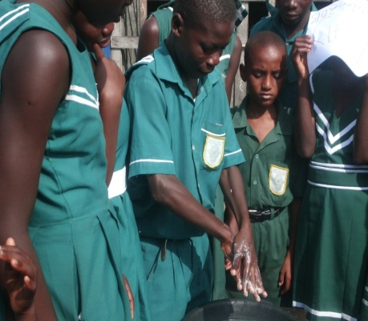

CAFAF, in partnership with JESDAN Hope for the Future, and other local authorities climax our Water and Sanitation Champions for Change Initiative with a full observation of the 2013, Global Hand washing Day on 15 October 2013.The maiden event was held at the Christ King of Kings School situated in James Town along the beach.

The campaign was intended to make water and sanitation (WATSAN) issues counts as far as health, cleanliness and overcoming the incidence of disease spread is concern. A series of face to face interaction with Youth Clubs in the Ashiedu Keteke District were engaged in a healthy discussion on how their platforms and partnership could be exploited further to address the unsanitary conditions prevailing in the communities. Again the Observation of the 2013 Global Hand Washing Day was to equally make children counts in the sanitation discourses. The day was used especially to interact, demonstrate correct ways of conduct of hand washing and to equally advocate for schools effective participation and to encourage them to provide hands cleaning tools for use by the children all the time.

The day’s event witnessed, management, our partners, and volunteers spend the day to provide education including helping the children do proper hand washing skills and knowledge acquired during the team’s presentation and interactions on the theme for the year. The team in the end made a donation received from the German friends for distribution to the schools mostly sanitary wares which the school is expected to use to ensure that a clean environment is created for the promotion of hygienic conditions in the school all the time. A total of 1589 children comprising of females 928 and males 661 benefited from the programme.

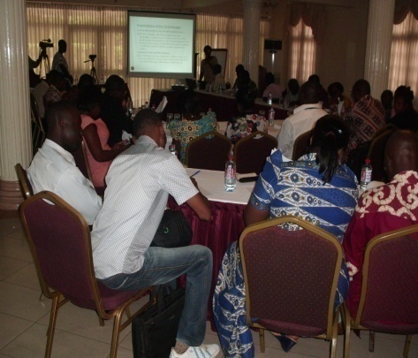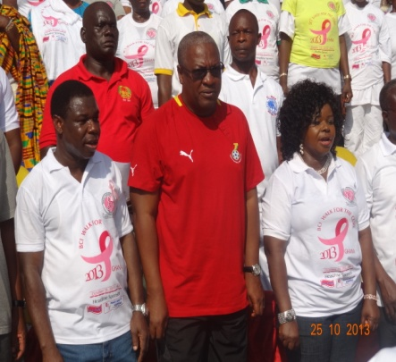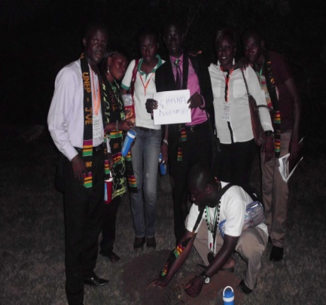

KICK MALARIA AWAY 2013

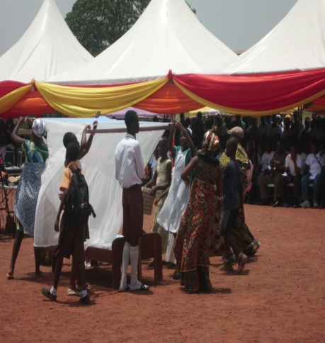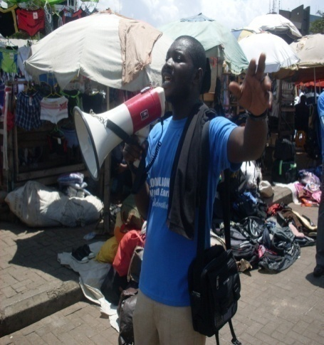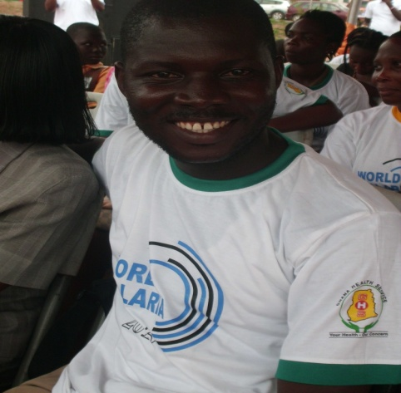

Malaria cases continue to receive attention at most OPD cases recorded at both private and public health service delivery facilities in the Ashiedu Keteke District. Thus, our health care interaction series with the public benefited from education on malaria. Women’s groups and youth clubs benefited immensely. our focus was to deepen our “WHY WE CARE” community action for change alerts messages across a broad spectrum of audiences whose step up efforts could cause change and spread positive preventive measures to the general population. Our encounter with the groups offered us the chance to clear the myth and long held misconception about malaria.

The activities were crowned with the team’s formal participation in the National Africa Malaria prevention launch at the Adenta Municipality on 25th July 2013. The day was used to evaluate and review the National efforts made so far. Civil society’s contributions were equally acknowledged as key in winning the fight.We are indeed happy to have scaled up our activity to reach out to 1251 people during the year. With the battle still half won and mosquito net use among the population low, we hope to direct our intervention scope to respond to such crucial areas of need.

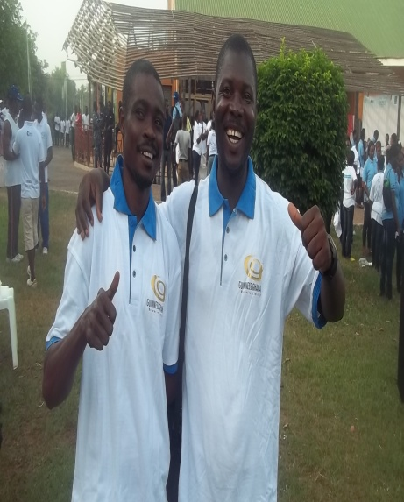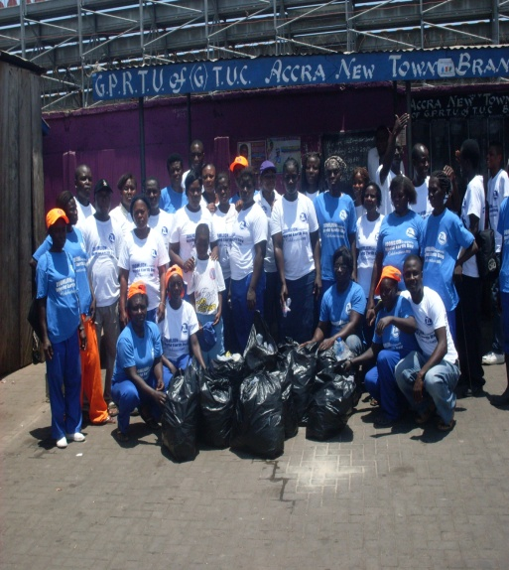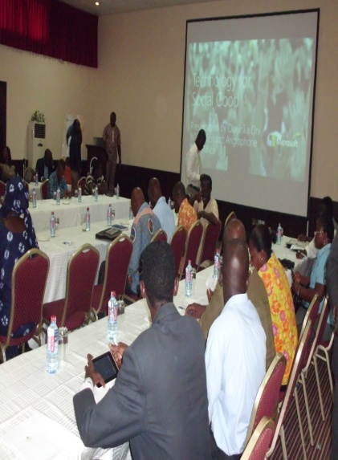

We join collectively to mobilize for change bringing critical environmental issues to bear at the public domain to influence lasting change. Scene of the world environmental day held at the TEMA STATION here in Accra

STOP TB CAMPAIGN 2013

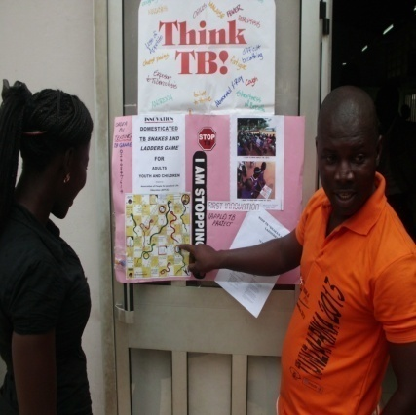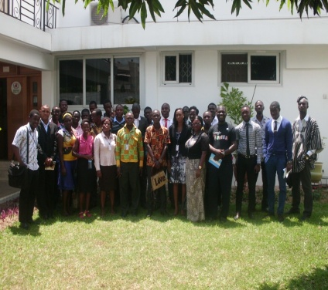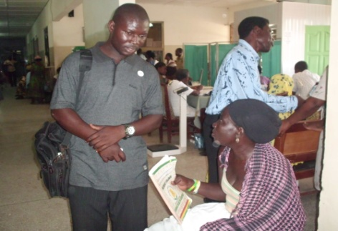

Though no formal funding was secured from the National chest to run our projected TB activates, effort was made to include TB education, awareness creation, alongside the HIV and AIDS campaign initiative. The linkage between HIV and TB makes case for inclusion and so during the outreaches IEC material were distributed, to spur our awareness creation and general preventions techniques. Some of the relevant issues discussed with our audience include but not limited to ,spread, treatment, prevention, case dictation, referral, treatments case and support were crucial in our deliberations largely.

Our team also participated in most of the STOP TB GHANA partnership and networks trainings,AGM, outreaches of which the last one was observed on 6th December ,2013, which was the Annual General Meeting of the partnership and marks the end of the years activity .the period was used to received update performance account from the National administrative office. The occasion was used to evaluate the overall performances and activities enshrined in our 2012 POA for delivery in 2013. Outcomes of grants awarded to the partnership members were shard with the members present during the meeting. These were highlighted on the day by Dr. Bonsu at the end of which he promised further support to members to enable them scale up their activities in 2014.In 2014 we look forward to submit proposal to the TB reach facility whilst mobilizing local resources to begun something on the grounds before a formal support is secured to venture into other critical areas.

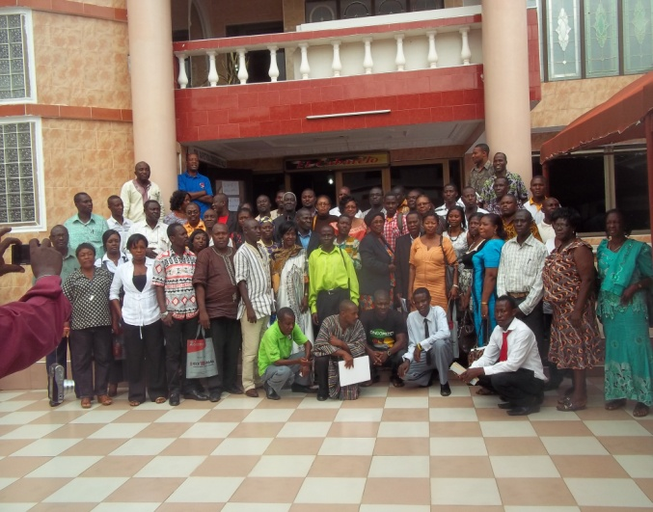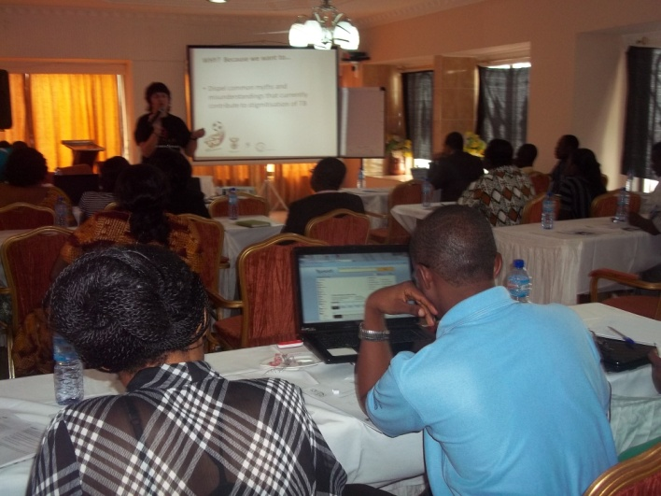
CAFAF management contributed to other relatable TB deliberation taking place at the Global level, in the sub-region, Africa among others. Through these efforts we were able to capitalize on the discourse to push relevant concerns of our communities at the boarder decision making table. With various engagements taking place around the post 2015,CAFAF is happy to have played instrumental role in the discourse that led to the formal formation of the Global TB Activist coalition which is mandated to play a frontline global advocacy efforts at addressing TB issues including contributing to what takes to protect the right and well being TB patient, and management .we contributed to the on going POST 2015 TB community voices counts engagement of which the outcomes have been shared with the committee tasked to collate views from across the world. We also joined formally the establishment of a special network to help push the TB agenda dubbed the Global Coalition of TB Activist in the cause of the year. This platform has been at the fore front of winning the fight in the areas of policy influence to the later. We have been communicated to them as well as receiving periodic our feedback from them.

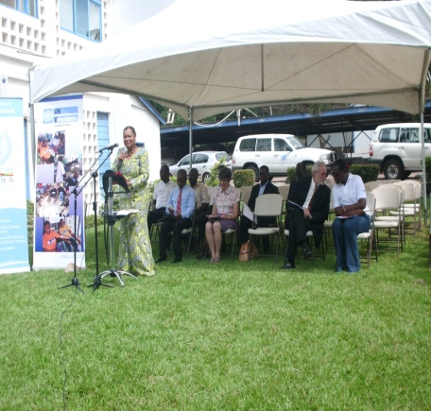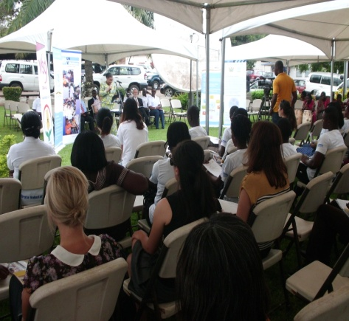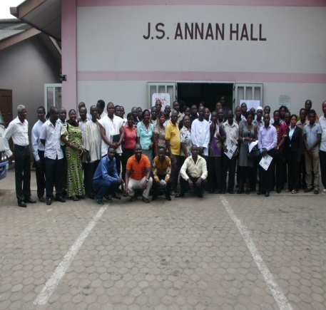
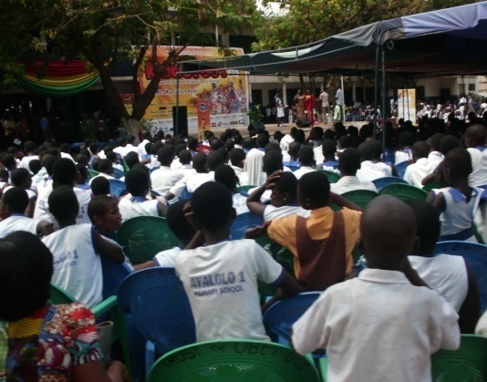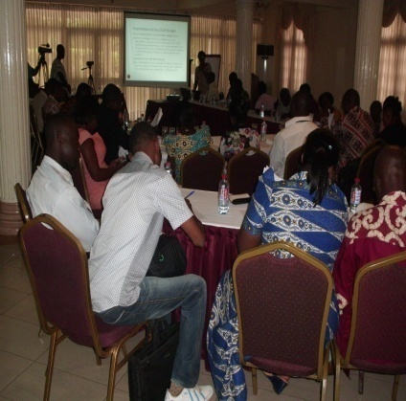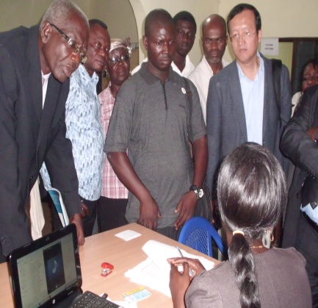
Our participation in such intervention helps to understand the realities on the ground to help us strategize to deliver effectively.

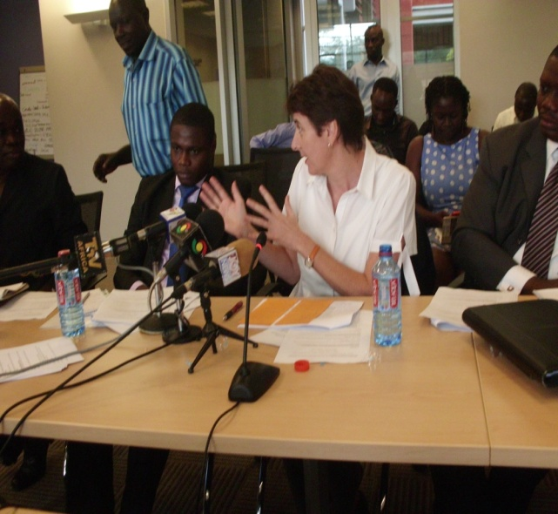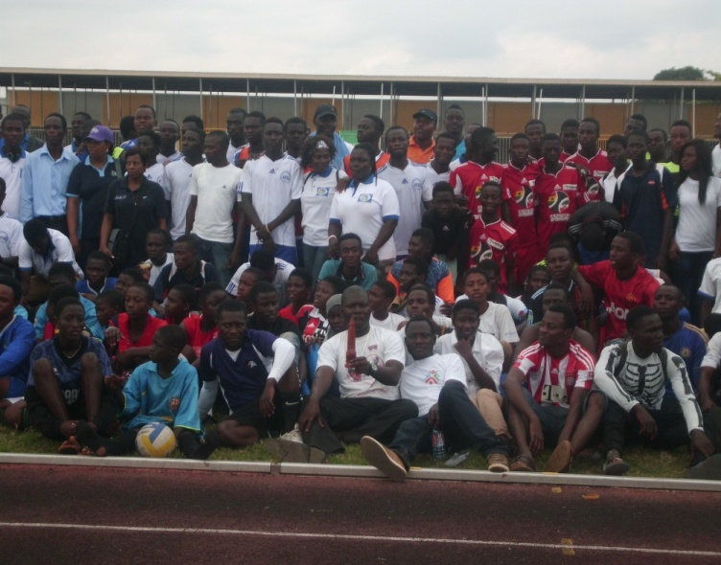

We care, help us to help

TUNZA AFRICA 2013

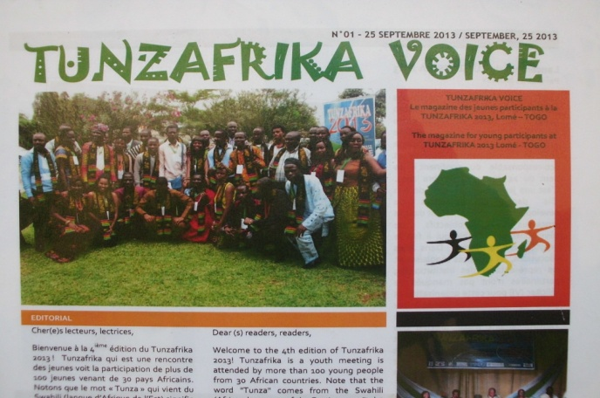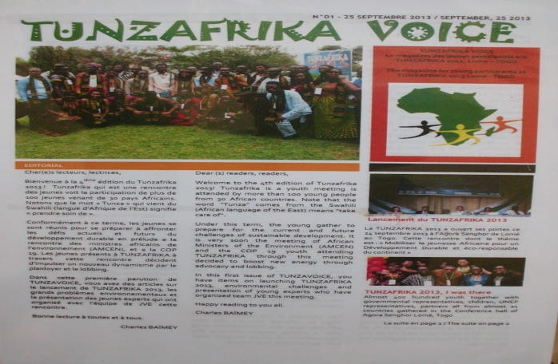

Another giant stride was our participation in the United Nation Environmental Programme-Tunza Youth Conference in Togo, the Forth Africa Children and Youth Conference on Environment and Sustainable Development Tunza Africa -2013 -24th -27th September 2013, Agora Songhor Lome Togo

During the Tunza International Conference which took place at UNEP headquarters in Nairobi from 11-14 February 2013 on the theme 'health and environment’, African youth gathered and brainstormed around their best engagement in environmental governance on the continent. Decision was taken to build on the opportunity provided by the Tunza concept, transform the African Youth Environment Network (AYEN) into Tunza Afrika and work towards greater participation and empowerment of young people in decision-making. The rationale is to provide a unique platform for all existing youth networks and youth organizations and serve as an interface between the young people and all development partners as well as regional and sub-regional political institutions on issues related to environment and sustainable development. This idea got positive response from the UNEP Regional Office for Africa and it decision was taken to formalize the Tunza Africa by defining its operational structures and institutional framework.

It is a fact that building long-term relationships between youth initiatives, engaging in a frank dialogue with government and supranational institutions (e.g. UNEP, the AMCEN, AU), facilitating clear dialogue and partnership grounds between young people and other International organizations fostering sustainable natural resources management in Africa are prerequisites for the release of the immeasurable energy and innovation potential within the African youth.

Long negotiations led to the choice of Togo and the Togo-headquartered pan-African organization Jeunes Volontaires pour l’Environnement to host and organize this land mark conference. With support graciously offered by UNEP (through UNDP Togo), Norwegian Ministry of the Environment, the Francophone, PACJA, JVE, NORAD through NNV and also the Togo Government, preparations started.

Thus, from 24 to 27 September 2013, took place at the Agora Senghor in Lomé, the 4th edition of the African Youth Conference on the Environment and Sustainable Development
5 hence onward known as TUNZAFRIKA, taken from the Swahili Tunza to mean the African
Youth’s commitment to treat the planet with care. With the theme "Charting a Sustainable and Eco-Responsible Africa: Harnessing Africa Youth Contribution" the conference brought together 130 leaders of youth organizations (including children and for the very first time disabled youths) as well as various international organizations, bilateral institutions and the media.

Major activities of this meeting were structured in seven (10) highlights namely: opening
ceremony, trainings, group discussions, field visits, the climate justice demonstration and tree planting, the project market development place, the legal adoption of the documents of the platform, the Organization of panel discussions, and eco-Dancing parties.

CAFAF was fully represented by JOSEPH SENY KWASHIE –ED and JOSEPH LAMPTEY which afforded them the opportunity to utilize the platform effective to influence key decision taken at the conference. With a view of ensuring that the youth participants do own all its outcomes, various working groups were set up to discuss, improve and validate for most of them, background documents prepared by the Organizing committee. Each group facilitators then present their new texts to the plenary which after further comments validate these organic Tunzafrika documents.
Groups include:

-Tunzafrika official document (constitution, charter)
-Tunzafrika action plan
-Institutional arrangements
-African Youth position in the post 2015 debate
-Youth and AMCEN
-Lomé declaration
-Electoral Committee
-Children and Youth living with handicaps involvement

Management is happy to have supported them to join a host of youthful Ghanaians to sacrifice their time, attentions and skills to champion this cause and in making the voices of youth be heard across the globe.

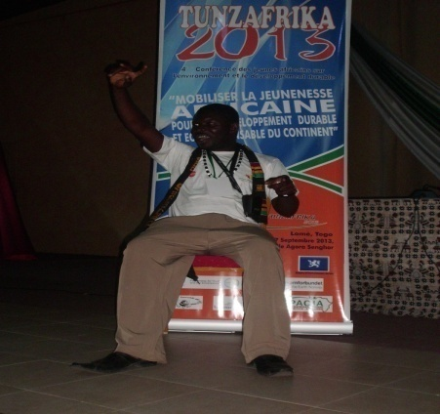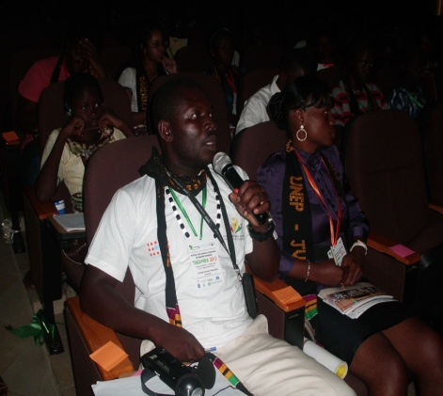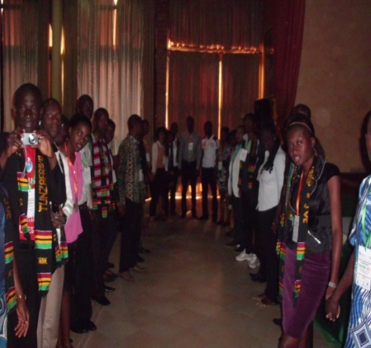
Scene of Mr. Kwashie making a point during the discussion on relevant pillars to secure youth effective participation on environment.

SRHR PLATFORM, KPO, INNEC SRHP AND KPO, GHWA CAMPAIGN

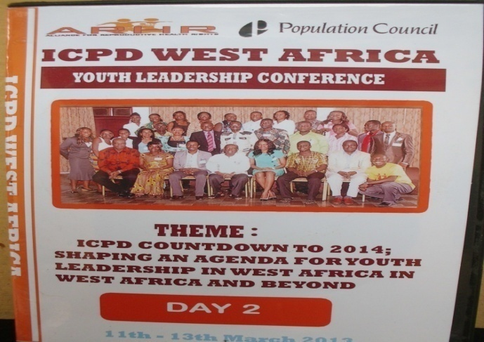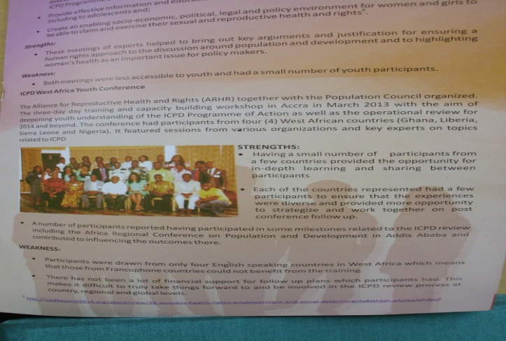

CAFAF continue to contribute largely to various discussions and deliberation on going at both the Regional and Global levels. To this end in the cause of the year, management interacted effectively on the Sexual Reproductive Health -SRHP, Global health Workforce Alliance - GHWA platforms on various health related issues moderated on the platform. This culminated into a formal Global advocacy effort leading to the acceptance of most of the position papers submitted for inclusion in the POST 2015 consultations at the UN.

On the International Conference on Population and Development-ICPD, the Ford Foundation in collaboration with other civil society think-tanks, the Alliance for Reproductive Health and Rights-ARHR, together with the Population Council organized West Africa Regional Youth conference on ICPD. The three-day training and capacity building workshop was held in Accra on march 3-5th 2013 with the aim of deepening youth understanding of the ICPD programme of Action as well as the Operational review for 2014 and beyond.
The programme brought together largely youth leaders across the region from Liberia, Ghana, sierra Leone, and Nigeria. This encounter translated into working on relevant issues which was later feed into a mid term African youth consultation on the ICPD by the AU commission set up the review the POA.

Aside this move the AU committee on ICPD consulted quiet a number of civil society actors on the continent to make expert input into the AU ICPD-POA Africa position paper and Africa program of action document. Here again management was able to make a submission which was acknowledged in most of our corresponding mails.

Through out the year management dedicated time to contribute to most of the GHWA 3rd HRH conference 2013 (November 9 – 13-Brazil), members engagement on effective placing for hosting of the conference, we made a series of suggestions on the entire conference package which was successfully hosted toward the end of the year. The only challenge encountered was our inability to sponsor a representative fully to participate in the conference. These and many other interesting platforms were used to amplify our voice especially to channel the vulnerable voice to the right for stakeholders whose decisions affect them irrespective of whose they are across the globe.

INFORMATION 4 TRANSFORMATION SERIES

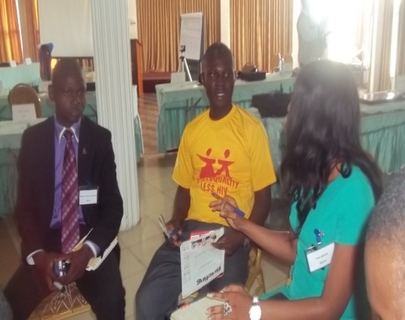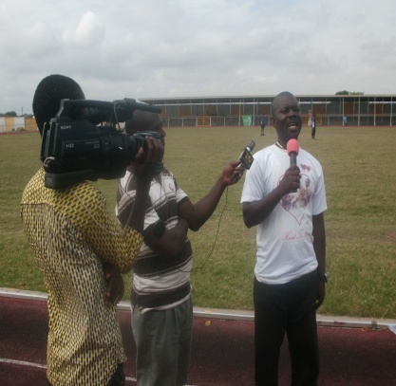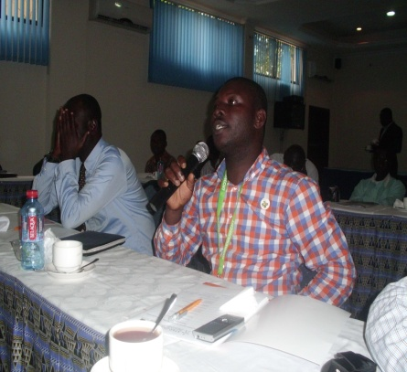

CAFAF in 2013 organized a face to face encounter for youth groups to educate them on real life matters dubbed “Information 4 Transformation Series” the project package seeks to reason with youth and build their capacities and capability, inspire them, provide them with the keys specially to identify their inner strength and courage for effective utilization. In all 10 youth groups and organizations benefited fully from the package.

Our respective role in this activity was to dispatch a season staff member well verse in the knowledge and skills of motivational message delivery to give a talk on the topic selected as part of the talk series. A special topic and group discussions, hands on practical demonstration, questions and answers interaction is then hosted for the group. In the end participants are exposed to the rudiment of specific skills they need to chart a new cause in the life.

We are indeed happy to be associated with this development where over 1566 youth comprising of 532 males and 1034 females have benefit from the programme. Our participation in other youth conferences, seminars, workshops enables our team to make presentations and shared our views on broader range of issues discussed at these levels. These engagements include but not limited to the World Bank youth entrepreneurship summit 2013, impact Generations- Youth Empowerment Seminar and the Global youth Exchange dialogues series.

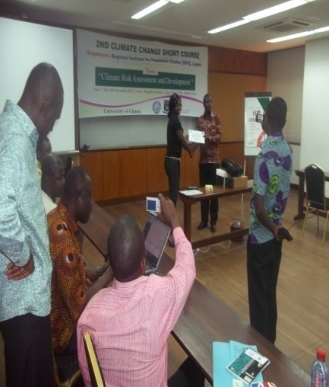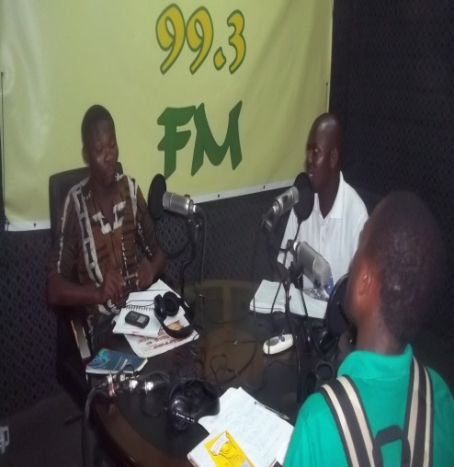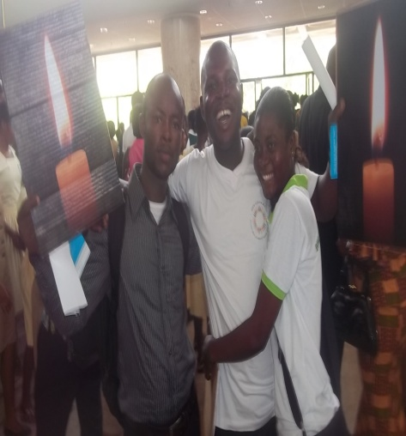

We inform the public to make informed fruitful choice

RUBELLA AND NATIONAL CHILD IMMUNIZATION CAMPAGIN AND MAF 2013

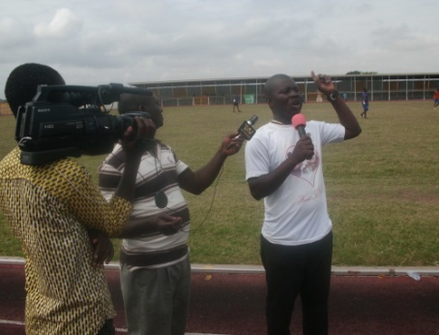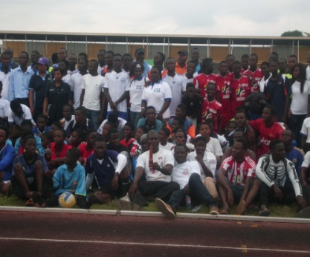

The Ghana coalition of NGOs in Health and a range of donor partners played active roles during the official implementation of this National assignment, the RUBELLA AND NATIONAL CHILD IMMUNIZATION CAMPAGIN AND MAF 2013. CAFAF was among the number of members of the coalition selected to supervise the field work carried out both by the Ghana Health Service health officials and community recruited volunteers during the exercise and to present independent report after the whole exercise.

These tasks were performed in two major districts, Ga West Municipality, and Ga South Municipality respectively. These activities were complementary and aimed at contributing to the National efforts of reaching out to the unreached. Whereas the immunization was preventing, providing treatment to children against childhood killer diseases, the Millennium Accelerated Framework (MAF) was toward tracking maternal health and service delivery. For this reason separate actions were taken resulting in positive gain. The next phase of the MAF is expected to be implemented in 2014 in close collaboration with the health facilities selected during the mapping exercise and stakeholders consultation. CAFAF is billed to work hand with yet again the Rural Project Support Network (RPSN), key NGO selected to perform this task in the Ga South Municipality. The results will be presented in our quarterly report the cause of the year 2014.

2013 significantly provided our team a fruitful avenue to chart a new cause of representing the interest of the vulnerable and make case for them at the many workshops, fora, conference, workshops, seminars, stakeholder consultations and a range of activities which cannot all be captured here. Looking back, management is happy to note that our works and activities have caught the eyes and attention of most of the authorities, who respect our views and efforts. This encounter as well as their suggestions will go a long way; continue to help shape our service delivery, unsurpassed quality health care service delivery across the country, hoping to participate actively in partnership in more of these engagements.

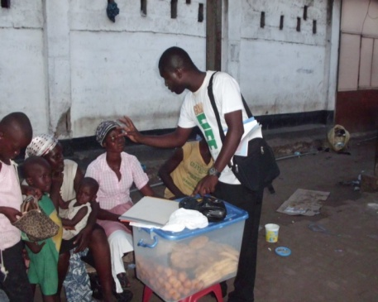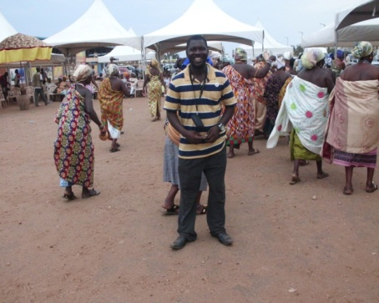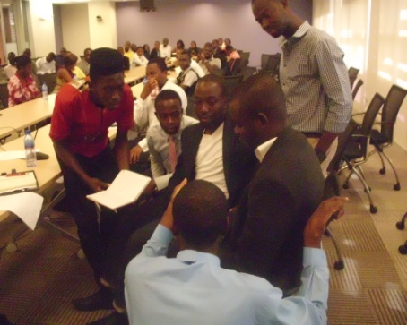

PARTNERSHIP FOR DEVELOPMENT

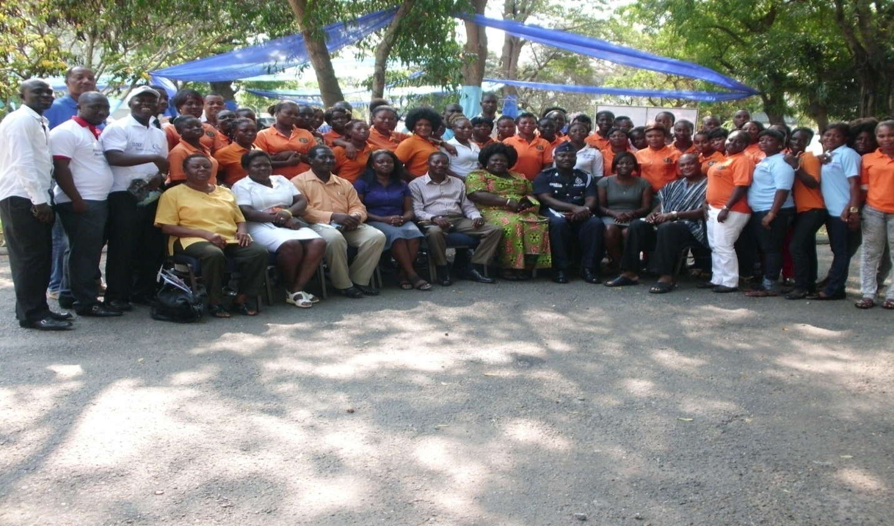

During the cause of the year management maintained our continuous collaboration with quiet a number of organizations and individuals with the hope of deepening our relationship and for a possible implementation of projects together. The following were some of the organizations hoping to continue to chart a new cause in 2014 with them to deliver as one body.

- Rural project support Network
- Women’s Vision 3000
- APPLE Project
- Women Thrive worldwide
- Share care Ghana
- Manehie women’s Association
- Dolly foundation
- Initiative for Equity
- JESDAN HOPE For THE FUTURE
- Nola Marshall – culture DNA-UK

Project UK and Ghana music 4 development Initiative
- Ghana Heritage Institution of performance of Arts/creative Arts
- Track Ghana – Alex Nii Armah Hayford
- Rural project support Network-RPSN

Management in collaboration with these organizations participated in a number of field work and community activities conducted by the organizations. These include but not limited to

- Rubella and child Immunization 2013 campaigns NGOs field monitoring
- MAF community feedback and input collation
- Project Abroad Human Rights women engagement research. RPSN-community human right awareness and education series
- TRACK-GHANA Team meeting with the Deputy Minister for Works and Housing-the meeting was intended to strike a formal partnership and advocate for fair policy on providing quality and affordable housing to the poor.

These projects helped us a lot which enabled management to dispose our expertise at the door post, quicken the pace of management of the projects for development.

WOMENS VISION 3000

We partnered and played active roles in most of the activities conducted by the foundation within the Ayawaso Central enclave. These include but not limited to
- Women’s capacity building
- Stakeholders engagement
- Community outreaches
- Proposal development for a possible roll out of food for 2014
- Design and piloting of new ideas such as the Operation Keep Ayidik Clean and community food fair
We are happy to be associated with them and hope to extend the same stock wealth support in the coming years to enable our partnership yield the necessary results of reaching out to the unreachable.

ASSOCIATION OF PEOPLE FOR PRACTICAL LIFE EDUCATION-APPLE -PROJECT
Management is happy to have associated ourselves with APPLE Project activities which is still ongoing hoping it translate into a bigger outcome in 2014. Through this linkage plans have been put in place to work as a consortium in development and submitting joint proposal to quiet a number of entities for funding. Our major roles in most of the project delivery will be to build capacities, mentor and reports on the impact of any project that may be supported in the coming years. We shall continue to explore other avenues to add especially more women’s groups on the list of groups we will be collaborating with across the various regions in Ghana in 2014.
MACHINE WOMENS ASSOCIATION
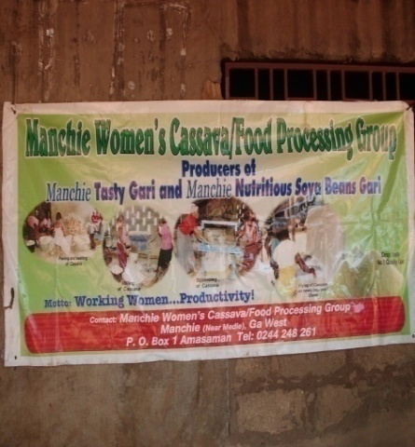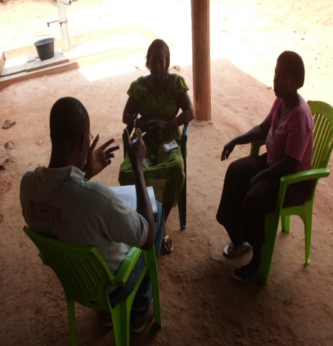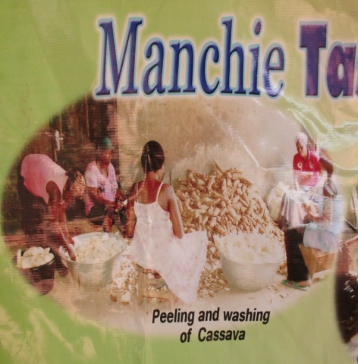
In 2013, towards the end of the year, management conducted a research among women’s groups for which reason the Machie women’s Association/Food Processing Group have been selected to benefit from our NGOs link up 4 change campaign initiative. This initiative is to adopt other organizations on the ground after which a formal MOU will be settled on. CAFAF and APPLE will own the cause of time develop series of project proposals and when it receives the necessary funding responses, both parties will depend on a shared resources to deliver the projects together. These efforts are the surest way of rallying bigger voices to be heard by potential donors. It will also enable both parties to put the necessary structures in place and help fulfill most of the donor demands as time goes on.

WOMEN THRIME WORLDWIDE

CAFAF is a member of several world wide coalitions and Alliances for which reasons the benefits are exploited toward the positive influence on the activities of management. On 2 December 2013 a delegation from WOMEN THRIVE WORLD WIDE-USA Were in the country to undertake a series of research and to observe what members are doing at large. The team met CAFAF officials for partnership drive, most of our interactions were focused on women’s empowerment project in the coming future. This effort is expected to translate into conducting more research, influence policies and develop more projects to be carried out to better the lots of women across the world through USAID support. As a member of this network CAFAF is poised to continue to be proactive and continue to increasingly Deeping the relationship further at the global level.

DOLLY FOUNDATION ASSIN FOSU

A series of meeting were held in the cause of the year both online and in Accra here with the Executive Director – Rosina Akuorkor with the possibly of hosting a joint activities. These were also to galvanize ideas to submit a proposal for funding but the response was not favorable. However, this collaboration will continued to be championed in the cause of 2014 to check out what will come out of it. IFE post 2015 community engagement is supposed to take place in Assin Fosu in 2014 in partnership with the Dolly Foundation playing a frontline mobilization and advocacy role.

INITIATIVE FOR EQUALITY – STANDFORD UNIVERSITY

CAFAF was selected to benefit from a Global Community Engagement activities taken place in our I5O countries. This special project is coordinated by IFE at the Stanford University USA which is intended to collect and report on feedback from remote communities whose participations in key decisions taken at the Global level is lacked at the grassroots level. This feedbacks will be collated into a formal working documented will be presented to the POST 2015 working committee for consideration into the official document.

A formal MOU was signed between both parties on 15th November, 2013, with IFE expected to raise the necessary funds to foot the bills of proposed activities of selected organization. Management participated in all the Skype meetings held and feedbacks collected online to feed into a formal proposal submitted as part of the fundraising efforts. CAFAF is likely to execute our part of the term of reference in 2014 when the necessary sponsorship packages are received in the 2014.

JESDAN HOPE 4 THE FUTURE

Management cooperated with JESDAN Hope for the Future - NGO operating in the Ablekuma District during the period under review to a execute quiet a number of projects. These include but not limited to

- Ghana must know HIV and AIDs campaign 2013
- WATSAN – Global Hand washing Day 2013 celebration.
- Langma Community School Support Project
- Youth Leadership Coaching- Entrepreneurship Skills Development Series etc

These projects yielded the needed impacts and touched the lives of our audience .the projects receive material support from both local and our foreign partners such as, GIZ,GAC,ACT 4 CHANGE, Friends of JESDAN Germany, USA, South Africa and a host of local individuals, stakeholders who have been the back bone of our successes. In 2014 we shall work along the same lines to complete some of the project activities in the pipeline anticipating a generous support from like minded institutions and individuals. JESDAN occupies a special position in CAFAF break through activities of which management is happy to be contributing to what it takes cushion the organization forward.

EMBRAZING YOUR INNER COURAGE - BOOK REVIEW

In August 2013, management was contacted to make a contribution to special book written by Mr. Zeph Atiomo - the executive Director of Trade line Consult both Ghana and Malawi. – The book titled “Embracing your inner courage” is a special package authored to expose readers to the secrets of life of tracing and sharing with all countless measures that can be tapped into to overcome the challenges and fears of life to reach the summit in life.

It’s set the records straight and breaks the silence, provides antidote to the secrets of success in life. This book takes the reader through a journey emphasizing that life is about planning and taking risks, failure of not planning anything at all means loose of courage to survive the tests of life. More details can be solicited via. led by Joseph Kwashie, the entire review lasted a period of two months. In the end a proof readers views was submitted to the author of the book -project who acknowledge receipts of the message with gratitude in return. Management conclusion on the book reads.

To this end, CAFAF is more than happy to be approached to provide such an excellence service free of charge which is an indicative of the trust and confident people and for that matter organizations have in us. The last time we played a similar role was in 2010 where we equally contributed to a book written by Helen Sawyer titled Living Values-Ubontu ,currently online which is assessed by many through out the world ,owned used in over million Institutions sites the world over.

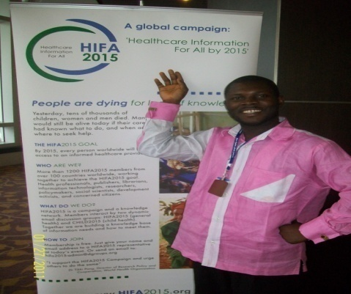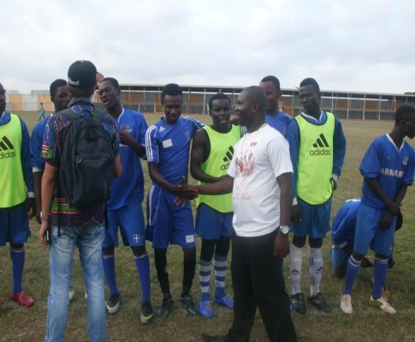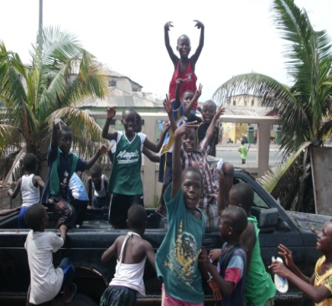

INNEE – BOOK REVIEW

CAFAF is also a member of the International Network for Education in Emergencies- INEE which is a world body committed to providing educational resources in partnership with voluntary online educational advocates across the globe contributing. During the period under review a special project was carried out to review a new tool kit to be used across the world. Selected members were were tasked to contribute to Education in Emergencies Conflict affected communities-starting it right book.

Here again CAFAF was tasked to review and provide independent feedback on the project, this have been completed. A critical reflection on the realities on the ground shows that 2013 had been a remarkable year in the life and existence of the organization. The inflow of opportunities in 2013 have surpassed all previous years passed. Our doors in 2014 will be opened to continue with such gesture and exposures.

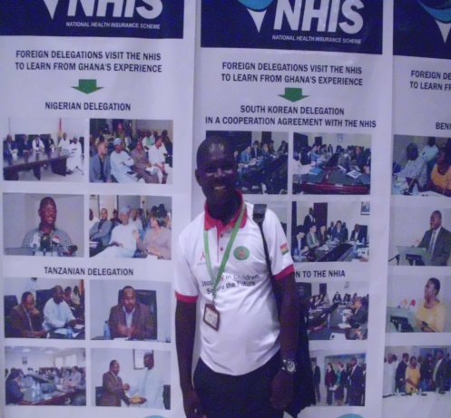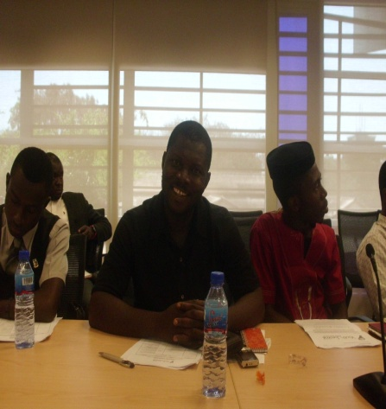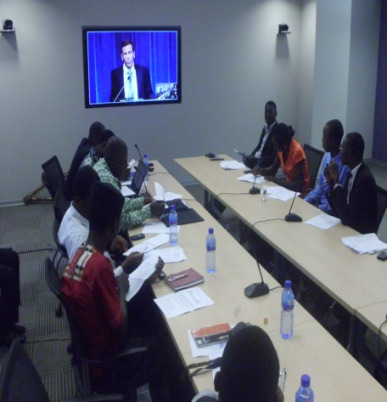

PARTICIPATION IN RESEARCH AND MAPPING EXERCISE

During the cause of the year several institutions approached CAFAF to participate in research and mapping activities aimed at using the outcomes to plan the successful delivery of projects in the future. The exercise was also intended to scouts organizations with the prequalify track records. This was done both online and office line.

The local institutions which under took the research and surveys include but not limited to in September 4, 2013

- Measure Evaluation – HIV and AIDS response by NGOs funded by the USAID through the school health.
- Department of social welfare-University of Ghana……Aged, support and survival special research - August 25, 2013
- Urban Assonates – Ghana coalition of NGOs in Health- member CSO mapping special exercise – USAID Dec 15, 2013 etc.

Our participation has open up a new era of trends and concerns that are urgent for CAFAF to make various reforms and adjustment, which will be tabled for Consideration and Implementation to enable CAFAF, stand the test of time. This will be critically undertaken in 2014 to position the foundation to meet certain requirement and to be in tune with standards donors currently expert NGOs to live up to.

PARTICIPATION IN LOCAL INITIATIVES

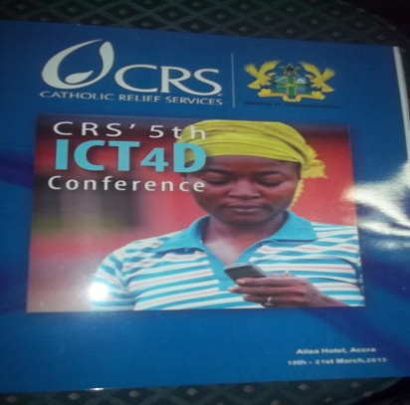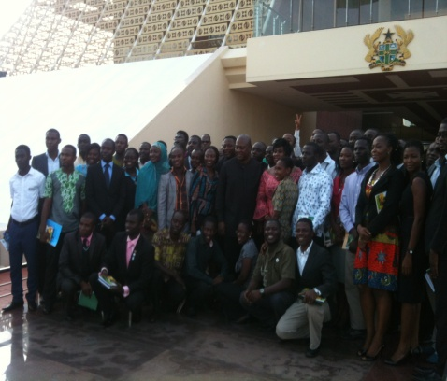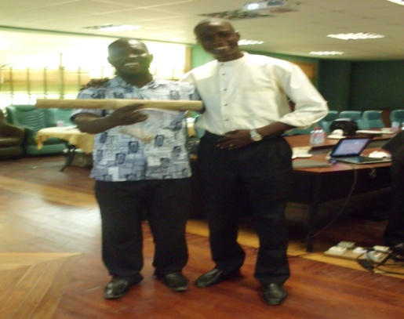

The role civil society play in shaping development policies that affects citizens cannot be under estimated. Such platform allows NGOs to represent the interest of the voiceless to communicate effectively to make them matter in any decisions that are taken for and on their behalf. Throughout 2013 management were invited to feature at over 100 meetings and other consultative dialogues to collect our position statement. It enabled our team to share experiences, best practices and to negotiate favorably. We believe such participation will go along way to affect the lives of the vulnerable now and in the future. The numerous Formal invitations letters extended to our organization is indicative of the confidence and respect stakeholders have for our contributions at all levels of engagement be it local, regional and at the global enclave. Categories of such meetings/platforms include but not limited to:

- ICPD – West Africa youth conference 2013 3-5TH March, Milklin Hotel Accra
- Ministry of Health summit 2013
- Ghana financial intelligent centre WASCI 2013
- Impact Generations USAID youth dialogue 11th October 2013
- ACEP National Gas – Oil and Gas policy consultation 17th October 2013
- Ghana Integrity Initiative Workshop on Taxation Advocacy for NGOs training at Aburi-Eastern Region
- MEST WATSAN / Climate change National Stakeholders Validation consultation 30th October 2013 with Acre Hotel
- Maternal Health Report – launch
- Mama Ye Initiative-Maternal Health project
- ISODEC social pact and other engagement
- UN Global compact
- Microsoft civil / NGOs capacity building
- HP partners meetings
- Google civil society capacity building
- Ghana Monitory and Evaluation forum 2013
- CHESS 2013 CHIPS consultation
- Presidential youth dialogue 12 August 2013
- NGOs in 5th Health National Health forum 27-28th June 2013
- AU may 25th youth conference 2013
- Sol official launch 2013
- Housing conference 2013

CAFAF WELCOMES 3 NEW VOLUNTEERS

The crucial roles volunteers play in developing communities and making change happen will continue to be a forever needed antidote every community will need to survive. Management had since the inception of the organization benefited from the service of volunteers to make the needed impact in the lives of the vulnerable. This ritual and custom will continue to be on the drawing board of CAFAF as it lessens the financial stress on the operation and enables the organization to cut down cost. Management is happy to welcome and to receive the following persons who joined the foundation as volunteers in the cause of the year 2013.

- Benjamin Nii Addo – March 2013
- Joseph Nii Lante Lamptey – August 2013
- Clement Edah – November 2013

These personals are still serving under probation anticipating their full confirmation in 2014 subject to a successful performance after appraisal of their works. Additionally, we have independent and due process they are expected to pass through before acceptance into the fold of CAFAF will equally be taken into account. The foundation is locally and globally known and had set a standard of bringing on board quality crop of people; hence we are extremely careful in selecting and appointing people in discharging duties at any level of encounter. Management wishes them a heartfelt warm welcome hoping their presence at the secretariat will witness new skills and knowledge investment to quicken the growth pattern of the organization to a new dimension.

PARTICIPATION IN INTERNTIONAL INITIATIVE

CAFAF by virtue of our membership with Alliances, Networks, and Coalition globally places us on high demand thus our presence and participation in key global interventions continues to be harnessed to the latter. During the period under review, management influence key advocacy discourses at several levels of encounter. We had the chance to participate in most online meetings to make contribution. We however, could not participate in most of the meetings which requires organizational funding to participate on face to face bases. Though we managed to participate in the online process there was disappointment as funds could not be secured to fund a formal representation at the final decision making table such as conferences, workshops, forum include but not limited to

African Peer Review mechanism-Book launch on December 2013 at the state house.

- Commonwealth youth and education conference 2013 in Durban, South Africa
- 17 Durbar 2013, South Asia
- Women deliver 2013, Malaysia
- The union TB conference 2013, Paris
- Third Global Health workforce Alliance meeting 2013, Brazil
- 2013 incorporation FP conference, Ethiopia
- Cop 19 Warsaw conference 2013

The major ones held locally and in within the sub region CAFAF made a representation were
- Tunisia West Africa Youth conference 24th – 29th September,2013, Togo
- Global voluntary principal 2013 workshop
- Israel Water Technology 2013…… public hotel area
- Global Renewable Energy conference,2013 M- Plaza
- Africa Net work of Human Rights ………… fourth meeting 2013
- West Africa Climate Change Stake holders workshop, UNESCO, TWM
- IDEG
- CDD Imo Ibrahim 2013 Conference ……… class 2013, Aliza Hotel
- National School feeding policy, Dialogue 2013 ILGS
- Participation in local and international courses

PARTICIPATON IN LOCAL AND IN INTERNATIONAL COURSES

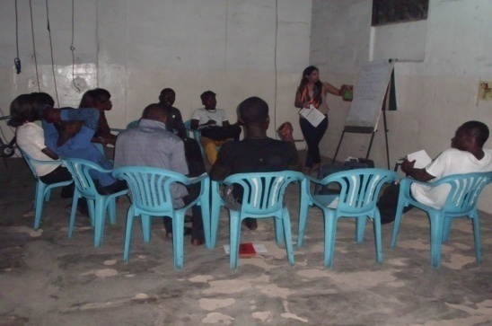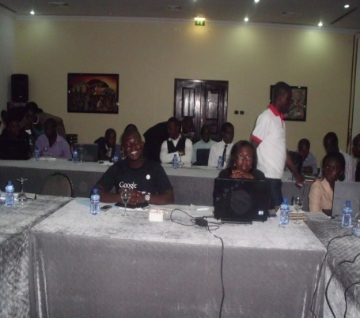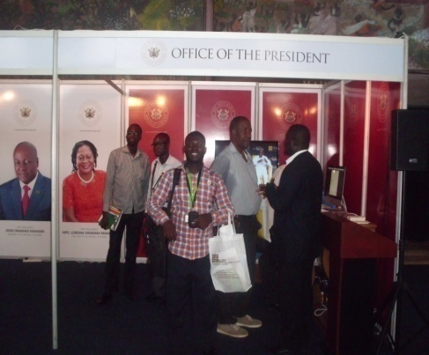
Management is happy to have taken advantage of the many Formal training and online courses organized for selected participants at different academic disciplines site both local and at the global level. Advancement in knowledge, skills and technologies keeps changing. Failure to be part of such developments is likely to affect anyone who fails to take advantage of such opportunity. Our team members participated in most courses of which participants were selected through competitive applications and screening. Most of these courses have new positive adverse effects on the overall contribution and performance of management at work.
The participation in these courses were mostly done online subject to the availability of internet, perhaps to give everyone the chance the world over and the flexibility to participate fully at the free will of participants. The courses pave way to interact, hold discussions and to submit course assignment on time. Certificates of distinction, pass, recommendation and specialization were awarded in the end. Members participated in the following courses and passed the necessary tests to receive either certificates or messages of congratulations.
Course on severer acute malnutrition-SAM ………….. By the international maternal Health ---Taskforce and the university of Southampton-UK
-Community water system management at university of South Carolina – scholarship
-Stanford University USA- Democracy and governance, USA
-Minority Rights Inter November 2013
-Climate Resilience cities-ELLA –January -May 2013 (5 months)
-World Bank Institute Basic Health Economics 2013
-FGM course 2013
-International medicine Institute.-DRR 2013
-John Hopkins University- centre for research course on managing Road Injury in Developing Countries
-Global Learning Center-course on Family Planning- FP 101 2013
-International Peoples Health University-Health care for Development 2013 etc

LOCAL COURSES
-Acumen Adaptive Leadership 1 – 31st November 2013 JCT
-Theatre Courage Hotel ……… Netherlands Diploma. In Aleme comedy workshop 2013; Sept 2013
-Google civil society training 2013-Coconut Glove Hotel Accra 2013
-University of Ghana/Regional Institute for Population Studies-June 2013 --Climate change and communication 2013
-CHF stakeholders Budget and performance-April 2013
-Monitoring engagement training 2013
-International Academy of Professional Counselors – membership accreditation (part 1 and 2) January-December 2013
-Global leadership from centre for transformational-Leadership for change course 2013 etc

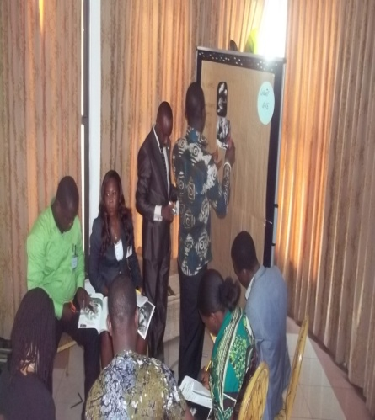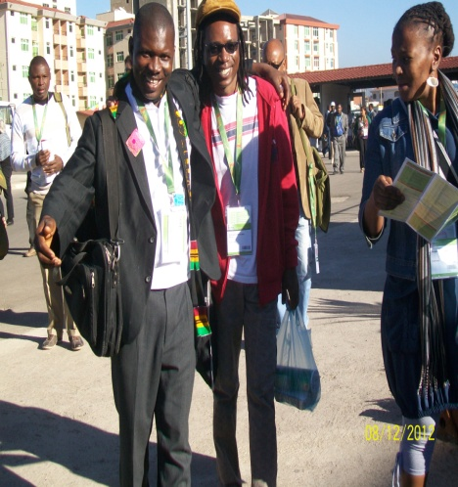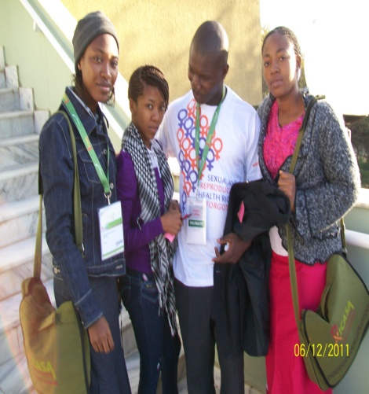
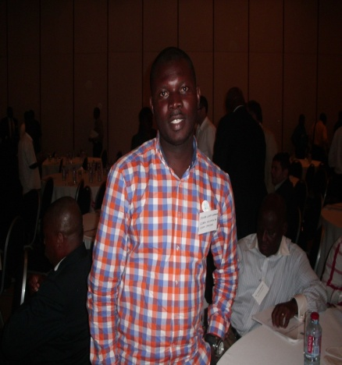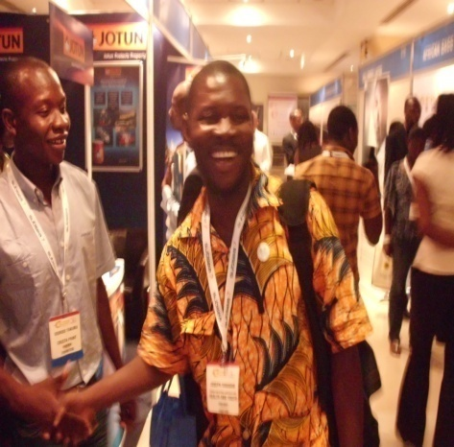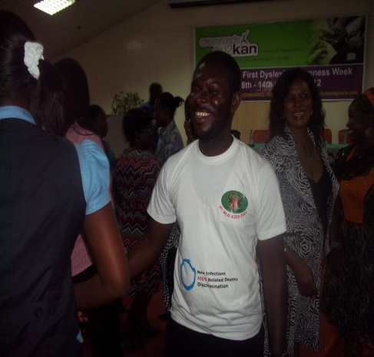

KWASHIE has been a strong pillar and a live wire igniting the CAFAF power for change around the world. His contributions has been recognized world wide and because of this there is nothing concerning development without us

ADMINISTRATION

BOARD MEETINGS
A series of planned face to face meetings between management and the board could not come on formally as majority of them were always occupied with tough schedule most of the times. However, an in formal meeting one on one took place where the executive director was able to brief majority of the members about what really is happening in terms of the foundations administration and to solicit their concerns as far as decision making and operations of the organization is concern. The office was always constantly in touch with them. Some have also given the green light for management to have them replaced by new crop of executives when the need arises at the pleasure of management. And so in 2014 critical steps will be taken to seal the loopholes created as far as decision taken at this highest level is concern.

STAFF MEETINGS
The executive Management Team met 10 times during the period. The meetings were used to discuss work program, job schedule of staff, effective and efficient ways of implementing cost free activities in 2013 and relatable partnership works. In addition to this effect the executive director had regular meetings with partners, friends of CAFAF, volunteers both online and off line. These meetings place management on top of the issues which prepare them to live up to the task fully. It brought a sigh of relief and the injection of new skills and strategies into the general administration of CAFAF as a whole.

MOBILIZATION AND ADVOCACY
CAFAF beef up our mobilization and advocacy efforts which were are a corner stone to achieving our set targets. We largely used these platforms to communicate our cause both locally and internationally. Management exploited both partnerships, other institutions platforms to air our constructive views for policy reforms. These avenues include but not limited to

- Meeting with the president of the republic of Ghana-the Presidential Youth Dialogue 2013( John Dramani Mahama)
- Energy conference in plaza
- Ministry of Health summit 2013 GIMPA
- Israel water conference 2013
- Ecological mini-conFAB/University of Ghana/RIPS/ CSIR-STEPRI/seminar 27-28 June 2013, Accra – Ghana

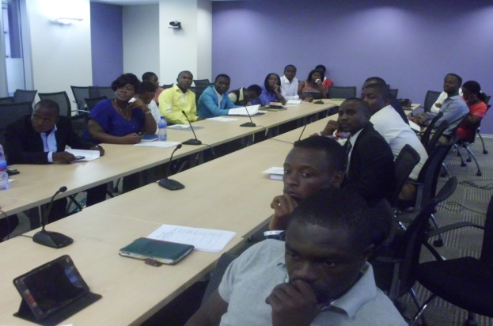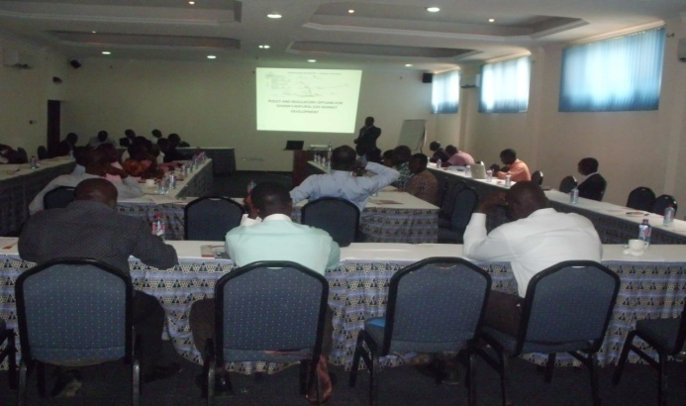

END OF YEAR REVIEW

As per the constitution and polices of CAFAF a regular yearly review meetings is expected to be held during which management present their performance and plan of action For the coming years , interact with members, volunteers partners, stakeholders and founders and the broader concern members of the public. Such decision is used again to interrogate the actions and interventions of the organization and offer suggestions to improve its performance.
However, are due to logistical constraints it was replaced with mapping research organized by the Ghana coalition of NGOs in Health. CAFAF was among member organization selected to participate fully for which the date coincided with the general meetings. The mapping indeed came off successfully; this was carried out by the urban Associates - a local research Think – Tank. The task was instituted by USAID to enable them work with the members of the coalition in the future. The results/report from the research will allow members capacity and structure issues to be looked into properly anticipating a further boost of support from USAID in executing projects in the future.

FINANCE AND ADMINISTRATION
The general running of CAFAF during the period under review In terms of finance and administration suffered a lot of set backs but with prudent strategic interventions management was duly able to salvage the image of the organization. The major source of funding for our activities was sourced from the CHF on going ICT School for life project. Greater chunk of our activities were delivered through partnership and voluntary schemes commitment from all. Management is still negotiating with other organizations and individuals to consider offering a regular donation into the coffers of the organization to enable it overcome most of the stresses associated with the administration of the organization financial wise. It is our fervent believe that the year 2014 will witness a different turn around which will help to spur the foundation to a higher heights.
FUND RAISING, PROPOSAL SUBMISSION
Prudent management of any organization depends on key factors such as requisite human resource, capital and external factors of production. Such ingredients are pillars that fuel the growth and impacts of any entity failure of which no gains can be made. In the course of the year management exploited most tangible avenues of fundraising, proposal writing, and call for proposals and applied for them but the response were not favorable both at the local level and on the international scale.
Weakness identified in these areas will be addressed in the cause of the year 2014 and beyond. The need to have a full time fundraising and communication specialist to be in charge to explore fundraising opportunities globally has become necessary and so steps will be taken to seal these loopholes. Additionally, our communication and fundraising document will be subjected to a thorough review to conform to current trends of doing business. The post of vacant voluntary position will be communicated to the public for interested applicant to come forward will be conducted in 2014.

UP DATE OF CAFAF WEBSIT
Management has since August 2013 taken steps to have a new website constructed and packaged to boost and market our intervention. The same will be applied to other social media sites including networks we are part of and have our details hooked to their domains will certainly be updated. A special blog will be created to place special document and reports to make them accessible to interested parties quiet easy. This is again is to demonstrate our commitment of operating in a transparent and accountability manner and right of people’s access to our information far easier. This is also to serve another avenue of storing most of our vital information as most storing devices can fail most of the time. Security measures and right to this information will be taken into account before delivering such document to the public domain for consumption.

APPOINTMENT of CAFAF MEMBERS SERVE ON LOCAL AND INTERNATIONAL BODIES
The year 2013 witnessed a steady transformation and reorganization of CAFAF team .How they could contribute to forester the growth and influence of wider stakeholder’s engagement. To this end some members had the chance to be committed competitively selected/nominated to serve on several committees, boards, executives teams to enable them transfer their expertise to amplify advocacy efforts being pursued at various levels. Most of such offers were accepted. Our key representations are still serving on this these committees and rendering their respective duties from time to time. These include but not limited to:
-Joseph Senyo Kwashie - elected to sever a three years term as the Greater Accra Secretary of Ghana HIV and AIDS Network on 25th July 2013 – 2016
-ISODEC- Social Pact-National Committee – youth representative till date
-Patient Alliance Organizations in Engagement (PAGE-Ghana) - 5th March 2013 – Management Team Secretary.
-Ghana Alliance for clean cook stoves- 10th august Greater Accra – Representative
-UN Global Compact- Ghana-Fundraising Team member 2013
PLAN OF ACTION FOR 2014
CAFAF is happy to have coined the 2014 programme of work (POA) from our strategic operation document that spans over a period of 2013- 2015. This is a 3 years work plan of action and presents a bigger vision of the organization which seeks to measure the outputs of the organization and impacts made in our project communities. Thus for 2014 the following activities and interventions are planned to be delivered. These include but not limited to
- Women in food security
- Climate change and environmental protection
- Communicable and non- communicable health education advocacy
- Youth for development
- Arts, cultural and music for development
- Human rights, peace, security, good governance
- Micro- Finance, financial inclusion etc
These broader headlines comes with a set of other key activities which are not covered here but are presented in the general framework which sets benchmarks for trading their implementation success (refer to our POA) for details on request. There aren’t any available funds to run them but the POA provides a concrete clue of at least what mandate and target we have set for ourselves for delivery. This is also to make our communication and interaction with donors flexible, clear and results oriented. Proposal details are projects cost with its assented beneficiaries, and receiving communities will be communicated in our fundraising materials. Our POA is clear and will serve as a mirror of reflection and a compass to direct the entire operations of the year and avoid duplication of efforts in 2014.

MONEY MATTERS

Due to policy change and a few financial guidelines, the foundation is adjusting to our independent audited accounts Statements could not be captured here. However, management is in interaction with auditors to finalize the process for which reason a separate copy will be made available from time to time. By virtue of this assertion financial matters of the organization are intact and in with this report. Measures are being put in place to ensure that our subsequent reports are accompanied by the financial matters associated with it. On a whole the year 2013 equally saw persistent and prudent measure put in place to control our expenses which have had a positive balance on our transaction leading to our all declaration of the period under review labeled as value for money year.

WAY FORWARD

The over all performance of CAFAF during the year under review speaks for itself and could be described as second to none. In spite of the daunting challenges that engulf our operations we mounted the courage to thrive which impacted positively in the lives of the vulnerable we have serve so. We have been part of the history makers which is a complimentary to government-efforts of offering alternatives of shaping people’s lives and make them counts in the development agenda.

Management can look back with swollen with pride and unceasing joy because this report has been produced not just like business as usual but from the hearts and evidences of our contributions to pursuing the mission and vision for which CAFAF was established to address. Countless lessons were learnt in the cause of our interactions with different categories of people and institutions we came across through the journey. We have taken note of the varied best practices, skills and knowledge derived from this engagement. Steps will be taken to have most useful methodologies, tools and practices in cooperated into our work to boost our performance.

As a human institutions ups and downs are a great deal of the life tests and so coming this far certainly makes our conclusion that complete that We have indeed obtained a distinction grade with a crown of success in 2013 hoping to surpass the coming year 2014.

CONCLUSION

Looking back to the year 2013 leaves much to be desired and as such management, indeed feel extremely proud to have directed our energies, expertise, skills, attention, and spirit of team work for a good working cause. Again going by the slogan which simplifies our ambition of existence “A person is a person through others persons” brings to mind our expectations for the coming year because of these wishes to send a timely clarion Call to all our sympathizers to come on board with your supports again and again to enable us touch the lives of the vulnerable.2014 offers another window of opportunity for all to extend your widows might for which reason CAFAF will be glad to do it for and on behalf you to reach out to the unreached.

By doing this you have sow everlasting seeds in the life of the weak and definitely to experience a turn around and no matter the magnitude, you will be remembered in the history books of our achievement forever.

Remember great things begin with small actions.
Help us to help.

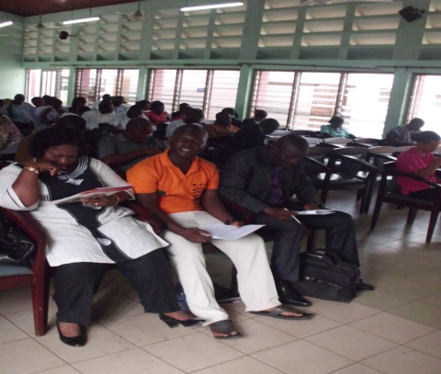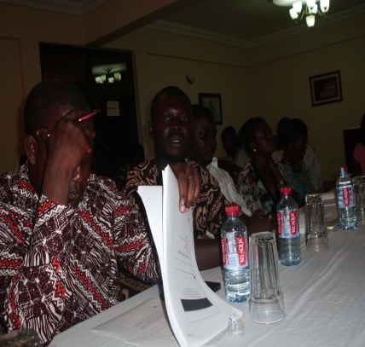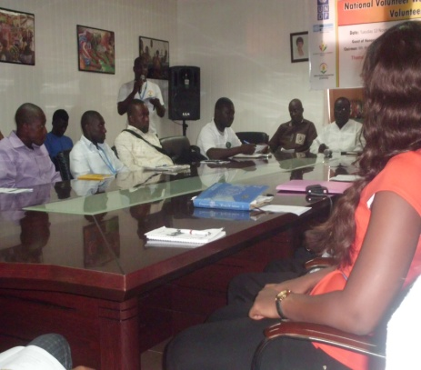
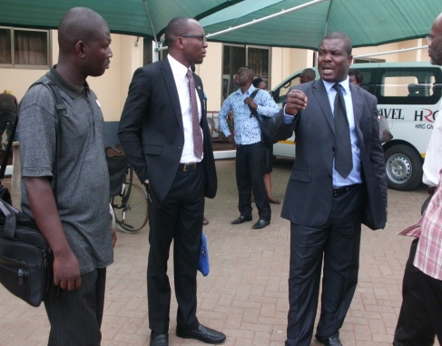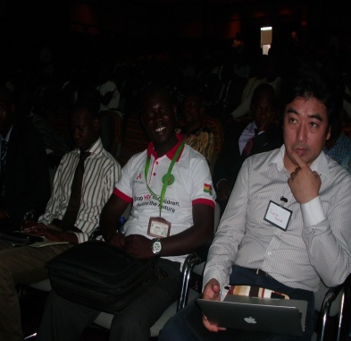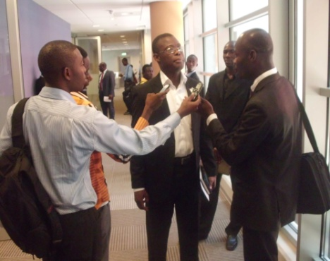
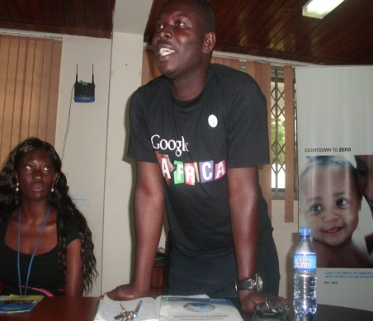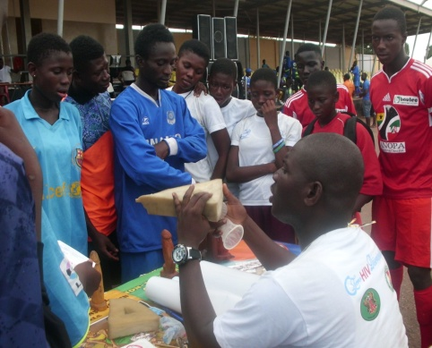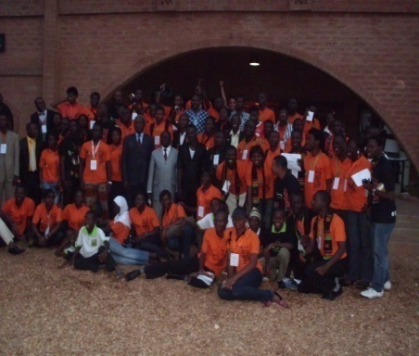
YES, we were part of the success stories of 2013 and are proud of it

