Intervention by the Women and Gender Constituency
SBI Closing Session Nov. 16, 2013 Poland Warsaw, internal gender conclusion

Dear all,
please find attached the original (long) version of the intervention and the shorter one, adapted to two minutes and to the situation, that the intervention was delivered before the conclusions of the SBI chair on gender and climate were adopted.
Constituencies were given the possibility to deliver their interventions quite early.
Shortly after the session was suspended until 10pm - and, following the webcast
Discussing a new paragraph in the gender and climate conclusions....
Cheers
Ulrike

=================================

From the women and gender perspective we have seen positive steps towards progress made in Doha and now here in Warsaw, which provide Parties a chance to lead on these issues, and, moreover, provide the UNFCCC process as a whole to be at the fore front on gender equality.
A great new chapter lies ahead of us. A broad coalition of women and gender stakeholders, including many Parties, the women and gender constituency and GGCA, have recommended some next steps in order to not lose track and we are happy to see them reflected in the SBI Chairs conclusions.
Congratulations!
Of utmost importance is to ensure an ongoing process to further discuss ways to implement gender equality during intersessionals and COP. Furthermore, the following funding provisions are needed:
- the allocation of resources in the trust fund should incentivize delegations to improve their gender balance and gender capacity.
- additional funding for participation of gender advocates should be provided
- funding for a regular gender specialist in the UNFCCC secretariat to follow up on the gender decision and the outcomes of the gender workshop must be allocated. Therefore, we urgently call upon Parties for additional funding for a supplementary budget earmarked to increase gender capacity in the UNFCCC secretariat.

Despite this progress, we are concerned.
Parties, in Poland we have come with various external but relevant events happening: Prior to our arrival , we witnessed the criminalization of environmental rights activists, upon our arrival we were faced with the irreparable losses and damages that have occurred from Typhoon Haiyan in the Philippines and during our stay the fossil fuel industry, one of the greatest contributors to climate change, is being given undeserved promotion and attention. Yet, the negotiations remain stagnant, the Parties remain polarized and decisions remain rhetoric. Civil society is inspired to act and now we need this intergovernmental body to do the same. It is your most urgent mandate at these negotiations and we expect no less than an overall decision about a future climate regime with strong and legally binding emission targets. You can not mainstream gender into a zero outcome.
Be now inspired to walk the talk on gender AND climate change!

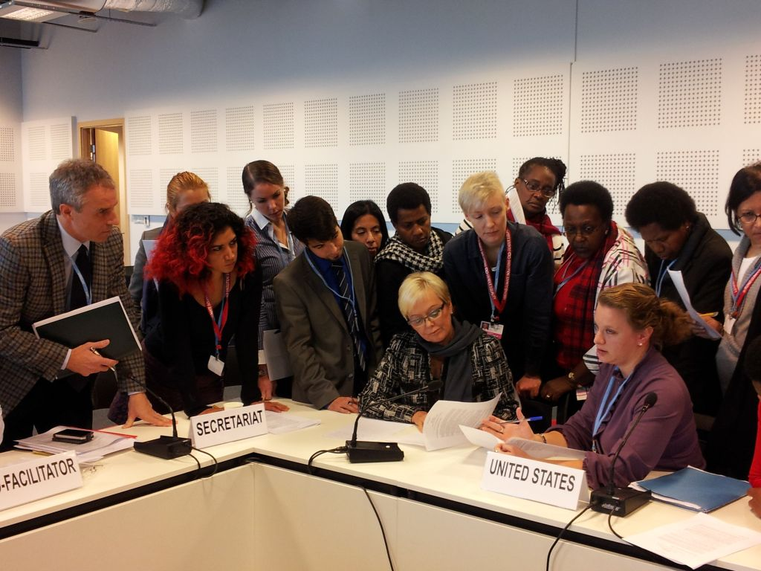

Intervention by the Women and Gender Constituency, SBI Closing Session Nov. 16, 2013
From the women and gender perspective we have seen positive steps towards progress
made in Doha and now here in Warsaw, providing the UNFCCC process to be at the fore
front on gender equality.
A great new chapter lies ahead of us. A broad coalition of women and gender stakeholders
has recommended some next steps in order to not lose track and we are looking to see them
reflected in the SBI Chairs conclusions.
Of utmost importance is to ensure an ongoing process to further discuss ways to implement
gender equality during intersessionals and COP. Furthermore, the following funding
provisions are needed:
1. the allocation of resources in the trust fund should incentivize delegations to improve
their gender balance
2. additional funding for participation of gender advocates
3. funding for a regular gender experts in the UNFCCC secretariat to follow up on the
gender decision must be allocated.
We urgently call upon Parties for additional funding for a supplementary budget
earmarked to increase gender capacity in the UNFCCC secretariat.
Despite this progress, we are concerned.
Parties, in Poland we have come with various external but relevant events happening:
Prior to our arrival , we witnessed the criminalization of environmental rights activists,
upon our arrival we were faced with the losses and damages that have occurred from
Typhoon Haiyan in the Philippines and during our stay the fossil fuel industry is being given
undeserved promotion and attention. Yet, the negotiations remain stagnant, the Parties
remain polarized and decisions remain rhetoric. It is your most urgent mandate to come to
an overall decision about a future climate regime with strong and legally binding emission
targets. You can not mainstream gender into a zero outcome.
Be now inspired to walk the talk on gender AND climate change!

