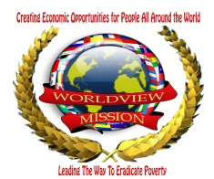
International day of peace celebration (IDP)
26 September 2012
8pm – 10pm
Family Club, Khartoum, Sudan

Introduction
In these days, Sudan is celebrating the signing of peace agreement with the republic of South Sudan, after the Public Referendum which leaded to the Separation of South Sudan in June 2011. This peace agreement is a very important step towards peace building and development in the two countries.
In this conjunction, the World View Mission (WM) Sudan celebrated the International Day of Peace on 26th September 2012, collaborating with regional and national NGOs.
The program included speeches by the main organizer and the representative of the organizing NGOs who stressed on the importance of the international peace day in spreading peace culture in the world. The organizers signed peace declaration that urges the government, the civil community and the international community to encourage and support peace building efforts and stop the armed conflicts which leaded millions of people to death.
The celebration was attended by 300 people from various categories, University Students, Social, Peace, and Political Activists, Artists and media. The guests of the programs included representatives from of foreign missions in Sudan and government officials.

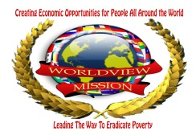
Organizers
The main organizer and sponsor for this event were the Afro Arab Youth Council and the group of youth organizations:
- Worldview Mission (WM) Sudan
- The United Nation Association – Sudan
- Education without borders
- Global change makers – Sudan
- The Arab African social interaction initiative
- Safari Sudan

Guests and VIPs
The Assistant of the president of Sudan H.E Abdulrahman Alsadiq Almahdi was invited to honor the celebration; the organizers received a phone call from him to accept his apology clarifying that at the same time he was in official trip to Adis Ababa to accompany the president of Sudan in signing the peace agreement with the republic of south Sudan.
The representatives of foreign missions in Khartoum included: the embassy of Saudi Arabia, the embassy South Sudan, the high commission of Libya and the embassy of Kuwait were among the guests.
Program
7:30 – 8:00 Arrival of guests
8:00 - 8:05 Recitation of Holy Quran
8:05 – 8:15 Welcome Speech by Secretary General of the African Arab Youth Council
8:15 -8:30 Address by the representative of the organizers
8:30 – 8:45 Peace Documentary
8:45 - 9:00 Honoring two Sudanese Peace figures
9:00 – 9:20 Peace Song Performance
9:20 - 9:30 Comedy show
9:30 – 9:45 Address by the guest of honor
9:45 – 10:00 Signage of Peace Declaration by the Organizers
End of Program
Pictures:
