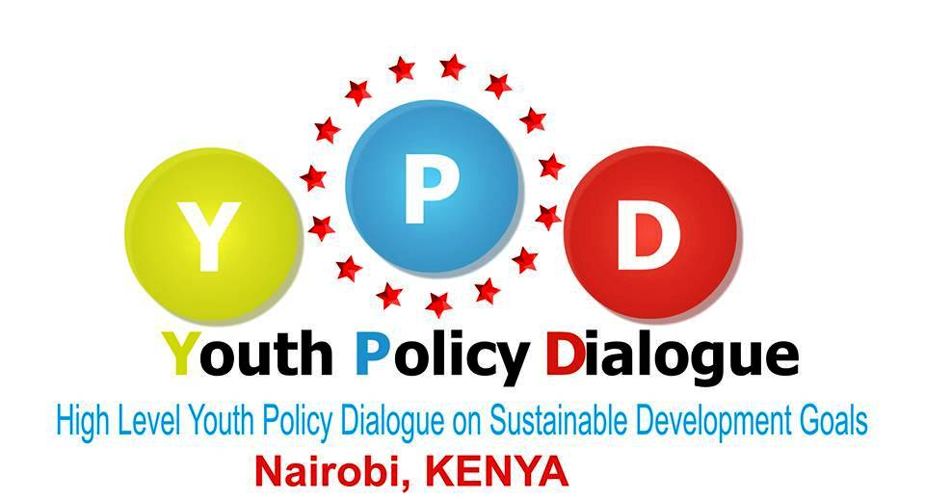
High Level Youth Policy Dialogue on Sustainable Development Goals
Theme: “Prioritizing an Investment in Youth Development in the Post-2015 era”

19th-21st August 2014, Nairobi, Kenya
Deadline 30th June 2014

APPLICATION FORM

Please type or write legibly. Kindly fill in the form in English.

I. INFORMATION ABOUT THE APPLICANT
- Name
Sex: Male Female Age: Nationality:
- Working languages
English French Others (Please specify all the languages you are able to work in):

- Contacts

Postal address (street, number, city, postal code, country):
Telephone: Telefax:
Mobile telephone: E-mail:
Current country location:

II. INFORMATION ABOUT THE ORGANISATION
- Sending organisation
Name:
Postal address:
Telephone: Telefax:
E-mail: Internet address:
- How would you best describe your sending organisation? (multiple answers possible)

an international youth organisation a national youth council (name):
a national youth organisation a local/regional youth organisation
a development NGO a governmental institution
a minority or minority rights association
other (please specify):
- What is your role/responsibility within your organisation?
volunteer employee board member (elected)
active member civil servant other (please specify):
- In what capacity are you involved in youth work or non-formal education?
full-time youth worker trainer of youth workers or youth leaders
volunteer youth worker occasional youth worker
teacher leader of a youth group or association
other (please specify)
- Why does your organization want to take part in this consultation meeting on Prioritizing an Investment in Youth Development in the Post-2015 era? (in less than 200 words)

- Please describe briefly any previous experience and/or future plans of your organisation in the context of Youth Participation in the Post-2015 development agenda (participation/representation in decision and policy making initiatives, interaction with local and national authorities.)? (in less than 200 words

- Please describe your role and position in your organization. (in less than 100 words

- What is your personal motivation to participate in the event? (in less than 200 words

- Have you any special needs or requirements? (e.g. dietary, mobility, etc.)

- Are you available for the entire duration of the meeting?

- Visas
If you are accepted as a participant on this course, will you require assistance in obtaining a Visa for Kenya?
No Yes
If yes, please indicate:
Date of birth: Passport No.: Issued at (place and date):
Place of birth: Date of expiry:
- Plane ticket, from airport of departure to Nairobi (Jomo Kenyatta International Airport), Kenya
Airport of departure:
Price of your ticket (in USD):
- Are you or your organization able to cover the costs of your participation? YES/NO
If yes, kindly state which the costs you able to cover (Note international participants are responsible for both costs)
Travel Accommodation and meals

Date: Signature:

The form MUST be saved in Microsoft Word format with filename “LAST NAME_First Name_Country Name.docx” (in this format)

Send application form and recommendation letter before the 30th June 2014

to dialogue@oayouth.org

