Workshop Report on Behaviour Change with Bamenda youth (August 2011)

The training on Behavior change was initiated by Eric Mbotiji and funded by the Waisenkinderhilfe Nigerian NGO based in Frankfurt Germany in collaboration with Youth Outreach Program Cameroon(YOP).

The main objective of this training was to empower 15 young people (aged 15-24) with skills needed to make informed decisions which will enable them to adopt positive behaviors and live healthily lives.

The training topics included amongst others Life skills (Bridge Model), Types of life skills, communication, Body language,
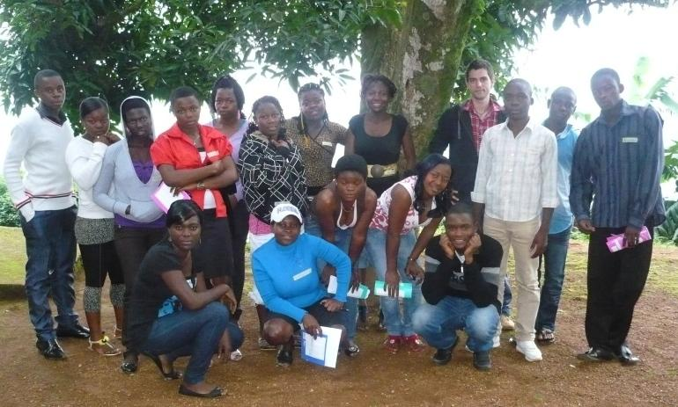

assertiveness, emotional management, decision making, goals setting, role modeling, identification of risky behaviour towards HIV/AIDS and delaying sex. Trainers included Nansing Jimai, Jonas Heckelei, Agwenjang Patience and Eric Mbotiji.

An important training area was communication skills. Areas explored included the methods of communication, elements of effective communication, body language, assertiveness and overcoming barriers of communication. In this session various case scenarios were used to illustrate forms of communication to the youth.
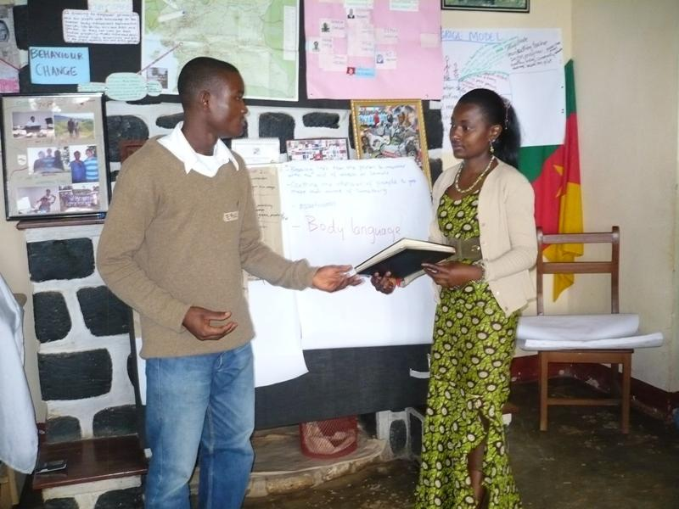

Eric and Jimai (in the picture on left) demonstration a case scenario on body language: A teacher calls for his student to take a book to his house and the student is frightened. Other case scenarios were demonstrated by the young persons.

In this training 15 youths gained self-development skills that enabled them to make informed decisions about their sexuality, be able to negotiate safe sex, set attainable goals, and their relationships and emotion. Most important was the fact that they developed strategies to address sexual harassment in schools and in their communities.

Submitted by
Eric Mbotiji

