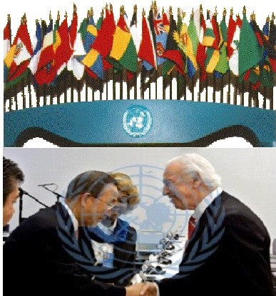
Meet and greet with United Nations Secretary General Mr. Ban Ki-Moon, Dr. J. Scott Moore, Dr. T.L. Lowery, Ms Hélène H. Oord
http://www.un.org/apps/news/story.asp?NewsID=53862#.VzZY8JGLTIU
AGENDA 21, BRADLEY COUNTY NEWS, CHURCH OF GOD, CLEVELAND TENNESSEE, ERADICATING POVERTY, MDGS, MILLENIUM DEVELOPMENT GOALS, TL LOWERY, UN, UNITED NATIONS

https://bradleycountynews.wordpress.com/tag/tl-lowery/

Dr. T.L. Lowery speaks at UN meeting in support of Millenium Development Goals

http://tllowery.org/promotional-materials/

http://tllowery.org/

In Uncategorized on September 13, 2012 at 11:43 AM
The United Nations I believe is using our local spiritual leaders to usher in a one world religion while preparing the world for the rise and implementation of the Antichrist upon our Earth.
It is no secret that the United Nations does not accept or acknowledge the deity of Christ and has pushed the UN’s Earth Charter as the replacement religious concept under a one world religion.
We must proceed with extreme caution as we form relationships with international bodies such as the UN that believe mother earth and humanism are the religious rule of thumb.
Participating in what many call the ushering in and offering assistance to the rise of the Antichrist is a very dangerous game we play and leads many to believe our world spiritual leaders have been lulled to sleep by by the great deceiver.
I believe in our quest to resolve the worlds problems we have aligned with a very evil organization that is co opting our religious leaders and infusing them with a new age religion that sounds good to many in their quest to rid the earth of poverty yet leaves us stranded struggling to maintain our own faith and beliefs.
If you read the goals of the UN and understand the global message of the UN you will begin to understand the true intent of the UN.
This train of thought is way bigger than what we can physically understand. The spiritual battle that is being fought is clearly the most misunderstood. Our participation and acceptance of a one world religion reinforces to me we are truly in the end times.
Dr. T.L. Lowery speaks at U.N. meeting
by Special to the Banner 22 months ago
GREETINGS — Dr. T.L. Lowery of Cleveland is greeted by United Nation’s Secretary-General Ban Ki-moon during a session reviewing Millennium Development Goals.
Dr. T.L. Lowery, president of the T.L. Lowery Global Foundation, was recently a guest speaker at a United Nations gathering to review progress on the world body’s Millennium Development Goals.
As a member of the International Association of Economic and Social Councils, a group selected from the top tier of 2,700 non-governmental organization leaders, Lowery was invited to address the council leaders Nov. 3 and 4.
In addition, he was asked to conduct a chapel service for U.N. staff and guests during a lunch hour. That voluntary meeting was attended by more than 200 people who sacrificed their lunchtime to take part.
The Millennium Development Goals are based on the United Nations Millennium Declaration, signed by world leaders in September 2000. They commit the international community to combating poverty, hunger, disease, illiteracy, environmental degradation, and gender discrimination, and set goals for 2015 in order to achieve milestones toward the goals. The meeting last week looked at progress toward target dates for key provisions of the goals.
“I was honored to receive the invitation, and I could not have imagined the regal treatment that was accorded to me,” Lowery said.
During the two days he spent in New York, he spoke to the members of the Economic and Social Council and met with three other committees of which he is a member by virtue of his council appointment, including the Millennium Goals Committee, the Business Administrative Affairs Committee, and the Peace and War Committee.
Lowery was also greeted by Secretary-General Ban Ki-moon and invited to a meal with him. Ban stressed the importance of the Millennium Development Goals.
He told the council members, “Your work is crucial to strengthening the participation and engagement of civil society in government at the national and international levels. Your workshops and meetings foster dialogue and focus much-needed attention on promoting social justice, deepening democracy, and advancing development.
“Your contributions are especially important to ECOSOC, where civil society voices and perspectives play such an important role in ensuring that our agenda and goals are balanced and well-coordinated. This hard work is vital, especially now.
Economies are still suffering from the financial, food and energy crises. Millions of people are jobless. Millions more have been pushed into extreme poverty. Natural disasters have demanded higher levels of financial and logistical coordination. Ongoing wars, conflicts, and humanitarian crises command our attention,” said Ban in challenging the group.
Dr. Scott Moore, assigned as Lowery’s host for the visit, commented on the effectiveness of Lowery’s remarks to the groups with whom he interacted, and especially on the chapel service. “It is unusual for world leaders to gravitate toward these meetings, but I observed the ambassador from Haiti and the ambassador from Nigeria in particular were strongly moved by Dr. Lowery’s prayers for them.”
Lowery presently leads the locally based Global Foundation. He formerly served on the Executive Committee of the Church of God, and earlier was pastor of the National Church of God in Washington, D.C., and the North Cleveland Church of God.
My many thanks to the Cleveland Daily Banner for their coverage of this very important Agenda 21 United Nations Millenium Development Goals coverage.
Source of info: Please continue to support this paper and please continue reading the articles placed herein as many have given us insight into the depth of influence the United Nations has had on our community https://bradleycountynews.wordpress.com/2012/09/13/dr-t-l-lowery-speaks-at-un-meeting-in-support-of-millenium-development-goals/
.http://www.clevelandbanner.com/view/full_story/10308881/article-Dr–T-L–Lowery-speaks-at-U-N–meeting
More: Meet and greet with United Nations Secretary General Mr. Ban Ki-Moon
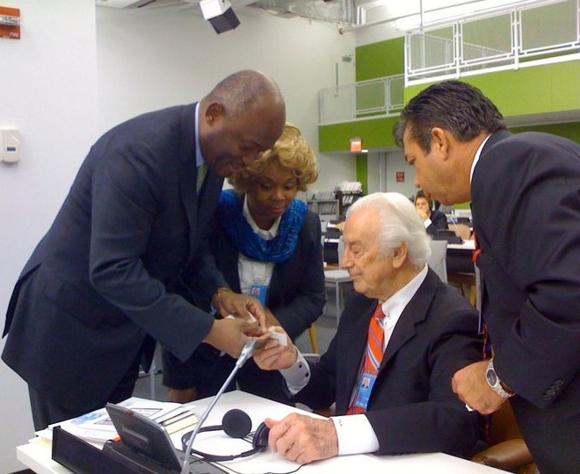
Dr. J. Scott Moore, Project One Inc, Dr. T.L. Lowery, Ms. Hélène H. Oord, Mr. Jean Victor Nkolo Spoke person for UN President 69 session Gen Assembly, New York
Jean-Victor Nkolo- Spokesperson for the President of the 69th Session of the UN General Assembly, Bio: http://www.un.org/pga/biography-nkolo/
http://worldviewmission.nl/?page_id=21400
https://www.youtube.com/watch?v=KjPGCKe_IzU

https://www.youtube.com/watch?v=2oQjacfXsd8

Project One Inc
http://j-moore-project-one-inc.webs.com/
.
http://worldviewmission.nl/?page_id=21400

TL Lowery Global Foundation Building Tour - YouTube

https://www.youtube.com/watch?v=agKBO7gdvM8

Hélène H. Oord CEO/Founder Worldview Mission
http://worldviewmission.nl/?page_id=22082

