Beyond 2015 Twitter chat

Date: Wednesday 17 February 2016
Time: 4pm-5pm in Brussels / 10am-11am in New York
Hashtag: #B2015lessons

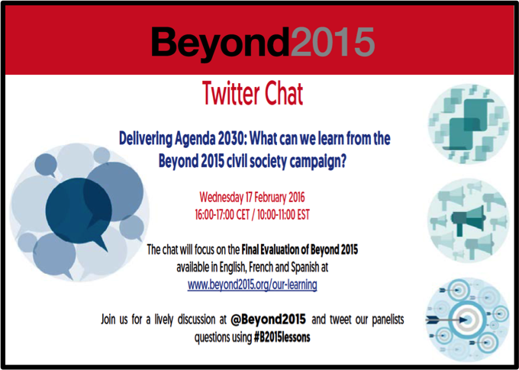
Click here to download this promotional flyer

Event description:

The Beyond 2015 Campaign is closing down in March this year after bringing together over 1,500 civil society organisations to advocate for an ambitious and universal post-2015 development agenda that will improve people’s lives, especially the world’s poorest and most marginalised. Agenda 2030 was adopted by the United Nations in September last year but the hard work continues!

Indeed, now that 2016 is underway, the clock has started ticking for all countries to deliver the new agenda and its 17 Sustainable Development Goals by 2030. What can civil society and government take away from the Beyond 2015 experience to successfully deliver the SDGs?

Join Beyond 2015 members and guest panellists to discuss the outcomes of the evaluation of Beyond 2015, and how its findings apply to the delivery of Agenda 2030. Tweet questions to our panellists using #B2015lessons.

Participating in the event

- The chat is open to anyone with a Twitter account.
- Participation is possible in English, French or Spanish.
- Click here for short guidance on how to participate.

