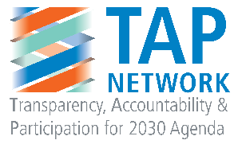

**TO ENDORSE THIS POSITION PAPER, PLEASE EITHER UPLOAD YOUR LOGO ONTO THE GOOGLE DOC OR SIMPLY LIST YOUR ORGANIZATION’S NAME IN THE SECTION BELOW.**

**DEADLINE FOR ENDORSEMENTS: MONDAY, 7 MARCH AT 5 PM NY time**

**ENDORSEMENTS FROM ORGANIZATIONS:**

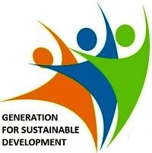 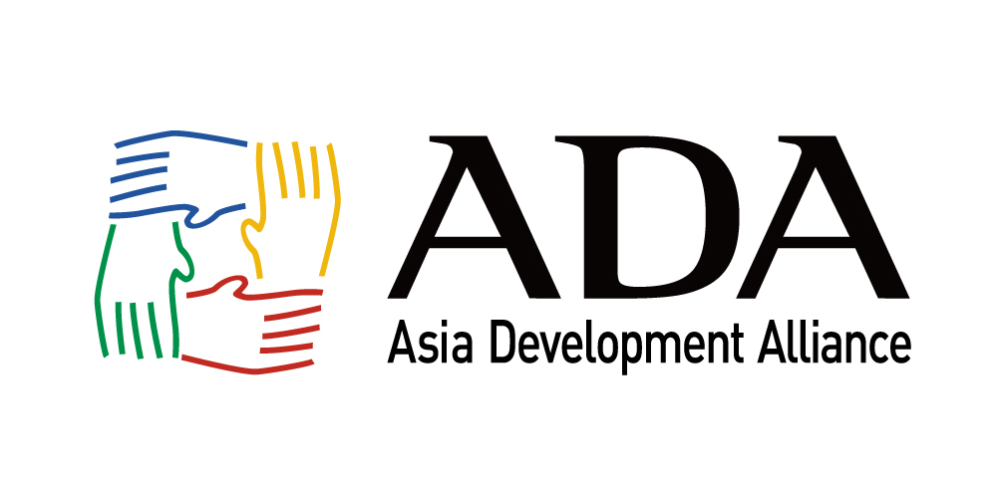

523399_379909578707607_908476807_n.jpg

**JasHim Foundation**

Rural Reconstruction Nepal (RRN)

[www.rrn.org.np](http://www.rrn.org.np)

**Minority Rights Group**

Restless Development

Saferworld

International Federation of Library Associations and Institutions

**Global SDG Indicators: Building a Framework that is Fit For Purpose**

The [Transparency, Accountability & Participation (TAP) Network](http://www.tapnetwork2030.org) welcomes the Report of the Inter-agency and Expert Group on Sustainable Development Goal Indicators (IAEG-SDGs), and believe that it represents a foundation for the international statistical community to build on as we look towards the implementation and monitoring of the 2030 Agenda. **We call for governments to adopt this report at the 47th Session of the UN Statistical Commission, with the recognition – as the IAEG-SDGs Report acknowledges – that additional work will be required to fill gaps and create a fully comprehensive global indicator framework that is fit for purpose.**

In particular, we recognize the immense efforts undertaken by the IAEG-SDGs thus far, and are generally encouraged by the proposed indicators for Goal 16 in particular. Despite this, we are specifically concerned about target 16.3, where the criminal justice indicators fail to capture the breadth of the target, and look forward to working further on these indicators with the IAEG-SDGs going forward. Additionally, we are encouraged by the work and ambition of the Praia Group on governance statistics, particularly as it relates to The problem the refinement of indicators, methodologies and support for further development of technical guidance for NSOs and stakeholders on data collection for Goal 16 issues. In particular, its multi-stakeholder nature is a model for NSOs and other similar groups to aspire to, and we look forward to further collaboration with the group going forward.

We’re also encouraged that the IAEG-SDGs proposes to draw on a combination of administrative and survey-based data to monitor Goal 16. With the “people-centered” nature of the 2030 Agenda, and its strong commitment that “no one will be left behind”, survey, perception and experiential data and indicators are a critical means for ensuring that sustainable development policies and implementation are not just outcome-oriented, but people-oriented as well. These kinds of data are critical to help identify areas for improvement for policy-makers at all levels, as they measure the needs, priorities, perceptions and experiences of citizens, and help maximize development gains by providing a more comprehensive snapshot of progress towards Goal 16, and all other SDGs.

**Building flexibility into global SDGs indicators framework**

**However, while we support the adoption of the proposed IAEG-SDGs report and final set of global indicators at the UN Statistical Commission at its 47th session, we strongly call for the IAEG-SDGs to build in flexibility in its working methods to ensure that this indicator set can be built upon and improved in the coming years ahead.** This is especially important in the context of the IAEG-SDGs admission that “in several cases, the Expert Group has highlighted that the proposed indicators do not cover all aspects of a given Goal and its targets.” Given the anticipated 15-year mandate for the IAEG-SDGs that is proposed in its report, this flexibility in its work around the global indicator framework is critical for ensuring that both the IAEG-SDGs and the global indicator framework are fit for purpose, and to help the international community fulfil the 2030 Agenda’s commitment to leaving no one behind. Additionally, the IAEG-SDGs and these global indicators must be reactive to emerging needs and challenges that face the international community, and adapt to changing technology, data availability and methodologies over time.

In addition to the flexibility that must be built in to the IAEG-SDGs going forward, it is especially important for the group to build upon its efforts to engage with a wide range of stakeholders – including UN Agencies, civil society, academia and the private sector – and strengthen transparency and inclusivity of its work. This will be in the interest of the IAEG-SDG’s own legitimacy and effectiveness during this critical next phase of work.

**Specifically, we would like to see the IAEG-SDGs, High-Level Group and UN Statistical Commission:**

* ***Improve inclusion and genuine participation:*** The processes to define the 2030 Agenda has seen unprecedented levels of engagement from civil society and a wide range of other stakeholders, and in new and innovative ways. We welcome that the IAEG-SDGs had again invited stakeholders to follow and participate in the Third Meeting of the IAEG-SDGs, but would encourage the expert group to allow for inputs from these stakeholders during the official meetings of the IAEG going forward. Special attention should be given to the poorest and most marginalized that are not only excluded from progress, but at times left out of survey data and other statistics. The openness and working methods of the Praia Group on governance statistics is an example of a model to build upon in this regard, as are the modalities for stakeholder engagement in the High-Level Political Forum on Sustainable Development (HLPF).
  + Additionally, the IAEG-SDGs – as well as the High-Level Group for Partnership, Coordination and Capacity-Building for Post-2015 Monitoring (HLG) – must not limit themselves to traditional thinking of “participation,” merely through attendance at meetings and online consultations. Instead, the IAEG-SDGs and HLG should provide opportunities for direct dialogue and exchanges between the IAEG-SDGs Members and civil society, academia, the private sector and other stakeholders and data providers outside of official meetings, and not merely through rigid online surveys.
* ***Establish transparent and open procedures for tiering of indicators, compilation of metadata and indicator review mechanism:*** With important work coming up within the IAEG-SDGs around the tiering of global indicators, as well as the compilation and dissemination of metadata, we urge the expert group to be thorough and inclusive of a wide range of data sources outside of official statistical systems when undertaking this work. While the main sources of data for SDG monitoring should come from NSOs and national governments, other data sources and methodologies from a wide range of stakeholders must be drawn upon, in order for this work to fully take into account the full data ecosystem for data collection around all SDG issues. Hybrid partnerships will be critical if we are to fill the looming capacity gaps we face.
  + Additionally, the IAEG-SDGs must develop a transparent and open mechanism for reviewing the relevance and potential expansion of indicators over time. Regardless of the form that this mechanism takes, this mechanism must take into account and solicit inputs from all stakeholders, including civil society, academia, research institutions, practitioners and the UN System. Inputs and perspectives of a wide range of stakeholders are necessary for a full assessment of whether existing global indicators are sufficient for tracking progress towards each target. If these revisions and decisions are made purely by national statistical systems alone, the expert group risks leaving critical issues and people behind regarding data that are needed or provided by stakeholders beyond these official data-gathering channels.

**Increasing support and capacity building for NSOs and stakeholders**

As the reports of the IAEG-SDGs and HLG both acknowledge, increasing resourcing, capacity building, partnership and coordination for international statistics will be a determinant factor in achieving our ambitions to measure and monitor global progress towards the SDGs. **Therefore, we call upon all governments, donors and partners to increase support for statistical capacity building at all levels, and look forward to working with the IAEG and HLG to help identify areas and opportunities of need.** In addition to providing sufficient resources and capacity for NSOs, the international community must also ensure adequate resourcing to UN-level efforts and secretariat functions that support the UN Statistical Commission, IAEG-SDGs and HLG – namely the UN Statistics Division. Finally, governments and donors should prioritize resourcing and capacity building for stakeholders outside of the official statistics realm – including civil society, academia and research institutions –to support organizations that provide complementary data sources for SDG issues, and to help boost data literacy amongst societal actors more broadly. A special challenge will be the inclusion of the poorest and most marginalized people, particularly including children, women, LGBTQI people, people with disabilities, indigenous people, people who are discriminated based on Caste, and people without basic literacy or access to information. These groups have the most immediate insights on their own experiences with sustainable development policies and progress. To leave no one behind, it would be beneficial for NSOs and other stakeholders to work with people living in poverty and exclusion to produce data that reflect their own progress. Further, data collected by organizations that work closely with these populations should be prioritized.

**Recognition of “Third-Party” or “Non-official” Data**

**We also call upon the IAEG-SDGs, the HLG and the UN Statistical Commission must broaden support for the recognition of “third-party” or “non-official” data sources to support measurement and monitoring of the SDGs at all levels, and ensure the inclusion of this kind of data in the IAEG-SDGs tiering and metadata compilation processes going forward.**

This data comes from a range of sources, including *inter alia*, the UN, other multilateral institutions, civil society organisations, research institutions, academia the private sector and citizens themselves. It ranges from global surveys (e.g Transparency International’s [Global Corruption Barometer](http://www.transparency.org/gcb2013) and the [Open Budget Survey](http://internationalbudget.org/opening-budgets/open-budget-initiative/open-budget-survey/)) and indices (e.g. UNDP’s [Multidimensional Poverty Index](http://hdr.undp.org/en/content/multidimensional-poverty-index-mpi)) to personal, qualitative data generated by some of the world’s most marginalised people at the local level (e.g. citizen-generated data project [Map Kibera](http://mapkibera.org/)). It also includes data translated from publicly available (open) data sets to track a specific phenomenon/issue (e.g. Publish What You Fund’s [Aid Transparency Index](http://www.publishwhatyoufund.org/index/)) and information collated through expert assessments (e.g. CIVICUS’ annual [State of Civil Society Report](http://civicus.org/index.php/en/media-centre-129/reports-and-publications/socs2015)). All of these existing data sources, and data sources that will be created in future, will play a critical role in measuring progress against the SDGs and the 2030 Agenda.

We also hope that the HLG will be able to provide a leadership role in discussions around data comparability around official and “non-official” data going forward, and in expanding the space for partnerships and collaboration between the official statistical community and stakeholders, as is indicated in the group’s proposed terms of reference. Additionally, other initiatives, such as the Global Partnership for Sustainable Development Data can help facilitate this work, and we encourage the HLG to collaborate with such initiatives in its own work.

***Read more on the role of “Third-Party” data from the TAP Network’s Discussion Paper here:*** [***http://bit.ly/1pmZZqW***](http://bit.ly/1pmZZqW)

**Establish Global Monitoring Groups**

Work in collecting and aggregating data for the SDGs will undoubtedly be a year-round effort for National Statistical Offices and third-party data producers alike. **Therefore, efforts should also be made to establish formal or informal multistakeholder “monitoring groups” – similar in structure to the Praia Group on governance statistics – which bring together NSOs, academics, civil society and the private sector to support data and methodological work around specific SDG or other thematic issues.** This will provide a year-round opportunity and entry point for experts and data providers on various issues to collaborate more intimately around these thematic issues. Such groups can also help boost the capacity of the international statistical community to undertake this ambitious SDG monitoring work, and can help spur innovative partnerships in areas of particular need. This will also help prevent the UN Statistical Commission, IAEG-SDGs and HLG from taking on an over-loaded agenda on such wide-ranging SDG issues, and will help improve the transparency, inclusivity and overall robustness and effectiveness of the SDG data and indicators work more broadly.

**Supporting the Praia Group on governance statistics**

In the next steps for the IAEG-SDGs’ work around the development of a “tier system” for global SDG indicators, this process must build upon existing mechanisms that work more intimately on various SDGs and thematic issues – including the Praia Group on governance statistics, and its proposed work around Goal 16 indicators and data. **Therefore, we strongly support the work of the Praia Group, and call upon other NSOs and governments to provide support for the group going forward.** The Praia Group’s proposed work plan, outlining its further work on Goal 16 methodologies and data mapping, provides the ideal forum to contribute towards the IAEG-SDGs continuing work around indicator methodologies and the compilation and dissemination of metadata for Goal 16 in particular. The Praia Group should work to strengthen Goal 16 indicators in the IAEG-SDGs “final” list, as well as strengthen or add additional indicators where the IAEG list falls short – such as the current indicators for target 16.3 on access to justice. The group’s commitment and dedication to providing a multi-stakeholder space for all relevant experts to contribute to its work is also a shining example of how the official statistics community can structure their engagement with all relevant stakeholders. Member States and NSOs should strongly support the Praia Group, and consider creating additional groups and forums like the Praia Group to facilitate the work of the global statistical community around various SDGs or thematic issues, which would report to the UN Statistical Commission.



ARTICLE 19