SAD NEWS: Juanita Bynum Grieves Loss of Pastor & Spiritual Father, Apostle John H. Boyd,Sr.
Thursday, July 12, 2012 at 12:24PM
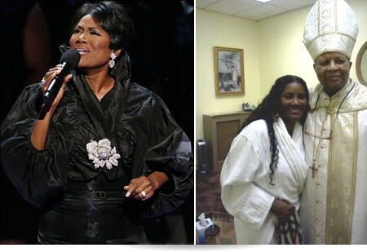
Juanita Bynum poses with her late pastor and spiritual father Apostle John H. Boyd, Sr.
By EEW News Staff
Juanita Bynum is soliciting prayers today as she mourns the loss of her pastor of 28 years and dear spiritual father figure, Apostle John H. Boyd Sr. of New Greater Bethel Ministries. When Bynum heard the news of his passing yesterday, she was at Macy’s department store and “hit the ground” from the terrible shock of it all.
Though EEW Magazine does not have the specific details surrounding the death of the beloved leader (Our staff will make them available to you as we learn more.), sources that knew the relationship well between Bynum and Boyd confirm that they were like father and daughter.
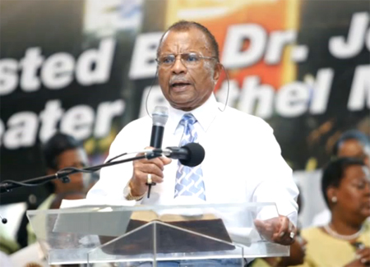Pictured Above: Apostle John H. Boyd, Sr. of New Greater Bethel MInistries in NYIn the wake of the news, Bynum has taken to the social networking site Twitter to air out her feelings through a series of anguish-filled tweets. She said:
Help me Lord. My pastor for 28 years today sits in the presence of God… crying… crying… MY GOD… numb. He was my dad...the only father I had left who knew the real me...before I preached for Bishop Jakes I was a flight attendant! He loved me the person, not the ministry!!! I was his daughter!!!!!!! Pray for me....I need it!!! My heart hit the ground in Macy's department store. I didn't even realize I had hit the floor...pray for me I need it!!!! Bad!!!!!! This was my dad.....crying....28 years the same pastor!!!! I love him and will miss him deeply. New York has a hole in it. However the hole in my heart today is bigger than the one in New York.....God has spoken !! Amen
Bynum lost her biological father in June 2008 in the middle of her difficult, public, and very painful divorce from ex-husband Bishop Thomas Weeks. In an interview with ESSENCE.com, Bynum describes a very personal and emotional conversation she had with her late dad.
With all that I'd been through, the world witnessed me endure 18 months of devastation. I literally died in that devastation. I remember sleeping in my bed for four days straight with no appetite and extremely depressed. My father asked me with a fierce anger, "What is your name?" And I said, "Juanita Bynum." And he said, "Don't you ever forget it; now get up!" I never stayed in my bed like that again.
He was my rock, because he was that real man that was tangible; that helped to reaffirm and validate myself again. When a man takes your femininity and womanhood and treats you like you're nothing more than trash it's devastating. Through it all my dad was there. When my divorce was finalized on a Friday, my father called and said, "I want you to fly to the top."
That following Monday he fell down dead in our kitchen from a heart attack.
Now Bynum is struggling to cope with another sudden loss. Our prayers are with the Boyd and Bynum family at this difficult time.
About Dr. John H. Boyd, Sr.
He was born July 17, 1926, in Bracey, Virginia, where he was raised on a farm. At the age of 16 he moved to New York City, graduating from George Washington High School. In 1944, Dr. Boyd was drafted into the U.S. Army, where he attained the rank of First Sergeant. After three years of service, he received an honorable discharge.
In 1945, he met Margie Jackson, and on August 16, of 1947 they were united in Holy Matrimony. From this union they were blessed with five children: Geri, Gail, John II, Rubina and Warren, all of whom are working full-time in the ministry.
Dr. Boyd served faithfully for 18 years under the leadership of Pastor Ernest Brown of Macedonia Church of Christ in Brooklyn, New York. During this time, he studied at the Manhattan Bible Institute and worked as a salesman and contractor. God dealt emphatically with him concerning full-time ministry. After much travailing and perseverance, he found his purpose: a vision of a Gospel Tent was conceived in his spirit.
With the blessing of Pastor Brown, Dr. Boyd entered the pastorship in 1972 and Boyd entered the pastorship in 1972 and opened the first Gospel Tent, giving birth to the New Greater Bethel Ministries. In September of the same year, "Little Bethel" became a reality located at 221st Street and Linden Boulevard, in Cambria Heights. On Easter Sunday 1975, Dr. Boyd led the congregation to their new home at 219-09 Linden Boulevard, which was the Old Cambria Heights Movie Theatre.
To this day the vision continues to be a driving force in the life of this remarkable man.
Dr. Boyd received his Doctor of Divinity degree from the United Christian College in Brooklyn. He has been cited many times for his compassion, commitment, and leadership. Among his awards are: a Citation of Honor from Queens Borough President Claire Shulman; recognition from former New York City Mayor, The Honorable David Dinkins; recognition from Presiding Supervisor of the Town of Hempstead, Joseph N. Mondello; and he has been cited by Radio Station WWRL for his out-standing leadership and outreach to the community.
Dr. Boyd was awarded the "Man of the Year" by The New York Christian Times, for his outstanding work in the State of New York and his outreach around the world. Both New York Newsday and The Daily News have honored him with a complete profile on him and his work at the New Greater Bethel Ministries, including the Lord's Food Pantry and Soup Kitchen. Dr. Boyd has received certificates of honor and special recognition from Superintendent Brian Fischer of the Queensboro Correctional Facility for his outstanding work with the Inmate Community Improvement Program.
In 1991 Dr. Boyd authored his first book, Coming Out of Your Grave Clothes, the first in a series he calls his "Coming Out" series. He is currently working on his second book, Coming Out of Your Cave.
Dr. Boyd's message of salvation and deliverance is seasoned with love.

http://buzz.eewmagazine.com/eew-magazine-buzz-blog/2012/7/12/sad-news-juanita-bynum-grieves-loss-of-pastor-spiritual-fath.html

