REPORT ON CHILDREN’S AID ACTIVITIES, Projects in Rwanda and Eastern Congo
- Introduction
Central Africa Deliverance Ministries (CADM) would like to report and provide action plan of November and December on activities of Children’s activities in Rwanda and next month we are planning to send a report and its Action plan on Eastern Congo combined with recent activities which is following up day to day by Eastern Congo Representative who is in Rural area without internet access.
Currently , Children in Rwanda are still in need due to Country history of Genocide of 1994 which left most of them orphans and without any property which seems to be a great a challenge , this why we , non-governmental organizations are wholeheartedly working to see how we can respond to this problem even if the demand is still very high.
Moreover, The demand of these children is food, clothing, medical care, school fees, cancelling and other training, entertainment materials,etc,,
Our Ministry Organized different training like hope, cancelling, hygiene and also entertainment games which greatly touched them in this semester.
In addition, we had played a significant role as our mission in Health care, school fees and appliances, feeding them, clothing them and organized entertainment games in different sites.
In this report , we are pleased to share with you activities supposed to be done in the two coming months while children will be in Holiday.
A. Background
Central Africa Deliverance Ministries (C.A.D.M) is committed to missions, training and sending missionaries across whole world.

In addition the (C.A.D.M) has the task to heal all broken hearts by using the Gospel of God firstly, to request people to change their attitude from evil works using the prayers, to hearten all people of worldwide especially in East Africa and Great lakes region to build the spirit of hope for many hopeless people.

The C.A.D.M do not only on spiritual deeds but also takes care of physical life for more people by feeding the hungry ,clothing the poor, educating many people at different ages, minister to elderly, widows , orphans, visiting prisoners and out to people of all ages and in all walks of life.

Besides, we have the special plan for East of D.R.C/CONGO because that region has passed many years in the strife and right now there is no worth improvement in many sectors, so, many people still suffering for all those problems that they are passing through, hence we think to create the orphanage for sustaining the orphans which have no means.
In the same way, we are planning to help the widows by gathering them in the projects and providing them basic needs for better unfolding their daily life.
We provide global humanitarian aid to hurting people and teach Christians and no Christians alike how to enjoy everyday life by applying Biblical principles in all they do. Our ministry desires to be deep well where everybody from every side of the world gets water of life.
Not at all but also preaching holy gospel as bible said in John 4:13-14

B. About Ministry

- In Rwanda;
Firstly, we, Central Africa Deliverance Ministries Organization, we are too grateful for much endeavors that Rwanda government has put for resolving the problems of children after the war of 1994 which left many problems within Rwanda society and with special emphasis on lives of children.
Some Children here Rwanda have the problems of getting food due to their families which do not have enough income, the matter of health care within some families which aren’t able to buy medical insurance, the problems of getting materials for attending school with all equipments as indicated by the rules of schools that they study in, the matter of earning clothes, shoes and other needs.
Other children are living in families which can’t stand the cost for all needs towards their children, this allow some children to leave their native villages and going in cities for researching jobs which probably provide to them some income, other fled their families and went in roads ,they became streets kids, also a little number of Children disagree to attend school due to their wrong will or thoughts.

- In Eastern of DRC/ Congo
Children have defined this often forgotten, but world’s deadliest, humanitarian crisis in the heart of Africa. Estimates place the total deaths at four million due to the conflict and violence that has consumed the DRC for nearly a decade. As a direct or indirect result of conflict, 2.000 people die every day in RDC and more than half of those are children. Children bear the brunt of conflict, disease and death, but not only as causalities but they are also witnesses to ,and sometimes forced participants in ,atrocities and crimes that inflict physical and psychological harm.
Problems facing children in DRC and mainly East of DRC;
- Sexual assaults, used as a weapon of war against women and children , have reached epidemic proportions. Last year alone, 25,000 reported cases of rape occurred in eastern of DRC.

- Children are caught up in war as refugees and internally displaced people.
In eastern of DRC, as many as 120,000people every month are being displaced from their homes and 1.66 million remain displaced. Constant migration robs children of schooling, health care and the chance for a normal life.
- As many as 30,000 children may be associated with armed forces or groups as fighters, sexual slaves and camp-followers.

- Rates of infant, under five and maternal mortality are staggering. One in five children dies before reaching the age of five.

- Mothers die in childbirth in 13 out of every 1,000 deliveries.

- Nearly one third of children are underweight. Malnutrition and micronutrient deficiencies are responsible for nearly half of deaths among children under age five.

- There are over 4million orphaned children in the country (DRC).

- School enrolment rates are declining. More than 4,4 million children( nearly half the school age population) are not in school. This number includes 2.5 million girls and 400,000 displaced children.

- Child labor is commonplace; More than a quarter of children ages 5 to 14 are working.

- Observation
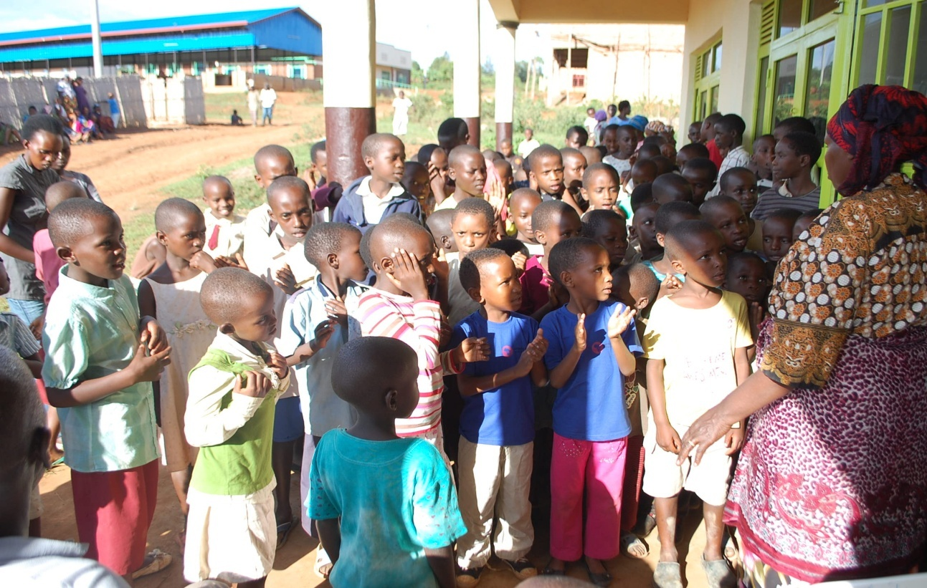
RUSHESHE in front of our Office it is in MASAKA Sector, Kicukiro District in The City of Kigali
This was a break in training on Hope and cancelling which took place at office hall on 15th July 2015.
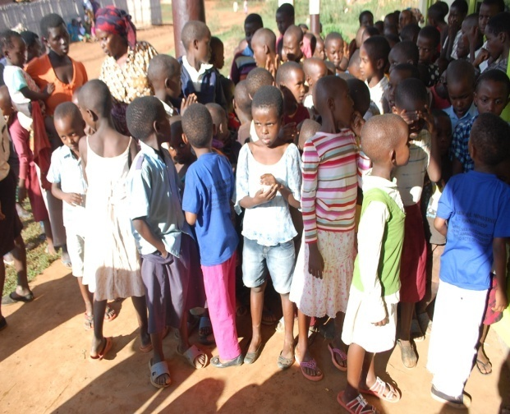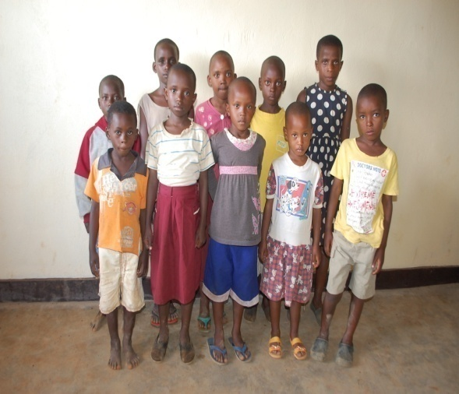
Training on Hygiene pic in front of office / some Children without shoes and other with improper ones.
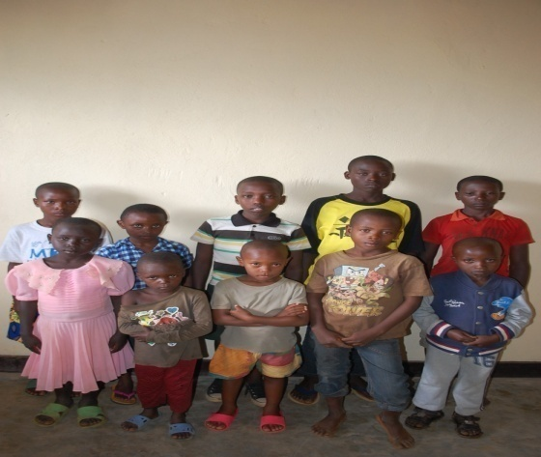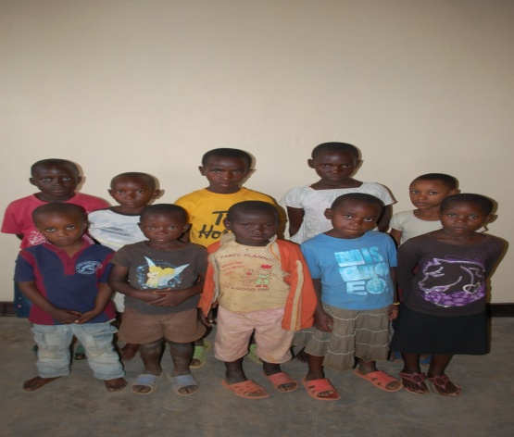
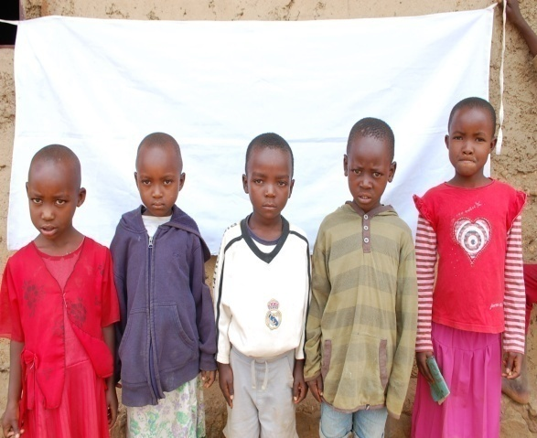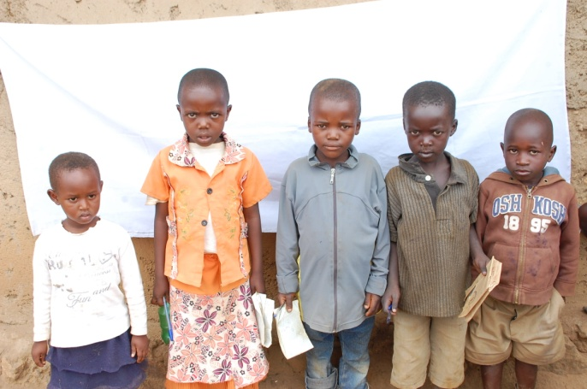
Children are mobilized to perform their home works at home and Education quality analysis based on practices.

3. Challenges:
- Children’s needs are still very high in our zone in Rwanda, A serious basic needs which we are facing is school fees and materials for most of orphans and children from poor families and this highly affect their future, also medical care, clothing and other basic needs.
- Most parents of children from poor families are claiming to be without any capital and knowledge in starting small business which will generate income to change the condition of living and specifically mindset is still a great dilemma.
- There is a great impact of orphans on households and community which requires support from non-governmental and governmental organizations.
- Illiteracy and mindset is still a challenge in most poor families in line of improving live condition and development.
4. Recommendations:

- We, Central Africa Deliverance Ministries (CADM) and other Organizations we should keep on help according to our resources and advocate to other partners to perpetually alleviate Orphan’s needs and vulnerable children towards bright future.
- Strengthening the capacity of families to protect and care for orphans and other children made vulnerable by Genocide, VIH/AIDS and other diseases.
- We, and other interested Organizations we should progressively Train people in different way in line of capacity building which positively affect the condition of living and alleviate the level of poverty.
5. Action plan During Holiday in Rwanda Zone (November and December)
No | Activities | Time/duration | Area
1 | Children Education ( Holiday)  - Follow up Education and visiting children at home  - Monitoring and evaluation  - Price giving and gifts to best performers  - Workshop and training on different topics  - Competition on poem ,song ,speeches ,etc, | November and December | Rusheshe, Karama and Rusororo
2. | Health care  - Testing HIV and other diseases like Tuberculosis  - Feeding children twice per week  - Cancelling workshops  - Hygiene and health workshops including reproduction | November and December | Rusheshe, Karama and Rusororo
3. | Spiritual Life  - Workshop on hope and good behavior  - Sunday schools  - Congregations leaded by children | November and December | Rusheshe, Karama and Rusororo
4. | Entertainment  - Visiting other children Center in Provinces ( Northern and Western )  - Competition and price giving to the best performers.  - Comedy competition | Nov and Dec | Rusheshe, Karama and Rusororo
5. | Capacity building to their formal or informal parents  - Training on grassroots projects and business plan  - Workshop on saving and rural development | Nov and Dec | Rusheshe, Karama and Rusororo

6. Conclusion:
We are so grateful to stand with Hélène H. Oord Ministries International for support our Projects in Rwanda and Eastern Congo and Our Ministry appreciates your great mission and vision over the world in line of supporting different organizations .I would also let you know that our Eastern Representative (Coordinator of Congo Children) is on field in nowadays and we hope to send you a report and action plan supported by current pictures of next month.

With Best Regards,
Pastor Denis Ruhorimbere

