HELENE H OORD MINISTRIES INT'L ELDORET – KENYA, Report .October 2015
Am glad to report that much of the work that we have done in the last 9 months has been very commendable and we thank God for it. This was in line with the UN goals for a sustainable community and Millenium goals. We thank God for the strenght He has endowed us with to go for missions and reach out to vulnerable groups of people, affected by diseases and malnoushed kids.
All this time ,we have been able to go and preach to churches in Western Kenya, Kiminini area, Sikhendu, and Maliki sub countries.
We experienced a lot of Challenges, i.e, communication problems, transport, due to rains and impossible roads. We had visiting friends from America who had come in April to preach at Lukhome churches, a compination of pastors Conferences, and later ,we were able to collect funds to buy Blankets for Widows and Orphans there.
The people assisted were very grateful and are still looking forward to much help, because the need is enormous.
As earlier expressed to you in 2014,we desire to reach to so many vulnerable groups of people, especially Ophans and Widows, but we lack resources to do that. Not many people are willing to invest their resources in seeing people helped. We need your support through ,Worldview Mission and HELENE H OORD MINISTIRS INT'L to help us reach out and meet the goals.
We cannot do it at our own level. We need your effort to sustain this woman of God.
You are a woman of God of integrity and God is using you in this season to help ,NOT ONLY Netherlands, Suriname, or USA, but we need your support, by praying, financial and otherwise to have these done.
As we approach December 2015,we look ahead again in the new year 2016 and beyond with a lot of hope and determination to do more for our community.

Recommendations.
We are recommending to have a vehicle that will help us move about effectively in all regions of Kenya and have funds set up for this mission.
We need your support in these..You are so inspiring and we trust you ,as our Visionary to come help us together with other Stakeholders.
I shall keep updating and sending you more reports by end of December 2015.
God bless and keep you well till then.
Regards.
Pastor Dr Antony Wabuge Wanjala,[Director]
Helene H Oord Ministies Int'l,
Dept Eldoret, Kenya, East Africa.
Em: wabawan7@gmail.com
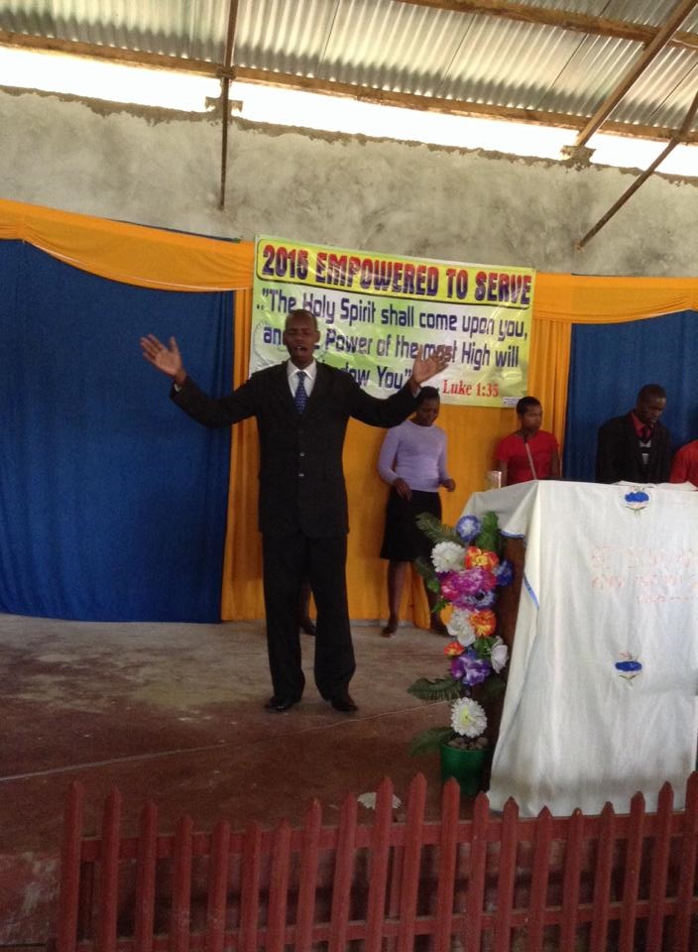

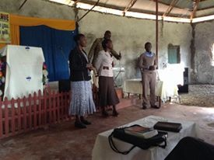

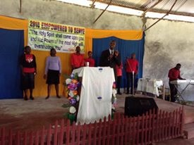

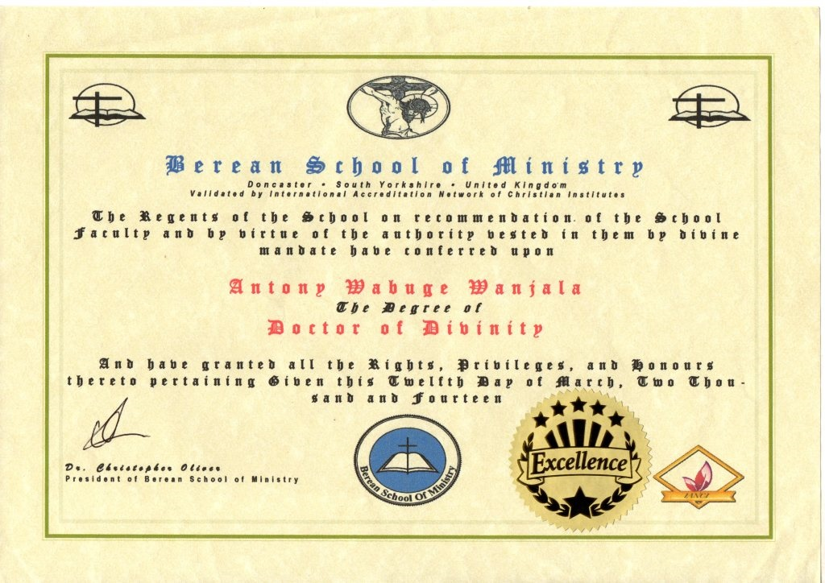

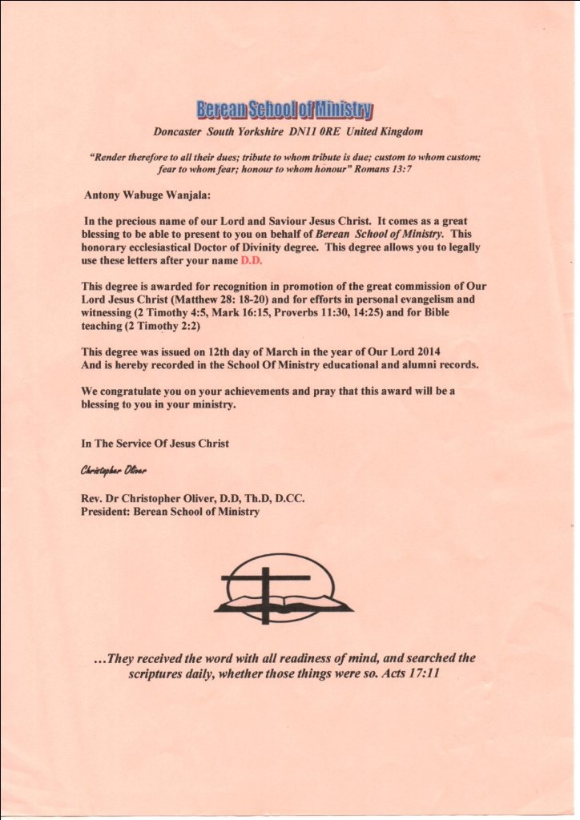

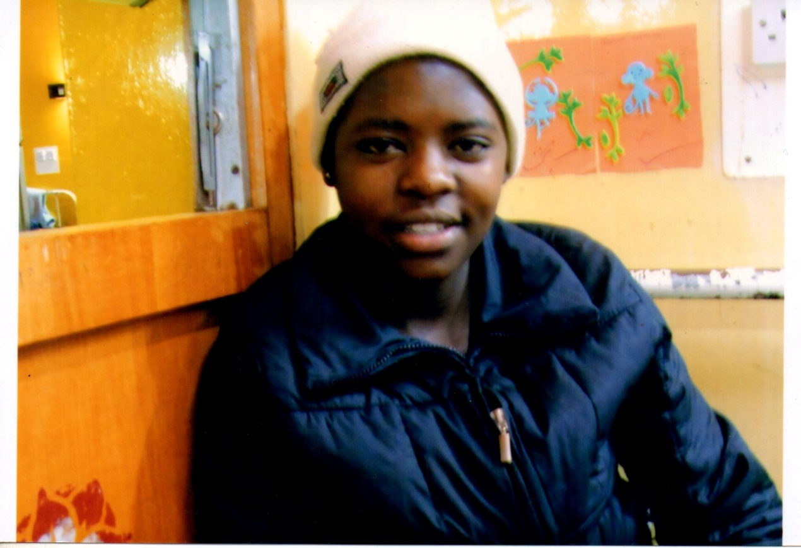

Rev.Helene,

Attached hereon is my daughters photo,the late FAITH NEKESA WANJALA and scanned DOCTORATE DEGREE FROM YORKSHORE,DONCASTER,BEREAN SCHOOL OF MINISTRY,UK.I earned the degree on 20th March 2014.

God bless you and look forward to hear from you soon.

Regards.
Pastor Antony Wabuge Wanjala,Helene H Oord Ministries Kenya Dept.

Rev.Helene,

Urambo city Photos,Dr.Antony at Revival
See below photos of Revival at Urambo.
Regards.
Dr.Antony W Wanjala
"But I do not consider my life of any account as dear to myself, so
that I may finish my course and the ministry which I received from the
Lord Jesus, to testify solemnly of the Gospel of the grace of
God."-Acts 20:24

