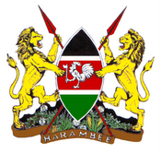

The Ambassador of the Republic of Kenya
H. E. Rose Makena Muchiri,
has the pleasure to invite

…………………………………………………

To the celebration of 51 years of independence of the Republic of Kenya on
Friday 5th December 2014 from 1700-1900 hours

Venue  Worldhotel Bel Air The Hague  Johan de Wittlaan 30  2517 JR The Hague | R. S. V. P.  Regrets only  Tel: 070 3504 215  info@kenyanembassy-nl.com
Please bring card

