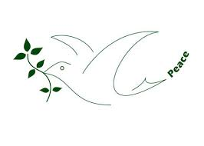

Hello colleagues and friends,
Just a note to wish you all a Happy New Year 2015.
Health and happiness be yours throughout the year.
Let’s join hands in whatever small way we can to bring Peace and peaceful living to all families, communities and nations on this Planet.

Michael Atchia

AFICS-Mauritius
22.12.14

