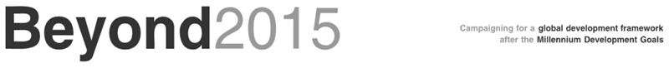

**Beyond 2015 media capacity-building webinar**

**Objective of the webinar:**

To increase the capacity of Beyond 2015 national leads and members to engage with traditional and social media to promote Beyond 2015’s advocacy asks and the post-2015 agenda.

**Date and time: 6 May, 11:30am - 12:40pm Central European Time**

**Agenda:**

11:30am CET: Introduction and welcoming remarks

11:35am CET - 11:55am CET: Engaging with media to promote the post-2015 agenda and the advocacy asks of Beyond 2015

* + *Myron Williams, PIANGO Communications Officer: follow-up on recent Pacific Media dialogues*
  + *Chuck Baclagon, 350.org: sharing of experiences about linking with traditional and social media*

11:55am CET - 12:05pm CET: Q&A, comments

12:05pm CET - 12:15pm CET: Reaching out to populations offline

*Busani Sibindi, Beyond 2015 Focal Point in Zimbabwe, Save Matabeleland Coalition: sharing of experiences and recent presentation on overcoming the Internet divide*

12:15pm CET - 12:20pm CET: Q&A, comments

12:20pm CET - 12:30pm CET: Making sense of big data

*Nick Adie, VSO: the use of infographics to share data on social media*

12:25pm CET - 12:40pm CET: Q&A, wrap-up