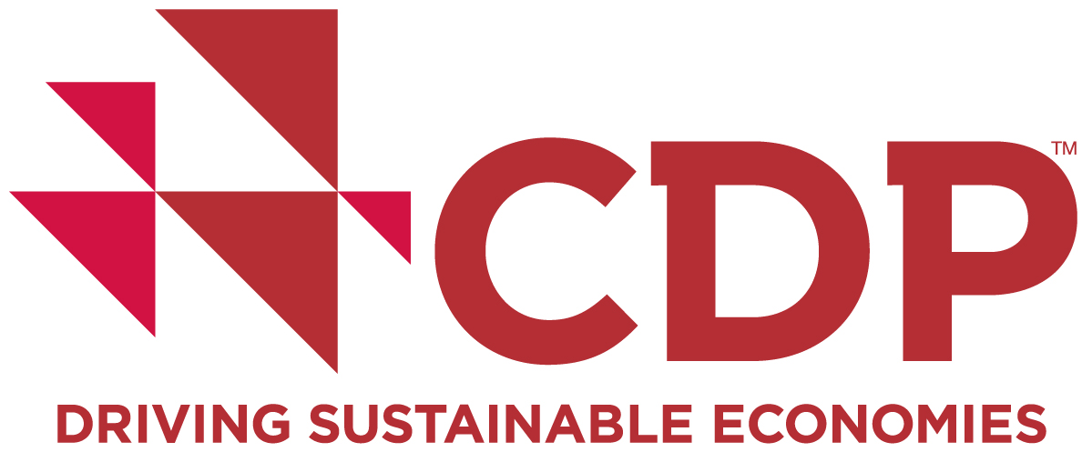

For press information:

CDP: Kharunya Paramaguru // communications executive // + 44 (0) 20 3818 3916 // +44 7798 36 13577

***EMBARGOED UNTIL 08:30 EST/ 13:30 gmt sunday december 6, 2015***

NEW REPORT: CORPORATE momentum on tackling DEFORESTATION AT RISK of stalling

6 December, 2015: Seven in ten companies have commitments to address deforestation yet few are translating these into meaningful actions, reveals new analysis from CDP, the global non-profit which gathers environmental data on behalf of investors.

“Realizing zero-deforestation: Transforming supply chains for the future”, launches today at the Global Landscapes Forum in Paris. The findings suggest there is a widespread understanding of the business case for action, with nearly 90% of companies identifying commercial opportunities from addressing deforestation.

However, without relevant procurement strategies and policies, commitments are not being implemented fast enough. Half (50%) the companies with commitments to source certified soy are yet to get any into their supply chains. For palm oil this is the case for over a quarter (26%) of companies. And while over three quarters (77%) of manufacturers and retailers have standards for sourcing commodities identified as among the largest drivers of deforestation, just over a quarter (26%) provide suppliers with training or workshops on this issue.

CDP’s global forests report 2015 is produced on behalf of 298 investors with US$19 trillion in assets. It analyzes disclosures from 171 of the world’s largest companies – including Cargill, Mars and Unilever – to establish how they are managing four key commodities linked to deforestation: cattle products, palm oil, timber products and soy.

With the vast majority of global deforestation connected to agriculture, these four commodities end up in widely-used products from chocolate to biofuels. Companies are already seeing financial impacts from the production of these commodities, including damage to brand value or higher operating costs from regulatory or reputational risks.

“Realizing zero-deforestation” sets out five steps through which buyers can work with suppliers to bring their commitments to life. The report highlights the approaches companies are taking to address barriers, including:

- Asia Pulp & Paper’s bottom-up approach of giving suppliers the tools to lead on implementing the company’s conservation policy;
- Offering financial support, as Brazilian food processor Marfrig reports doing, to encourage producers to seek certification and pursue sustainable agricultural practices; and
- Working with not just large landowners but also smallholder farmers, as the world’s biggest agricultural trader Cargill is doing, to enable them to reap the benefits of developing sustainable land use and agronomic practices.

Katie McCoy, head of forests at CDP, says: “In an era of climate change, protecting our forests is one of the best things we can do to prevent dangerous global warming. Reaching a climate change agreement in Paris is therefore critical for creating a level playing field for companies already striving to address deforestation. While policymakers have their role to play, companies too must enable suppliers to join their efforts to protect forests. The long-term viability of agricultural production, food security and climate action depend on this.”

Jonas D. Kron, director of shareholder advocacy at Trillium Asset Management, says: “Investors want to understand what management understands: Does management understand their supply chain; does management understand the risks they face related to deforestation and do they understand the risks they’re creating? This is particularly true whenever we talk about agriculture. It’s about that double edged sword: The impact we have on climate change as well as the impact that climate change has on supply chains.”

The report, “Realizing zero-deforestation”, and 2015 results from CDP’s forests program is available here.

Ends

About CDP
CDP is an international, not-for-profit organization providing the only global system for companies and cities to measure, disclose, manage and share vital environmental information. CDP works with market forces, including 822 institutional investors with assets of US$95 trillion, to motivate companies to disclose their impacts on the environment and natural resources and take action to reduce them. CDP now holds the largest collection globally of primary climate change, water and forest risk commodities information and puts these insights at the heart of strategic business, investment and policy decisions. Please visit www.cdp.net or follow us @CDP to find out more.

For media information:

CDP

Kharunya Paramaguru
Communications executive
+ 44 (0) 20 3818 3916
+ 44 (0) 7798 3613577
kharunya.paramaguru@cdp.net

