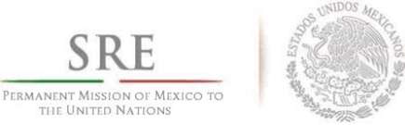
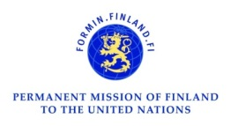
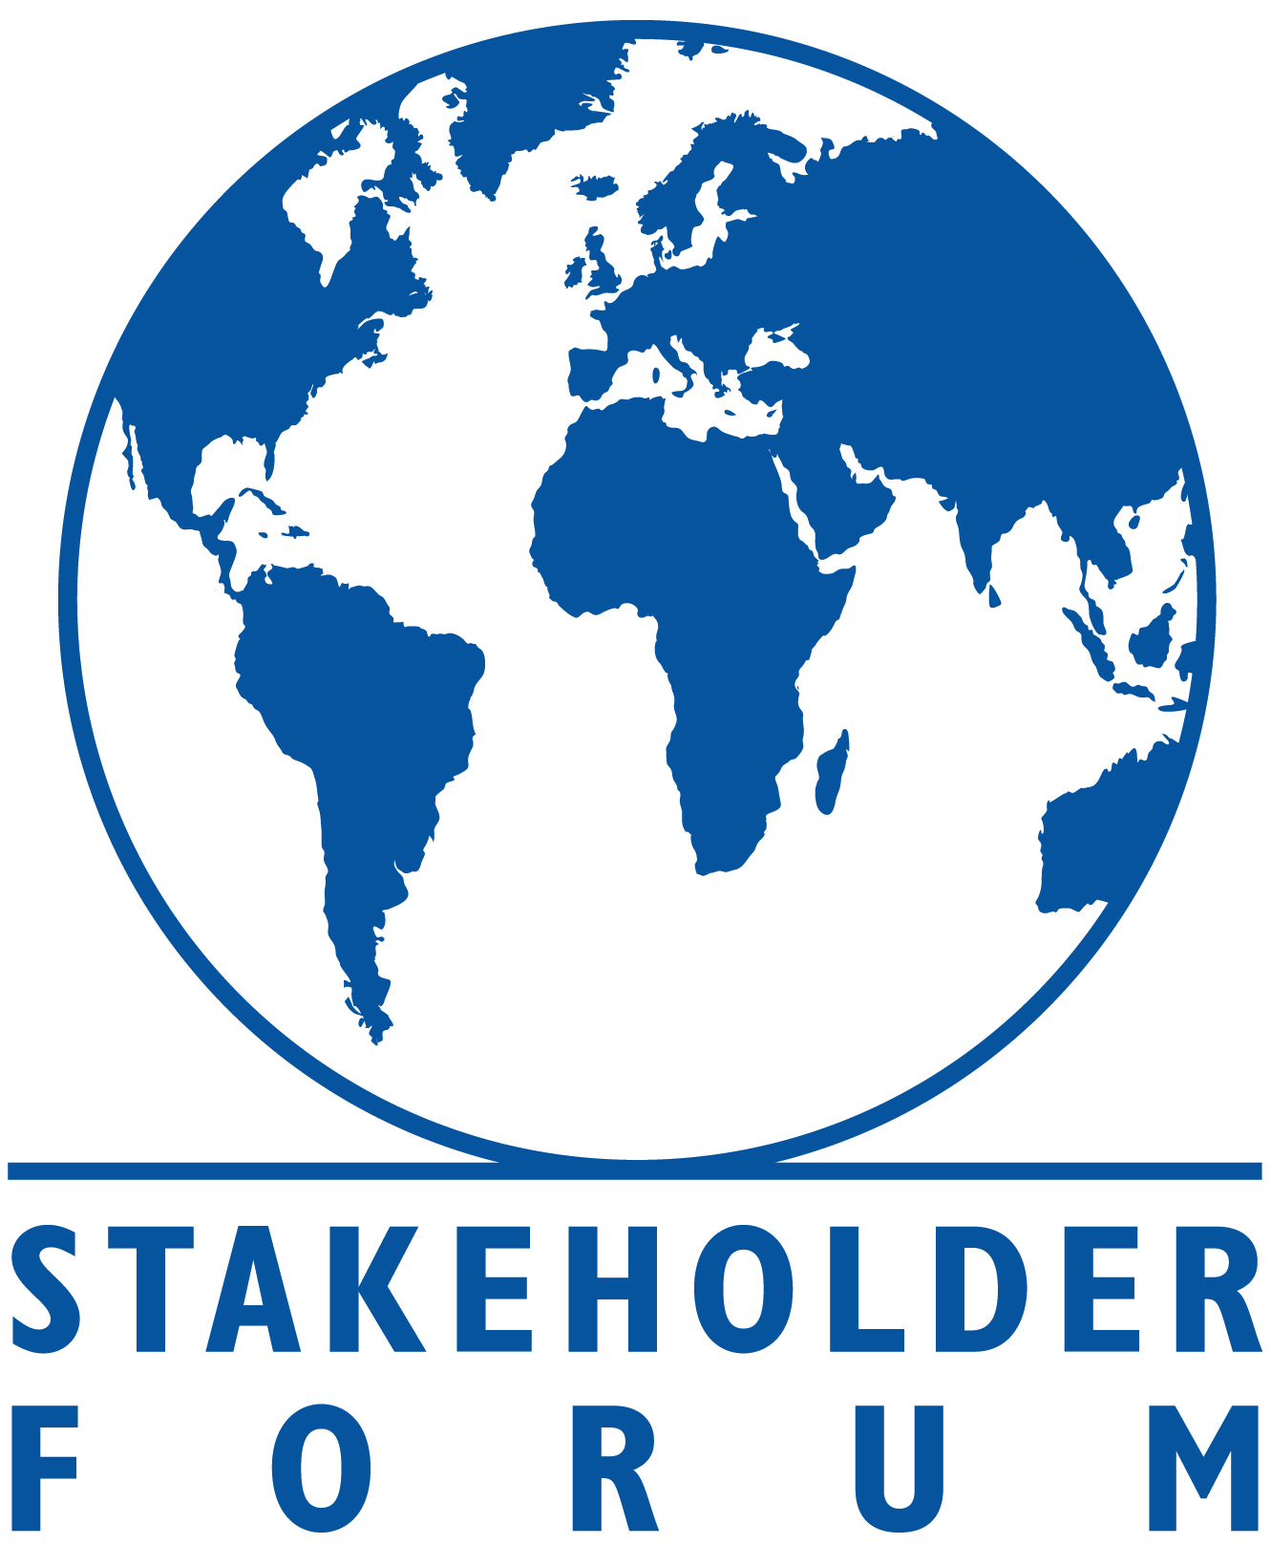
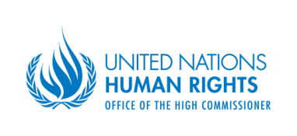
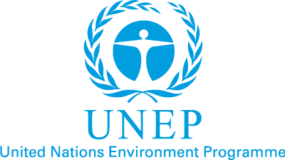
____________________________________________________
SIDE EVENT
Universality and the
Post 2015 Sustainable Development Agenda
June 23rd 2015, 1h15 – 2h45
Conference Room 1 (Conference Building)
In the Post-2015 context, universality implies that all SDGs will apply to all countries. For some, universality also implies overcoming the dichotomy of “developed” and “developing” to see all countries on a continuum. Others see universality as linked to the central message of ‘leaving no one behind’. Some have expressed concern that universality could potentially undermine the focus on the poorest. Given the varying interpretations, it is important to fully understand the concept as it applies to the Post 2015 context – so as to help facilitate consensus towards the Declaration and Outcome of the Post 2015 Agenda to be approved by Heads of State in September 2015.
Co-hosted by Missions of Finland and Mexico, UNEP, OHCHR, and the Stakeholder Forum, this side event will draw on lessons from many years of experience and practical application of the concept of universality in the international human rights and environmental arenas. It will also learn from a recent study by Stakeholder Forum on how the SDGs can be applicable to developed countries. Country representatives will lead a discussion on how a universal agenda can be applied to their countries.
This interactive dialogue is moderated by Ms. Kitty Vander Heijden, and the Panellists will be:
- Ambassador Kai Sauer, Permanent Representative of Finland to the UN

- Dr. Roberto Dondisch Glowinski, Director General for Global Affairs of Mexico

- Mr. Ivan Šimonović, Assistant Secretary General OHCHR

- Mr. Elliott Harris, Assistant Secretary General of UNEP

- Mr. Farooq Ullah, Stakeholder Forum

