[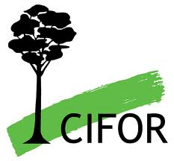](https://www.flickr.com/photos/ilri/4344827617/) 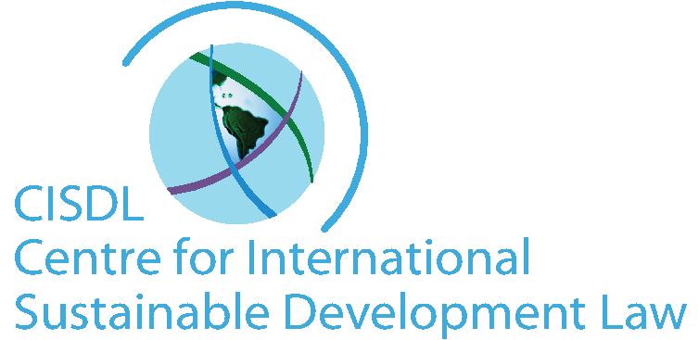 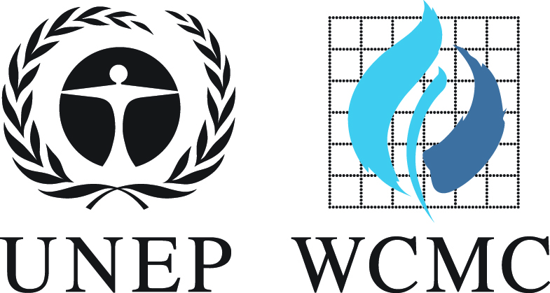

 

 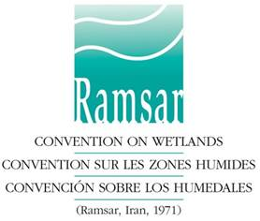







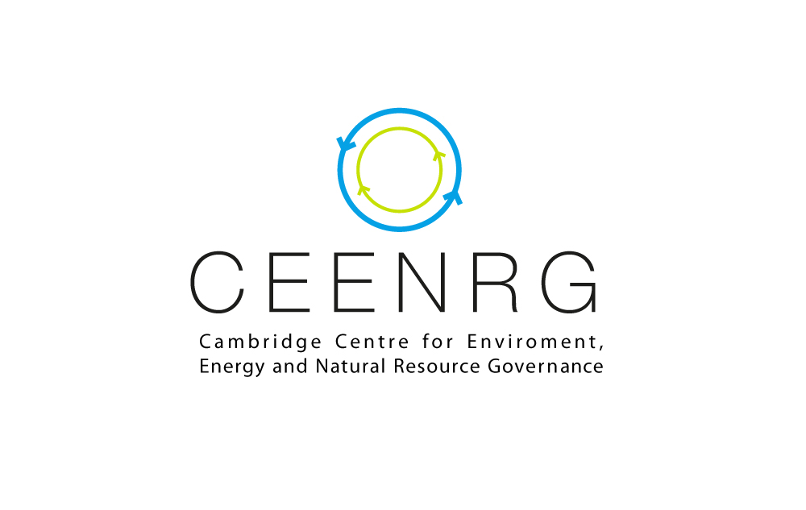

**Biodiversity, Sustainable Development & the Law**

**20–22 February 2015**

**Cambridge, UK**

**FINAL DRAFT PROGRAMME**

**Experts Seminar &**

**International Symposium**

**\* * * \***

[](https://www.flickr.com/photos/ilri/4344827617/)

**DAY 1**

**Friday, 20 February 2015**

**CITES As a Tool for Sustainable Development Experts Seminar**

**&**

**Evening Guest Lecture Event**

**9:00am–9:30am Experts Seminar: CITES As a Tool for Sustainable Development**

**Welcome & Opening Remarks**

**(Hughes Hall Panel, Cambridge)**

**9:30am–12:00pm Expert Peer Review Roundtables I & II**

**(Hughes Hall, Cambridge)**

**12:00–1:00pm Authors Luncheon (Hughes Hall, Cambridge)**

**1:00–5:00pm Expert Peer Review Roundtables III & IV**

**(Hughes Hall, Cambridge)**

**6:00–7:00pm Evening Keynote Lecture Event (Faculty of Law, University of Cambridge)**

**Welcome: Dr Markus Gehring** (University of Cambridge /Lead Counsel, CISDL)

**& Professor Jorge Vinuales** (University of Cambridge /Director, C-EENRG)

**Chair: Dr Marie-Claire Cordonier Segger** (Senior Director, CISDL/Affiliate Fellow, LCIL)

* **Keynote Speaker I: Dr Jon Hutton (Director, UNEP-WCMC)**
* **Keynote Speaker II: Mr John Scanlon (Secretary-General, CITES)**

**7:00–8:00pm Drinks Reception (Faculty of Law, University of Cambridge)**

**DAY 2**

**Saturday, 21 February 2015**

**Biodiversity, Sustainable Development & The Law**

**International Symposium I**

**(St John’s Divinity School, Cambridge)**

**8:30–9:00am Registration**

**9:00–9:30am International Symposium Welcome**

**Dr Markus Gehring** (University of Cambridge / Lead Counsel, CISDL)

**& Dr Jon Hutton** (Director, UNEP-WCMC)

**9:30–10:30am Opening Plenary: Biodiversity Accords & Sustainable Development Goals**

**Chair: Dr Marie-Claire Cordonier Segger** (Senior Director, CISDL)

* **Dr Chris Briggs** (Secretary-General, Ramsar Convention)
* **Mr John Scanlon** (Secretary-General, CITES)
* **Dr Bradnee Chambers** (Secretary-General, CMS)
* **Dr Amy Fraenkel** (Representative of the Executive Secretary & Director, UNCBD)

**10:30–11:00am Tea/Coffee & Refreshments**

**11:00am–12:30pm International Specialist Panels**

1. ***Convention on Migratory Species (CMS) – Legal Innovations & Trends for Sustainable Development***

**Chair: Dr Bradnee Chambers (Secretary-General, CMS)**

* Ms Genevieve Hayes (BirdLife), *Implementing the Migration Hierarchy: Utilizing Multiple Levels of Legislation for Effective Conservation Outcomes*
* Ms Stephanie Forte (CISDL), *Law and Policy Innovations to Implement CMS and CITES across the Caribbean (prov title)*
* Dr Marie Bonnin (Institut de recherche pour le développement), *Contaminants in International Law: Time for New Rules to Implement CMS (prov title)*
* Dr Lia Helena M. L. Demange (University of São Paolo), *Biodiversity Conservation Outside of Protected Areas*

1. ***Ramsar Convention - Legal Innovations & Trends for Sustainable Development***

**Chair: Dr Chris Briggs (Secretary-General, Ramsar Convention)**

* Professor Royal Gardner (Stetson University, Scientific Technical and Review Panel, Ramsar Convention), *Habitat Mitigation Banking in Policy, Law and Practice (prov title)*
* Dr Maria Leichner Reynal (Fundacion Ecos, Uruguay), *Transparency and Participation in* *Landscape Planning of Important Wetlands of Latin America (prov title)*
* Professor Marcel Szabó (Ombudsman for Future Generations, Hungary), *Harmonization of Legal Instruments for Wetlands & Biodiversity Conservation in the EU (prov title)*

1. ***Convention on international Trade in Endangered Species (CITES) – Legal Innovations & Trends for Sustainable Development***

**Chair: Mr John Scanlon (Secretary-General, CITES)**

* Dr Annecoos Wiersema (University of Denver), *Uncertainty, Precaution and Adaptive Management in Wildlife Trade*
* Dr Philip J. K. McGowan (Newcastle University), *Issues and Challenges Limiting the Effectiveness of Wildlife Legislation in West and Central Africa*
* Professor Mohammed Sghir Taleb (Mohammed V University), *Important Plant Areas in Morocco: Importance, Diversity, Threat and Conservation Strategies*

1. ***United Nations Convention on Biological Diversity (CBD) & its Protocols – Legal Innovations & Trends for Sustainability***

**Chair: Dr Amy Fraenkel (Director, CBD)**

* Dr Dimitra Manou (CISDL) & Professor Ilias Kouskouvelis (University of Macedonia), *Legal and Policy Framework for Access and Benefit Sharing of Marine Genetic Resources: Greece’s Experience*
* Professor Simon Marsden (Flinders University), *China and the Third Pole: Asian and Polar Precedents for Effective Biodiversity Conservation*
* Ms Lori Frater (Government of Wales), *Implementation of the Convention on Biological Diversity in Wales*
* Professor Sergio Peña, *Equitableness and Justice in Sharing Benefits, Outcomes from the International Law on Sustainable Development in the CBD*

**12:30–1:30pm Symposium Luncheon & Book Launch**

* **Chair: Dr Marie-Claire Cordonier Segger** (Senior Director, CISDL)
* **Toasts: Professor W.H. Adams** (University of Cambridge) & **Dr Andrew Wardell** (Director, CIFOR)
* Sarah Milne, S Mahanty (eds), ***Conservation and Development in Cambodia: Exploring Frontiers of Change in Nature, State and Society*** (Routledge & Earthscan, 2014)
* Jorge Vinuales (ed), ***The Rio Declaration on Environment and Development***(Oxford University Press, 2015)

**1:30–2:00pm Afternoon Keynotes: Biodiversity & Sustainable Resources Governance**

**Keynote Speaker I:** **Dr Andrew Wardell (Director, CIFOR),** *Governing Forests & Sustainable Landscapes: Challenges & Opportunities*

**Keynote Speaker II: Dr Chris Briggs (Secretary-General, Ramsar),***Accelerating Wise Use of Wetlands and Water for Sustainable Development (prov title)*

**2:00–3:00pm Afternoon Plenary: Synergies for Implementing Biodiversity Treaties**

**Chair: Professor Catherine Redgwell (Professor, University of Oxford)**

* Dr Valerie Hickey (Global Practice Leader, World Bank), *Transnational Legal Means to Prevent Species Loss and Promote Sustainable Development (prov topic)*
* Dr Kala Mulqueeny (Vice-Counsel, Asian Development Bank), *Promoting Access to Justice for Biodiversity Conservation in Asia and Worldwide*
* Professor Jorge Cabrera (Professor, University of Costa Rica / Lead Counsel, CISDL), *Legal Instruments for Integrated Implementation of the Aichi Targets (prov topic)*

**3:00–4:15pm International Expert Panels I**

1. ***Natural Resources Governance for Sustainable Landscapes***

**Chair: Dr Andrew Wardell (Director, CIFOR)**

* Dr Michelle Lim (University of Dundee), *The Role of International Law in Achieving the Sustainable Development Goals: The Gaps, the Barriers and the Future*
* Ms Caroline Haywood (ODI), *Legal Pathways for Low-Carbon Investment in Sustainable Landscapes in Africa*
* Dr Hafijul Islam Kahn & Dr Sharaban Tahura Zaman (Centre for Climate Justice - Bangladesh), *Legal Challenges for Co-management of Natural Resource Management in Bangladesh*
* Dr Ekeoba Matthew Isikhuemen (University of Benin), *Conserving Biodiversity in Protected Landscapes: A Case Study of a Private Sector Funded Community-driven Project in Urhonigbe Forest Reserve, Nigeria*
* Mr Wamba Kamta Galbert (Ministry of Environment, Protection of Nature and Sustainable Development, Cameroon), *Framework for Sustainable Utilization of Mount Cameroon Fore*st

1. ***Conservation, Indigenous and Community Rights & Sustainable Livelihoods***

**Chair: Dr John Hutton (Director, UNEP-WCMC)**

* Dr Annalisa Savaresi (University of Edinburgh), Dr Elisa Morgera (University of Edinburgh), Dr Louisa Parks (University of Lincoln) & Elsa Tsioumani (University of Edinburgh), *Benefit-sharing as a means to operationalise equity in managing protected areas and sustainable landscapes, and ensuring community livelihoods*
* Ms Elizabeth Gitari (WildlifeDirect INC), *Innovation in Conservancy Models that Insure Community Livelihoods while Promoting Wildlife Conservation in Kenya*
* Mr Guy-Jules Kounga (CISDL, Cameroon), *The Ownership of Biodiversity Products in Development Projects in Africa: The Case of the Mbalam Iron Ore Project*
* Dr China Williams (Royal Botanic Gardens, Kew), *ABS, Biodiversity Conservation and Sustainable Use: The Role and Delivery of Non-Monetary Benefits*

1. ***Regulating Endangered Species & Biodiversity Value Chains***

**Chair: Dr Marcos Silva (Chief, CITES Secretariat)**

* Professor Alison Rieser (University of Hawaii), *History, Trade and Extinction: The Debate at CITES Over Cuba’s Endangered Sea Turtles*
* Dr Ngozi Finette Stewart (University of Benin), *International Trade in Endangered Species as a Protocol to the Convention on Biodiversity 1992: Exploring a Practical Path to Sustainable Development*
* Ms Anastasiya Timoshyna (TRAFFIC), *Towards Sustainable Value Chains in Wild Plants Harvested through FairWild Standard*
* Dr Tarun Kathula (UNDP), *Regulation of Import of Hunting Trophies of Exotic Species into India by Framing a Look-Alike Policy to Conserve Indigenous Wildlife Fauna*

**4:15–4:45pm Tea/Coffee & Refreshments**

**4:45–6:00pm International Expert Panels II**

1. ***Biodiversity Science, Policy & Law Interfaces***

**Chair: Dr Bhaskar Vira (University of Cambridge Conservation Research Institute)**

* Dr Henning Grosse Ruse-Khan (University of Cambridge), *Traditional Knowledge Protection in the Nagoya Protocol: A Step Forward for Indigenous Peoples?*
* Dr Luther Rangreji (South Asian University), *GM Crops in India: Tenuous Interface between Science, Policy and the Law*
* Mr Justice O. Derefaka (Shell) & Dr John A. Matt (Shell), *Integrating Marine Biodiversity and Ecosystem Services into Shell Nigeria Exploration and Production Company Ltd (SNPCo) Deepwater Oil and Gas Project Life Cycle: Considerations and Approaches*
* Dr Yaffa Epstein (Uppsala University), Dr Guillaume Chapron (Swedish University of Agricultural Sciences) & Dr José Vicente López-Bao (Oviedo University), *Clarifying Legal Concepts within the Habitats Directive’s Favourable Conservation Status*

1. ***Protected Areas, Public Participation & Access to Justice***

**Chair: Dr Kala Mulqueeny (Vice-Counsel, Asian Development Bank)**

* Mr Erick Kassongo Kalonji (Kinshasa and Mbandaka Bar; CISDL), *Managing Protected Areas, Sustainable Landscapes and Community Livelihoods*
* Professor Adrian Wood (University of Huddersfield), *Wild Coffee Conservation in Ethiopia: Exploring the Potential of Participatory Forest Management*
* Ms Beatriz de Sousa Fernandes (University of Edinburgh), *Beyond National Obligation: Use of Collaborative Efforts for the Conservation of the Hidden Treasures of the Deep Sea*
* Professor Toshinori Tanaka (University of Tokyo), *Governance for the ‘Beyond the Boundary’ Model: The Case of Japan’s National Parks*

1. ***REDD+ & Sustainable Biodiversity Incentives in the Green Economy***

**Chair: Mr Alberto Sandoval (Executive Director, CIDEPP Transversal)**

* Ms Elina Väänänen & Blaise Bodin (UNEP-WCMC), *Operationalizing REDD+ Safeguards through National and Sub-National Legal Frameworks*
* Ms Jessica di Maria & Mr Yves Van Brussel (University of Vienna), *Taxation: A Powerful Tool to Achieve Sustainable Development Goals*
* Professor David Grinlinton (University of Auckland), *Sustainability and Biodiversity in New Zealand: The Use of Biodiversity Offsetting in Mining and Energy Development*
* Dr Warren Lavey (University of Illinois), *Channeling Trillions of Dollars Annually to Conservation?*

**7:30–10:30pm Symposium Dinner: Advancing Biodiversity Governance**

**(Westminster College Dining Hall)**

* **Chair & Keynote:** **Dr Marie-Claire Cordonier Segger** (Senior Director, CISDL) & **Hon Justice Antonio Benjamin** (Supreme Court of Brazil; Chair, IUCN Environmental Law Commission)
* **Launching Event: Professor Jorge Vinuales** (University of Cambridge), *Celebration of the Launch of C-EENRG*
* **Master of Ceremonies: Mr Cameron Miles** (Symposium Coordinator, CISDL)

**Day 3**

**Sunday, 22 February 2015**

**International Symposium II**

**(St John’s Divinity School, Cambridge)**

**9:30–10:00am Registration and Coffee**

**10:00–11:00AM Morning Keynote: Inter-linkages and Implementation**

**Keynote Speaker: Dr Bradnee Chambers (Secretary-General, CMS),** *Advancing Interlinkages and Implementation Migratory Species Habitats and Sustainable Development (prov title)*

**11:00am–12:30pm International Law Specialists Panels**

1. ***Transparency, Participation & Rules of Procedure***

**Chair: Ms Hélène Molinier (Programme Manager, IDLO)**

* Mr Freedom-Kai Phillips (CISDL), *Securing Transparency and Participation through Innovations in Treaty Rules of Procedure*
* Mr Frederic Perron-Welch (CISDL), *Promoting Biodiversity Treaty Negotiations & Implementation for Sustainable Development*
* Dr Denis Ruysschaert (TBC), *Protecting Biodiversity: Innovative Compliance through New Mobilizing Technology Tools to Link Global to Local*

1. ***Biodiversity Monitoring, Reporting & Dispute Rules***

**Chair: Professor Jorge Cabrera (University of Costa Rica)**

* Mr Alberto Sandoval (CIDEPP Transversal), *Governing Monitoring, Reporting and Verification (MRV) for REDD+ Biodiversity Co-Benefits*
* Dr Markus Gehring (University of Cambridge; CISDL), *International Trade and Investment Disputes on Biodiversity*
* Mr Cameron Miles (University of Cambridge; CISDL), *Provisional Measures and the Regulation of the Environment: International Organizations in the Borderlands*

**12:30–1:00pm Tea/Coffee and Refreshments**

**1:00–1:30pm Sunday Afternoon Keynote: Systems and Synergies**

**Keynote Speaker: Dr Elisabeth Mrema (Director, UNEP DELC),** *Promoting Synergies among Conventions on Biodiversity for Sustainable Development (pro title)*

**1:30–2:15pm Future Directions for Biodiversity Treaty Implementation for Sustainable Development – Final Plenary Roundtable**

**Chair: Dr Marie-Claire Cordonier Segger (Senior Director, CISDL)**

* Mr Freedom-Kai Phillip & Mr Frederic Perron-Welch (CISDL), *The Interface of CITES, the CBD and the Nagoya Protocol: Mutually Supportive Implementation at the National Level*
* Professor Marcel Szabó (Ombudsman for Future Generations, Hungary), *Strengthening Regional and National Institutions for the Interests of Future Generations (prov title)*

**2:15–2:13pm Symposium Closing**









[](https://www.flickr.com/photos/ilri/4344827617/)  

 

 

**Open Invitation for Registration**

**Biodiversity, Sustainable Development & the Law**

**International Symposium**

**St. John’s College Divinity School, Cambridge, UK**

**20-22 February, 2015**

**Are you an expert, policy-maker, professional, scholar or student working on law and policy aspects of biodiversity, protected species and sustainable development?**

**Would you contribute to a discussion world-class international conference on key challenges and innovative legal solutions for the implementation of international treaties on biodiversity, species at risk, forests and wetlands?**

The Centre for International Sustainable Development Law (CISDL), in a cooperative partnership with the University of Cambridge Centre for Energy, Environment and Natural Resources Governance (C-EENRG) and Lauterpacht Centre for International Law (LCIL), the UNEP-World Conservation Monitoring Centre (UNEP-WCMC), the Secretariat of the Convention on International Trade in Endangered Species of Wild Fauna and Flora (CITES), the Secretariat of the Ramsar Convention on Wetlands, and the Centre for International Forestry Research (CIFOR), among other partners, is delighted to announce the international symposium *Biodiversity, Sustainable Development and the Law*, to be held at the University of Cambridge, UK, on 20-22 February 2015.

**All interested researchers, academics, students, policy-makers, practitioners and others from law and biodiversity-related fields are invited to register before 15 February 2015 and participate.**

In the 21st century, the scope of biodiversity degradation and loss has reached alarming levels, and the possibilities to achieve sustainable development goals appear terribly remote. Consistent with the growing complexity of international law as a whole, many international treaties and organizations are struggling valiantly to reverse current trends. International treaties on the environment and sustainable development, including the UN Convention on Biological Diversity (CBD), CITES, the Convention on Migratory Species (CMS), the Ramsar Convention on Wetlands and others, can make an important difference. In pursuing this mission, however, international law and governance face many practical challenges, with space for increased support and engagement from the international research and academic community, leading countries and firms, and civil society on many levels. This international conference gathers leaders working to secure biodiversity, sustainable development and the law, to share knowledge, discuss challenges, and develop diverse solutions to common problems.

The Symposium will discuss, among others, the following topics:

* Governing the interface of science, policy and the law
* Managing protected areas, sustainable landscapes and community livelihoods
* Promoting trade, investments and financial incentives
* Regulating biodiversity products along complex value chains
* New trends in transparency, rules of procedure and dispute settlement
* Innovative implementation and compliance on regional, national and local levels
* Law of international organizations and biodiversity treaties

The conference will be preceded by an **International Experts Seminar on CITES as a Tool for Sustainable Development** and a **Keynote Guest Lecture Evening Event** at the Faculty of Law of the University of Cambridge, and will include a special **International Dinner and Research Centre Launching Event in the historic Westminster College Hall of Cambridge**. A registration fee of £20 (exclusive of the Symposium Dinner £36pp) will be payable for the weekend of the conference to cover lunches, hospitality and materials, with waivers for student volunteers.

**Those interested in advance registration for the conference, or in assisting in conference outreach, should email the Conference Coordinators at** [**conference@cisdl.org**](mailto:conference@cisdl.org) **by 15 February 2015. Numbers are limited, so early registration is preferable to avoid disappointment.**