





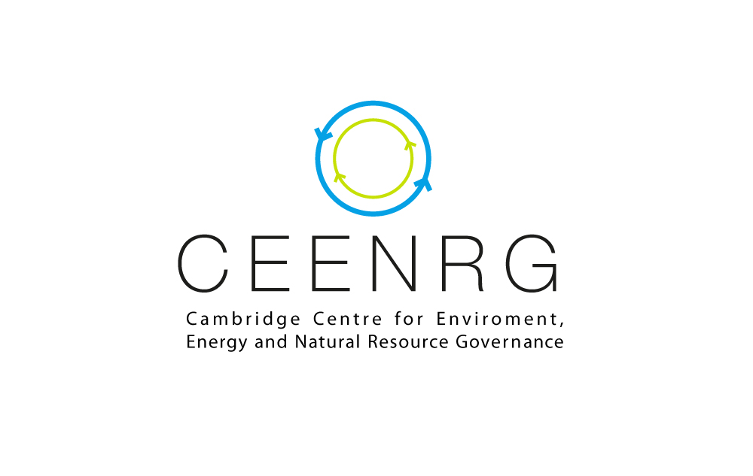

[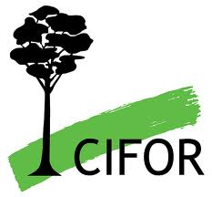](https://www.flickr.com/photos/ilri/4344827617/) 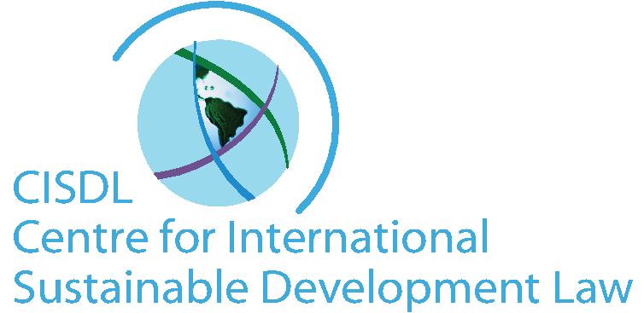 

 

 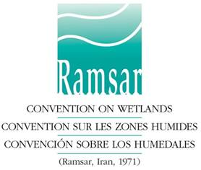

**Open Invitation for Registration**

**Biodiversity, Sustainable Development & the Law**

**International Symposium**

**St. John’s College Divinity School, Cambridge, UK**

**20-22 February, 2015**

**Are you an expert, policy-maker, professional, scholar or student working on law and policy aspects of biodiversity, protected species and sustainable development?**

**Would you contribute to a discussion world-class international conference on key challenges and innovative legal solutions for the implementation of international treaties on biodiversity, species at risk, forests and wetlands?**

The Centre for International Sustainable Development Law (CISDL), in a cooperative partnership with the University of Cambridge Centre for Energy, Environment and Natural Resources Governance (C-EENRG) and Lauterpacht Centre for International Law (LCIL), the UNEP-World Conservation Monitoring Centre (UNEP-WCMC), the Secretariat of the Convention on International Trade in Endangered Species of Wild Fauna and Flora (CITES), the Secretariat of the Ramsar Convention on Wetlands, and the Centre for International Forestry Research (CIFOR), among other partners, is delighted to announce the international symposium *Biodiversity, Sustainable Development and the Law*, to be held at the University of Cambridge, UK, on 20-22 February 2015.

**All interested researchers, academics, students, policy-makers, practitioners and others from law and biodiversity-related fields are invited to register before 15 February 2015 and participate.**

In the 21st century, the scope of biodiversity degradation and loss has reached alarming levels, and the possibilities to achieve sustainable development goals appear terribly remote. Consistent with the growing complexity of international law as a whole, many international treaties and organizations are struggling valiantly to reverse current trends. International treaties on the environment and sustainable development, including the UN Convention on Biological Diversity (CBD), CITES, the Convention on Migratory Species (CMS), the Ramsar Convention on Wetlands and others, can make an important difference. In pursuing this mission, however, international law and governance face many practical challenges, with space for increased support and engagement from the international research and academic community, leading countries and firms, and civil society on many levels. This international conference gathers leaders working to secure biodiversity, sustainable development and the law, to share knowledge, discuss challenges, and develop diverse solutions to common problems.

The Symposium will discuss, among others, the following topics:

* Governing the interface of science, policy and the law
* Managing protected areas, sustainable landscapes and community livelihoods
* Promoting trade, investments and financial incentives
* Regulating biodiversity products along complex value chains
* New trends in transparency, rules of procedure and dispute settlement
* Innovative implementation and compliance of biodiversity treaties on regional, national and local levels
* Law of international organizations and biodiversity treaties

The conference will be preceded by an **International Experts Seminar on CITES as a Tool for Sustainable Development** and a **Keynote Guest Lecture Evening Event** at the Faculty of Law of the University of Cambridge, and will include a special **International Dinner and Research Centre Launching Event in the historic Westminster College Hall of Cambridge**. A registration fee of £20 (exclusive of the Symposium Dinner £36pp) will be payable for the weekend of the conference to cover lunches, hospitality and materials, with waivers for student volunteers.

**Those interested in advance registration for the conference, or in assisting in conference outreach, should email the Conference Coordinators at** [**conference@cisdl.org**](mailto:conference@cisdl.org) **by 15 February 2015. Numbers are limited, so early registration is preferable to avoid disappointment.**