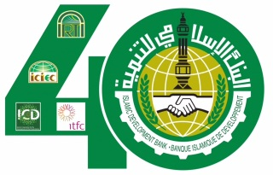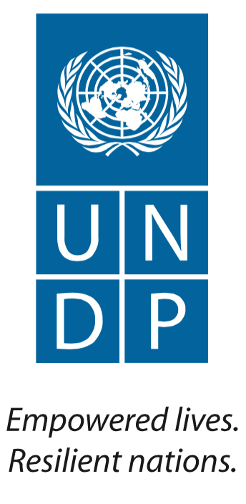

Save the Date

Side Event: “Role of Islamic Finance in Implementing the Sustainable Development Goals (SDGs)”

Hosted by the Islamic Development Bank (IsDB) in collaboration with the United Nations Development Programme (UNDP)

10 am – 12 pm
Saturday, 26 September 2015
Conference Room 2, UN Secretariat, New York
The United Nations Sustainable Development Summit

Achieving the SDGs will require the international community to unlock substantial new sources of public and private financing. Islamic financial instruments are well suited to address and finance the implementation of many of the SDGs, as they seek to promote social, economic and financial inclusion of the poor and the underserved. With its emphasis on risk-sharing and asset-backed financing, Islamic finance can provide long-term financing solutions to social and economic development through a wide range of financial products including Sukuk (i.e. Islamic bonds) and social welfare tools including awqaf.

The objectives of the side-event are to: i) explain the concept of Islamic Finance with special emphasis on how it balances rewards and risks in a fair and transparent manner, and how it links finance with the real economy; and ii) discuss how various components/instruments of Islamic Finance could be a transformative force for unlocking resources to finance the SDGs. A panel of experts from the Government of Turkey and Benin, UNESCAP, the World Bank, the IsDB and UNDP will present, followed by discussion in the plenary. An agenda will be circulated prior to the event.

RSVP
e-mail: aismail@oicun.org

