United Nations 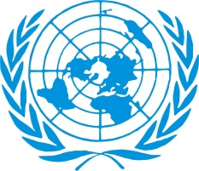 Nations Unies
New York, USA

Office of the President of the General Assembly

~ Save the Date ~

United Nations High Level Forum on The Culture of Peace

Tuesday, 9 September 2014 from 10.00am - 6.00pm

Trusteeship Council Chamber, UN Headquarters, New York

This day-long General Assembly High Level Forum is an open public opportunity for UN Member States, UN system entities, civil society including NGOs, media, private sector and other interested stakeholders to discuss ways and means to promote the Culture of Peace. Special focus will be on the implementation of the UN Programme of Action on Culture of Peace adopted by the UN General Assembly in l999.

Convened by H.E. Mr. John W. Ashe, the President of the 68th Session of the General Assembly, the Forum will have an opening ceremony where the President and the Secretary-General will speak. This is to be followed by a keynote speaker and a general debate. The Forum will feature two panel discussions on: "The role and contributions of women and youth to the Culture of Peace" and "Global citizenship as a pathway to the Culture of Peace”. The programme will finish with a closing session in which the Deputy Secretary-General will join the President to speak.

You are cordially invited to attend and join in the panel discussions.

FURTHER DETAILS WILL FOLLOW.

