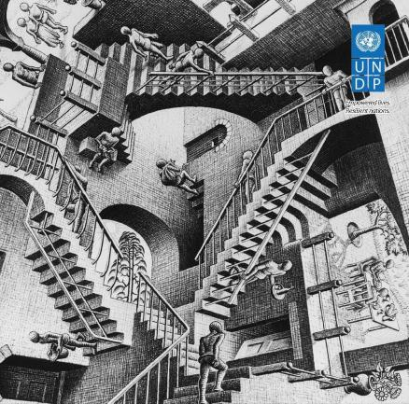
HUMANITY DIVIDED: Confronting Inequality in Developing Countries
You are invited to watch and participate in the launch of the report "Humanity Divided: Confronting Inequality in Developing Countries”.

Wednesday, 29 January 2014 11h00 – 14h00

You are Invited Pit la feu feum ip eugait, con velit dolestie tisi.obeu feum ip eugaitortie di eugait pit, vulla commodiat.

18 January 2010

5:30pm

555 5th Row, New York, NY
The report will be launched by Ms. Helen Clark, UNDP Administrator. The launch event will be chaired by Mr. Magdy Martinez-Soliman, Director a.i.of the Bureau for Development Policy, w the participation of H.E. Ambassador Antonio de Aguiar Patriota, Permanent Representative of Brazil to the United Nations, H.E. Ambassador Csaba Körösi, Permanent Representative of Hungary to the United Nations and H.E. Ambassador Asoke Kumar Mukerji, Permanent Representative of India to the United Nations. A panel discussion with the authors of the report will follow.
The Report revisits the theoretical concepts of inequalities, analyzes global trends, presents the policy makers’ perception of inequalities in 15 countries and identifies various policy options in combating this major development challenge of our time. The Report makes the point that in spite of the impressive progress humanity has made on many fronts over the decades, it still remains deeply divided. In that context, the Report is intended to help development actors, citizens, and policy makers contribute to global dialogues and initiate conversations in their own countries about the drivers and extent of inequalities, their impact, and the ways in which they can be curbed.

Please join us virtually on UStream at: http://www.ustream.tv/channel/17023744

