Netherland’s , December 8th, 2013
The South African Embassy 210 Florence Ribeiro / Queen Wilhelmina Avenue, Cnr Muckleneuk Street
Wassenaarseweg 40 0181 New Muckleneuk
2596 CJ , The Hague Pretoria
Netherlands Telefoon +27 (0)12-425 4500
Email: info@zuidafrika.nl Email: rso-zaf-ca@minbuza.nl

Condoleances 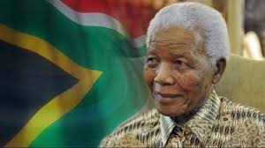
Dear, Mr Peter Goosen, Ambassador (NL)
(cc) Mrs. Anna-Maria Jojozi, Counsellor Bilateral (NL)
Letter to the family of Nelson Mandela, Government of South Africa leaders of the World & Friends.
On behalf of the board of directors, “Worldview Mission”,we want to extend our condoleances and send our deepest sympathy. It brings back difficult memories. We will keep praying for the Nation, sending you much love and light. “GOD BLESS AFRICA”
In some ways, loosing somebody can be difficult, and we know, no one understands this kind of grief.
Please accept our sympathy and good wishes. Revelation 21.1-7

With Deepest Sympathy of Worldview Mission RR’s, CR’s with his Board of Directors,
Statements made by:
- The New York Thimes: “Our nation has lost its greatest son,”

- The Life of Nelson Mandela, 1918-2013”

Yours trully,

Worldview Mission (WM)
Chair & Founder
Ms. HÉLÈNE H. OORD
PR-Media - Int’l Relations Liaison to the United Nations
Mob: +31 (0) 636108563 / Phn/Fax +31 (0) 107857863

Do not stand on my grave and weep;
I am not there. I do not sleep.
I am a thousand winds that blow.
I am the diamond's glint on snow.
I am the sunlight on ripened grain.
I am the gentle autumn's rain.
When you awaken in the morning's hush,
I am the swift uplifting rush of quiet birds in circled flight.
I am the soft stars that shine at night.
Do not stand at my grave and cry;
I am not there. I did not die

http://www.nytimes.com/video/world/africa/100000002467609/documenting-a-massacre.html

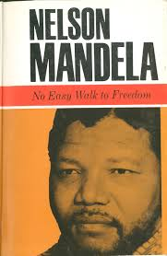
http://www.southafrica.info/
“I WOULD LIKE IT TO SAID THAT HERE LIES A MAN THAT HAVE DONE HIS DUTY ON EARTH” “ That’s All ”
“GOD Bless Africa”
https://docs.google.com/document/d/1WnVMjP1sjAtyNNaBx3tuXb4AIhK5Vy5aY5SL7siQNjc/pub

