***From:*** *Dr Michael ATCHIA [mailto:mklatchia@intnet.mu]*   
  
Seasons Greetings

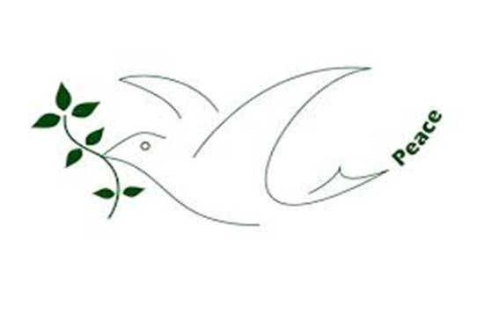

Hello colleagues and friends,

The planet moveth constructively ahead with COP 21, with the 17 UN Sustainable Development goals and the thousands of local initiatives in favour of ecological life-styles. Unfortunately, like never before, dark forces with the unwitting help of modern technology have led us from crisis to crisis, back to the dark ages of killing other humans for no reason, just sectoral. Yet we, all nations of this Planet, have adopted the Universal Declaration of HUMAN RIGHTS which states under its first Article “All human beings are born free and equal in dignity and rights. They are endowed with reason and conscience and should act towards one another in a spirit of brotherhood”

Just a note to share with you the hope of Christmas and wish you all a ***Happy New Year 2016.***

Health and happiness be yours throughout the year. Let’s join hands in whatever small way we can to bring ***Peace and peaceful living*** to all families, communities and nations on this Planet.

Michael Atchia

AFICS-Mauritius , DWM

22.12.15