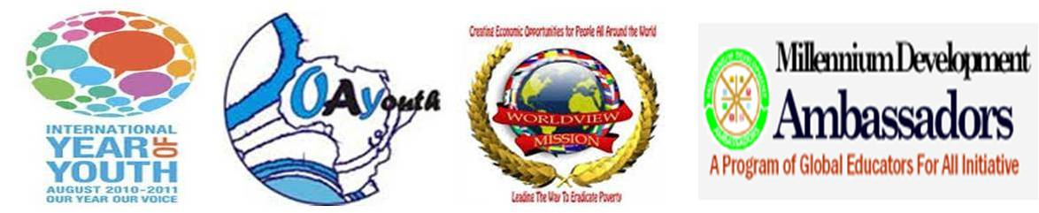

Youth Millennium Development Ambassadors Initiative Sierra Leone
15 A Main Motor Road,
Freetown Sierra Leone
Tel: +23278442956
Email: isslcouncil2@gmail.com

The Global Alliance for Climate-Smart Agriculture

Dear Sir,

Expression of Interest in becoming a member of the Global Alliance for Climate-Smart Agriculture in Sierra Leone
The Youth Millennium Development Ambassadors initiative (YMDAs) is a global network of youth leaders dedicated to facilitating and championing the realization of the Millennium Development Goals locally by connecting to information, colleagues, and resources worldwide in local communities.
1. YMDAs cultivate the right and desired attitude toward community development.
2. YMDAs acquire the capacity to serve as facilitators of global development.
3. YMDAs have the resources and tools to drive the desire for development and pledge their commitment to advance the realization of the MDGs.
Our Objectives Seek To Achieve
We Support the UN Millennium Declaration and promote the localization of the MDGs to the individual and family levels. Encourage the implementation of the MDGs across all traditional borders of religion, political affiliation, social status, race, ethnicity, nationality, etc. Promote the fundamental principles and values essential to international relations in the 21st century and Contribute towards the realization of world peace and the achievement of the UN.
As a youth serving organization promoting the MDG in local communities in Sierra Leone we have also been working in partnership with INGO and local NGOs such as Worldview Mission, Global Educators for All Initiative, Millennium Development Ambassadors Council, National Youth Commission Republic of Sierra Leone, and the District Youth Councils.
As a way to end poverty in Africa and the global by 2050, we will like to join The Global Alliance for Climate-Smart Agriculture in promoting it vision for Sustainable development agricultural initiatives and youth involvement and engagements opportunities.

As we are aware that the Alliance seeks to improve people’s food security and nutrition in the face of climate change. As MDG Ambassadors we’ll like to join the Alliance to help governments, farmers, scientists, businesses, and civil society, as well as regional unions and international organizations, to adjust agricultural, forestry and fisheries practices, food systems and social policies so that they better take account of climate change and the efficient use of natural resources. We will like to join Members working toward sustainable increases in the productivity of food systems, by a sustainable management of natural resources – including soil, water and biodiversity, the adaptation of people’s livelihoods that are threatened by climate change, and agricultural practices that contribute to reduced emissions and less deforestation/land degradation as a result of agriculture. As Ambassadors we support the Global Alliance in enabling governments and other stakeholders to make these transformations in ways that bridge traditional sectoral, organizational and public/private boundaries.

The Global Alliance for Climate-Smart Agriculture is an opportunity to engage our young people of Sierra Leone in a sustainable agricultural initiative that create self sustained development and environmental growth.
We kindly look forward to your response as soon as possible
Yours sincerely,
Amb. Paul Lengar
Country Coordinator
Youth Millennium Development Ambassadors Initiative
Sierra Leone
Tel: +23278442956
Email: isslcouncil2@gmail.com
Web. www.mdgambassadors.org

CR- Worldview Mission Sierra Leone
Email: paullengar@worldviewmission.nl

