#### *NGO-Member of Economic & Social Counsel to the United Nations.*

*Enhancing the World one Child and one Senior at a time, from “Start to Finish”.*

*New York, January, 2011*

*The* *purpose of this document is to provide a letter of engagement for Ms. Hélène H. Oord to conduct work relating to developing relationships on behalf of the organization. The effective dates of service for Ms. Hélène H. Oord for Project One shall commence on January 15, 2011 thru April 15, 2011, and shall be renewable only in writhing by Dr. James S. Moore, President Project One. This letter serves as an official appointment for Ms. Helene Oord represent as an Ambassador at the United Nations Headquarters in New York City.*

*Ms. Oord will be contacting various Diplomats, Ambassadors, and department personnel within the United Nations system and will be governed by its’ regulations pertaining to NGO accessibility and by the bylaws of Project ONE, Inc. Ms. Oord has been entrusted with a NGO grounds pass as a representative of Project ONE, Inc.*

*Ms. Oord has been commissioned to represent Dr. J. Scott Moore providing his approval in matters pertaining to booking appointments, speaking engagements, research of NGO’s privileges and possibilities, attending select meetings, and developing networks of like-minded NGO’s for possible partnership in achieving the Millennium Development Goals of the United Nations through DESA.*

*Project One Inc. is complying with the 8 major Millennium Goals, the MDGL’s statements of General Secretary Ban Ki-Moon, of the United Nations to reduce the poverty by 2015.*

[](http://www.undp.org/mdg/goal1.shtml) [](http://www.undp.org/mdg/goal2.shtml) [](http://www.undp.org/mdg/goal3.shtml) [](http://www.undp.org/mdg/goal4.shtml) [](http://www.undp.org/mdg/goal5.shtml) [](http://www.undp.org/mdg/goal6.shtml) [](http://www.undp.org/mdg/goal7.shtml)  [http://www.un-eu.org](http://www.un-eu.org/)

*Sincerely yours,*

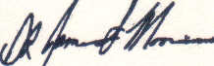

*Dr. J. Scott Moore*

*President/CEO*

*Project One Inc, UN/NGO with UN/ECOSOC Status*



*Project one* ***™***  *Inc 244 / 5th Ave./Suit 1544 / New York/NY 10001-7604 / Phone: (866)298-1108 /**Fax: (205) 424-8608 President/CEO: Dr. J. Scott Moore*

*Hélène H. Oord / Ambassador to Project One Inc. to the United Nations/ (917) 362-6748* [*worldview.mission@gmail.com*](mailto:worldview.mission@gmail.com)

**™**

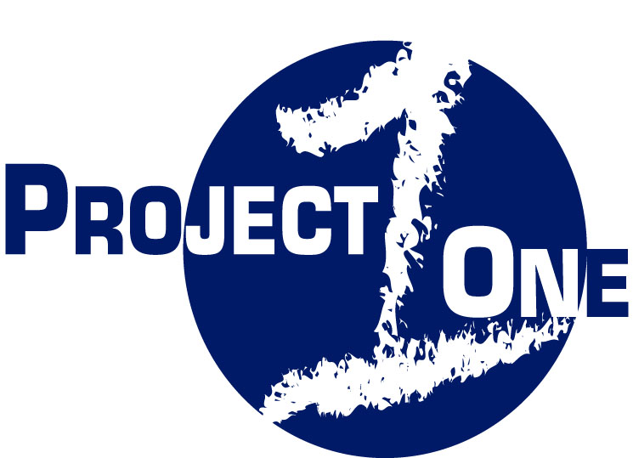

*“Enhancing the world one child and one senior at a time, from start to finish.”*