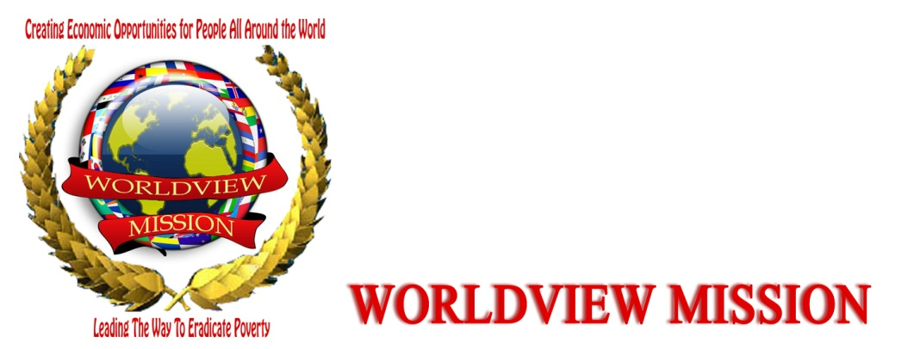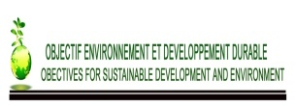
Name of Contact Person: MBUYI LUKUSA DANNY
Title: EXECUTIVE DIRECTOR
Address: Quartier Himbi1, avenue de la paix numero 10 City: Goma State/Province: North-Kivu
Postal Code: +243 Country: DEMOCRATIC REPUBLIC OF CONGO
Web Site : Telephone : +243 992034976
FAX Email : mbuyilukusadanny@gmail.com , ong_oed@yahoo.com

PROJECT PROPOSAL
WORKSHOP OF CAPACITY OF LOCAL ACTORS EASTERN ON REDUCING EMISSIONS OF GREENHOUSE GAS AND OTHER FUELS TO ZERO Fossils

I.CONTEXTE
Annual emissions of the DRC from deforestation and forest degradation neighboring 300mt, CO2 for deforestation rate of about 0.3% per year. Forest, precious capital and a major asset to the DRC with 145Mha forests, the DRC has 10% of global tropical forests. The Congolese forest stores about 40 Gt carbon equivalent 140Gt about potential CO2 emissions, approximately three years combined global emissions.
The main contributors to emissions of greenhouse gases in the DRC factors are twofold. It is direct and underlying causes. Direct causes are cited : The slash and burn agriculture, artisanal logging, charcoal / wood and energy wood, mining, wildfire. Among the underlying causes are listed : Population growth, institutional, infrastructure and urbanization, economic aspects (economic crisis and unemployment and poverty).
Meanwhile, more and more, there is an increasing population pressure becomes a problem in cities with 47% of the population congolese that focuses on 10% of the territory. Faced with the progressive loss of biodiversity, the DRC has built a network of protected over 9% of its territory areas. Several endemic and rare species are protected. These areas are, however, plagued by destruction caused by the intrusion of individuals on the area of the park (Virunga National Park) through hunting, poaching and agriculture claiming logging rights. This degradation is also a serious problem , The Congolese Institute for the Conservation of Nature (ICCN) has also taken special measures to deal with this situation.
When the forest disappears, men, women, children, flora and fauna are at risk. Or Congolese forests represent 60% of the great Basin Forest and is a huge reservoir of biodiversity : 400 species of mammals (Okapi bonobos, chimpanzees and last mountain gorillas ....) Forests also guarantee us that water is a source of life and food, because plants transpire and participate in the water cycle. T he ​​roots bind the soil, give way to the water. T he ​​leaves provide shade and also humus when they rot on the ground. T he ​​rains born of perspiration forests make agriculture possible and feed the river level and rivers.
Nearly 87% of households Congolese use wood as an energy source, unaware that this practice is harmful to the environment and contributes to global warming.
Forests capture the Carbon, the global warming gas, and therefore, burning releases the stored carbon because once the slash and burn shifting cultivation had little impact on the environment, because population in the region was smaller. Currently 20% of global CO2 is produced by this type of agriculture.
With the growing population, cities that extend, needs charcoal continue to grow and the search for new land clear. After two or three harvests, these lands s' already depleted, it must then still clear a new portion, which releases carbon into the atmosphere.
It is important to note that if the presence of gas in Lake Kivu is a hope of raising the standard of living for people nearby, it is a terrible short-term threat. Indeed, in addition to methane gas, the lake contains carbon dioxide in the deep strata. The high pressure keeps the gas dissolved 2. But these gases accumulating in the action of fermentation, they will one day soon to saturation. Bubbles form and then ascend to the surface. In doing so they will cause a mixing of deep waters and the appearance of other bubbles of methane and carbon dioxide and this will be the beginning of a chain reaction like that occurring at the opening of a bottle champagne. Huge quantities of gas ascend to the surface. Methane is lighter than air, will be lost to the atmosphere without further damage directly. Carbon dioxide, however, heavier than air, so will flow around the lake, suffocating the surrounding populations. This phenomenon occurred in Cameroon in the night of August 21, 1986 around Lake Nyos suffocating more than 1,800 people, not counting the cattle, and over a radius of 30km. When you know that Lake Kivu contains more than a thousand times more carbon dioxide than Lake Nyos, we realize the magnitude of the catastrophe that threatens the city of Goma, Gisenyi, Bukavu, Cyangugu or Bujumbura. The consequences would be cataclysmic.
For all these reasons, it is high time that the state is considering to be for the benefit of rural people to live peacefully around the Great Lakes, while ensuring an important part of our independence in energy by exploiting methane resources of Lake Kivu.
However, the situation could quickly evolve and take on the appearance of a disaster if nothing is done, where the necessity to involve local actors share a different trends in this campaign that s' proved a great importance for the risks limit emissions of greenhouse gas emissions and other fossil fuels, (oil, coal, ...), deforestation, illegal exploitation of forest wood, famine, poaching, disease, and also prepare these players strengthens capacity to be unifying with their laps breasts in their communities to engage discussions direct with existing policies on the issue of optical emissions.
II. AIM GLOBAL
Contribute to reducing emissions to zero and the use of other fossil fuels by 2015.
I II. SPECIFIC OBJECTIVES
- Organize workshops to discuss and reflect on the reduction of emissions ;
- Animate subjects on reducing emissions and the use of other fossil fuels.
IV. ACTIVITIES
- Organize a day of restitution about WM mission, objectives and other;
- Strengthen capacity by local actors on reducing greenhouse gas emissions to zero and other fossil fuels
- Sensitize and mobilize local actors on reducing greenhouse gas emissions to zero and other fossil fuels
- Produce a report on all the results obtained during the workshop
- To follow up the recommendations of the workshop to be performed by actors strengthened capacity within their communities
THEMES TO DEVELOP CFR SCHEDULE OF ACTIVITIES
How to reduce emissions to zero (with a sub-theme developing) ;
The consequences of deforestation (to be developed with sub-themes) ;
Importance of using renewable energy (to be developed with sub-themes).
V.BENEFICIAIRES PROJECT
This project will directly benefit local actors and indirectly in the local community in the eastern region of the DRC.
V. EXPECTED RESULTS
- 50 local actors, including 20 women and 30hommes strengthened capacity on reducing greenhouse gas and other fossil fuels campaign.
- Number of people sensitized and mobilized to fight the campaign against global warming
IMPACTS
Stakeholders and local communities in the eastern region of the DRC, motivated, involved and engaged in the campaign in the fight against greenhouse gas and other fossil fuels

Danny MBUYI
> Country Rep Member of Worldview Mission in DR Congo
> Executive Director of OBJECTIVES FOR SUSTAINABLE DEVELOPMENT AND
> ENVIRONMENT
> Member of Global Young Greens International
> Member of SUSANA NETWORK
> Member of BUTTERFLY EFFECT
> Volunteer Outreach Team Leader, (DRCongo)
> UNCSD Major Group for Children and Youth/RIO+20
> National coordinator of Global Music Youth Contest/Glocha. IAAI, partner
> of Road to RIO+20
> partner of Peace Child international, Road to RIO+20
> Goma/RDC
> ong_oed@yahoo.com
> mbuyilukusadanny@yahoo.fr
> +243 992034976
> skype: danny.mbuyi3
> facebook: dannylukusa
>
> 2013/8/14, Danny mbuyi lukusa <mbuyilukusadanny@gmail.com

