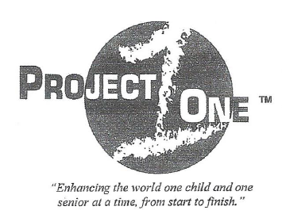
NGO-Member of Economic & Social Counsel to the United Nations.

New York, January, 2015
The purpose of this document is to provide a letter of engagement for Ms. Hélène H. Oord to conduct work relating to developing relationships on behalf of the organization. This letter serves as official authority for Ms. Hélène H. Oord, appointed as an Ambassador to represent Project ONE, Inc. in matters regarding the United Nations at the United Nations and at the United Nations Headquarters in New York City.
Ms. Oord will be contacting various Diplomats, Ambassadors, and department personnel within the United Nations system and will be governed by its’ regulations pertaining to NGO accessibility and by the bylaws of Project ONE, Inc. Ms. Oord has been entrusted with an NGO grounds pass as a representative of Project ONE, Inc.
Ms. Oord has been commissioned to represent Dr. J. Scott Moore in matters pertaining to booking appointments, speaking engagements, research of NGO’s privileges and possibilities, attending select meetings, and developing networks of like-minded NGO’s for possible partnership in achieving the Millennium Development Goals of the United Nations through DESA.
Project One Inc. is complying with the 8 major Millennium Goals, the MDGL’s statements of General Secretary Ban Ki-Moon, of the United Nations to reduce the poverty by 2015.

President & CEO/Project One Inc.
Dr. James S. Moore
