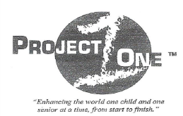

#### *NGO-Member of Economic & Social Counsel to the United Nations.*

*Enhancing the World one Child and one Senior at a time, from “Start to Finish”.*

#### *NGO-Member of Economic & Social Counsel to the United Nations.*

*New York, January, 2016,*

*The* *purpose of this document is to provide a letter of engagement for Ms. Hélène H. Oord to conduct work relating to developing relationships on behalf of the organization. This letter serves as official authority for Ms. Hélène H. Oord, appointed as an Ambassador to represent Project ONE, Inc. in matters regarding the United Nations Offices and at the United Nations Headquarters in New York City.*

*Ms. Oord will be contacting various Diplomats, Ambassadors, and department personnel within the United Nations system and will be governed by its’ regulations pertaining to NGO accessibility and by the bylaws of Project ONE, Inc. Ms. Oord has been entrusted with an NGO grounds pass as a representative of Project ONE, Inc.*

*As well, Ms. Oord has been commissioned to represent Dr. J. Scott Moore in matters pertaining to booking appointments, speaking engagements, research of NGO’s privileges and possibilities, attending select meetings, and developing networks of like-minded NGO’s for possible partnership in achieving the Millennium Development Goals of the United Nations through United Nations DESA.*

*Project One Inc. is complying with the UN Millennium Goals statements of General Secretary Ban Ki-Moon, of the United Nations to reduce the poverty with the Post Development Agenda.*

[](http://www.undp.org/mdg/goal1.shtml) [](http://www.undp.org/mdg/goal2.shtml) [](http://www.undp.org/mdg/goal3.shtml) [](http://www.undp.org/mdg/goal4.shtml) [](http://www.undp.org/mdg/goal5.shtml) [](http://www.undp.org/mdg/goal6.shtml) [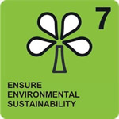](http://www.undp.org/mdg/goal7.shtml) 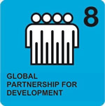

<https://sustainabledevelopment.un.org/?page=view&nr=1021&type=230&menu=2059>

<https://sustainabledevelopment.un.org/content/documents/1616child_friendly_OWG_english.pdf>

*Sincerely yours,*

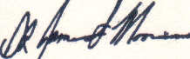



*Dr. J. Scott Moore*

*Chief / CEO Project One Inc, UN/NGO with UN/ECOSOC Status*

*Mr. Bert G. Davi*

*CAO/ Project One Inc*

*Ms. Hélène H. Oord*

*Ambassdor to Project One Inc & Secretary*

*Project one* ***™***  *Inc : Dr. J. Scott Moore Mob: +1205 260 7489, Email* [*j*scottmo@aol.com](mailto:jscottmo@aol.com)

*Ms.Hélène H. Oord / Ambassador to Project One Inc. to the United Nations 06-36108563 / 010- 7857863* [*worldview.mission@gmail.com*](mailto:worldview.mission@gmail.com)

*Cc/* [*info@worldviewmission.nl*](mailto:info@worldviewmission.nl) */ Mr. Bert G. Davi / Email:* [dsthompson@bahamasny.com](mailto:dsthompson@bahamasny.com) / [bert@foxminingbolivia.com](mailto:bert@foxminingbolivia.com)

**™**

*“Enhancing the world one child and one senior at a time, from start to finish.”*