BRIEFING ON:
“A POST 2015 GLOBAL GOAL FOR WATER—SECURING SUSTAINABLE WATER FOR ALL”
By Ms. Mel Bromberg-Team Leader, Water, UN SD Education Caucus
For release to: The UN Sustainable Development Education Caucus

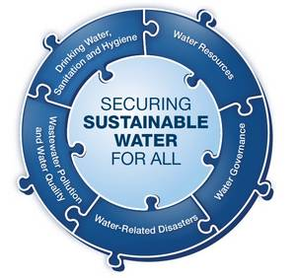
This is to call attention to the recent UN Water Report: A Post 2015 Global Goal for Water released on January 27, 2014. The report is a synthesis of input from all other UN related member departments and organizations, working groups, networks and previous summits, in leading up to the development of United Nations’ Post 2015 Sustainable Development Goals (SDG’s). * (See below for participating groups). (UN Report http://www.unwater.org/)

This UN Water Report is written as an amicus curiae (friend of the court) appeal so as to allow the ambitious realization of “Securing of Sustainable Water for All” to become a singular dedicated and universally applicable global water goal, in tandem with other proposed SDG goals. This report is especially important prior to the February 2014 UN Thematic Debates on Water and Sanitation, because it has synthesized input and content from both internal water related UN agencies as well as external stakeholders engaged in water, sanitation access, water resource management, rights to water, sanitation implementation and climate change/disaster risk reduction activities. Building from the collective input, UN WATER has designed a hypothetical framework in response to the need for a dedicated integrated water and sanitation goal addressing core areas, targets and indicators pertinent to the post 2015 water environment and responsive to a Sustainable Water for All goal.
Within the framework, four (4) water pillars are identified that carry forward prior water/sanitation MDG work including work implemented under the 2005-2015 UN International Decade for Water. These pillars are as follows:
- Universal access to safe drinking water, sanitation and hygiene, ( MDG carry forward)
- Improving ( per each countries target) the sustainable use and management of water resources per country, ( MDG Carry forward)
- Strengthening of equitable, participatory and accountable water governance ( Partial attention under MDG’s , especially with respect to the General Assembly adopted UN Human Right to Water and Sanitation, 2010).
- Reduce mortality, economic loss (set target per country) from human induced water related disasters. (Carry forward from MDG’s and Hyogo Framework, with more emphasis on mortality reduction, early warning systems, preparedness from water related disaster risk referencing most vulnerable populations and groups).
The report takes into account previous efforts by MDG countries to align and achieve their water/sanitation access commitments as well as other related sector targets in the areas of water resource management, climate change and implementation of water based human rights.
The report also draws from conferences, reports, resolutions and regional meetings held over the past ten years during the International Decade of Water as follows:
- The 2000 UN Millennium Development Goals (MDG’s)
- The United Nations Framework on Climate Change (UNFCCC)
- The 10th Conference of Parties (COP) on Biological Biodiversity ( Aichi Biodiversity Target document)
- Hyogo Framework For Action 2005-2015
- UN General Assembly’s 2010 Resolution on the Human Right to Water and Sanitation
- The 2012 Rio 20+ Summit
- The African Ministers’ Council on Water (AMCOW) as supported by the Global Water Partnership (GWP)
- World Water Day events ( 2005- present)
- The International Year of Sanitation (2008)
- The International Year of Water Cooperation ( 2013)
- The World We Want 2015
- My World voting processes where water and sanitation were ranked 5/17 issues.
* Participating UN departments, organizations and working groups which contributed their input to the report development include: UN Water and its member agencies and partners, the UN Secretary General’s High Level Panel of Eminent Persons on the Post 2015 Development Agenda (HLP), the UN Sustainable Development Solutions Network (SDSN), the UN Development Group (UNDG), the Budapest Water Summit, the Open Working Group on Sustainable Development Goals (OWGSDG’s), and various other thematic, national, regional stakeholder consultations and constituencies.
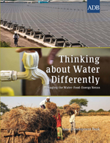
The report highlights the many interrelated linkages between water and development outcomes including: healthy people, increased prosperity, equitable societies, protected ecosystems and resilient communities. It recognizes the many linkages and connections to other sectors including food and energy security though no specific targets for these interlinked sectors are provided within the purview of this report. Water resource management and its many connections to countrywide social, economic and ecologic sustainability are addressed. More intensive emphasis on implementation of the human right to water and sanitation is addressed as a core area within this report through the creation of sub-targets around participation, justice, equity, accountability and inclusiveness.
While this report is pre-requisite to upcoming “stock taking” reports on the UN SDG’s to be held later in the year, the UN WATER report initially paves the way for the creation of a schemata of various water related targets, indicators and core areas upon which a Sustainable Water Goal for All might be focused.
While the UN under the MDG’s has intensively focused on water access and sanitation targets for countries in working to halve the proportion of those without access, and has made large strides in progress around improved water access from (2.6 billion people to 783 million), the sanitation access target lags way behind: (still 2.6 billion people without improved sanitation access as of 2014). Thus the sanitation sector post 2015 is likely to be targeted with much greater intensity until improved universal access is attained. Additionally, since the 2013 Year of International Water Cooperation, the report has worked to incorporate efforts around more integrated and cooperative water resource management including attention to shared regional watersheds, transboundary issues, and integrated growth and development of water resources addressing spatial and temporal freshwater related scarcities and stresses, ecological and environmental sustainability and climate change drivers and pressures. During the international decade of water (2005-2015) it has also worked to underpin the capacities upon which resource allocation and decision making are dependent. These include addressing capacity building within several arenas including: (a) the recognition and proliferation of knowledge management, (b) technology transfer, (c) innovation and (d) broad implementation (under the umbrella of UN CEO Global Mandate) around public/private partnerships whose financing and investment in water and sanitation infrastructure help countries to expand upon their infrastructures and build countrywide resiliency to climate related disasters.
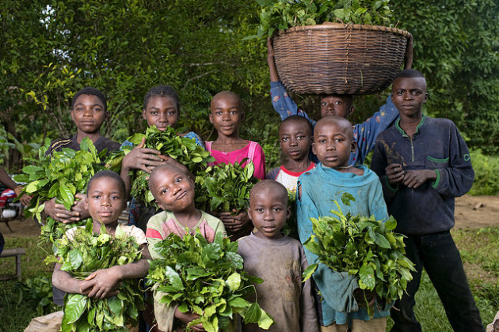
Both the energy and food sectors, which are linked to the “water nexus”, have become an intrinsic part of water dialogues and discussions in this era of sustainability. While each was not specifically referenced within this report, they are sure to hold a place in subsequent iterations of a UN Water goal, given the fact that 2013 was designated by the UN as the International Year of Sustainable Energy, and now 2014-2024 has been designated by UN Secretary General Ban Ki Moon and the General Assembly as the International Decade for Sustainable Energy.
Thus this report published by UN Water, serves as a first attempt to craft a singular and improved universal sustainable water goal through examination, review and collection of input and summary of major work done under the MDG architecture, with an eye to addressing

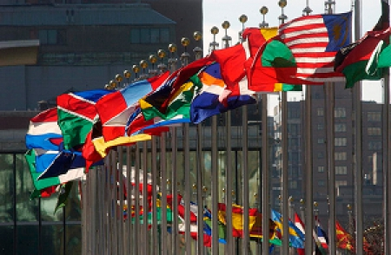
unresolved targets, new connections and linkages, and putting water and sanitation in its rightful place as fundamental to attainment of global poverty reduction and economic prosperity and health and well- being and sustainability post 2015. The timeliness of this document allows it to serve as a preparatory document for member states, organizations an d stakeholders engaging in the first of six thematic debates, the first of which is on Water and Sanitation under the direction of General Assembly Chairperson John Ashe, February 18-19, 2014 at UN Headquarters – New York.

Contact:
Mel Bromberg <mel@watershedint.com>
UN SD Education Caucus – Water Co-Coordinator

