Policy Brief #8
Recommendations on the Oceans and Seas
for the UN General Assembly Open Working Group on Sustainable Development Goals (OWG on SDGs)

NGOs vision & priorities for the Sustainable Development Goals and the post-2015 development agenda

A position paper for the programme:

“Post 2 Post: Enhancing Stakeholder Engagement in the Post-Rio+20/Post-2015 Process”

Please send to:
Leida Rijnhout (OP for MG NGO)
European Environmental Bureau
Leida.Rijnhout@eeb.org

www.worldaquarium.org  Contact us at: info@worldaquarium.org | EXPLORE THE WONDERS OF WATER | 701 North 15th Street, 2nd Floor  St. Louis, MO 63103 USA  (314) 647-9594 Info. Hotline  (314) 647-6011 Administration  (314) 647-7874 Fax
A Not-For-Profit Corporation Committed to Learning by Participation

Introduction
First of all, the Oceans must be considered a stand-alone goal point for the next SDGs. Oceans provide a majority of the productivity for the planet in the form of oxygen, carbon sequestration, protein production, livelihoods, and more. As a cross cutting referent as in the previous MDGs the Ocean issues tended to be a second string thought and action. We believe also that supporting the advancement of technology transfer to future ocean related activities, support of formal and informal education programs aimed at understanding and action, and utilizing statistical models and actuarial science for providing prediction for productivity, sustainability, and disaster can better prepare societies for dealing with the economic, social and disaster concerns that are increasing due climate change and other challenges. We also forward the idea that there is a need for mechanisms at the ocean level for carbon-offset-like economic considerations for support of actions from the local to the global level, however these financial equations should consider overall ecosystem productivity, societal benefits and the effects of that proactivity and valuation negative pollution effects in a checks and balances type of equation.

Our position
Conservation for the Oceans Foundation sees climate change as a worldwide phenomenon that has drastic effects on our oceans and lands. Mostly what has been focused on is what happens on land, but it is worthwhile to consider the effects upon aquatic ecosystems, which cover approximately 70% of our planet. Oceans are critical to regulating carbon dioxide and provide a primary economic resource worldwide. Through the conservation and sustainable use of our oceans, the oceans in turn provide poverty eradication, food security, and sustainable livelihoods. Economic, conservation, and natural resource policy planning needs to include conservation and sustainable use of the oceans and seas and their resources, reduction of marine pollution, and concentration on ocean acidification and climate change. Formal and informal education towards awareness, understanding and action needs to permeate all levels of society. Current and future technological advances addressing issues such as desalination, temperature changes, ocean acidification, radioactivity, pollution, fertilizer runoff, disease, mangrove protection, marine protected areas, stock enhancement, and oil drilling should be demonstrated, discussed and debated. Overall, these technological advances can be a major tool aiding the resilience of nature to ensure conservation as the wise use of natural resources from an aquatic perspective for a profoundly positive impact to society and ecosystems including financing mechanisms for sustainable implementation.
We additionally recommend the use of statistical analysis and predictive modeling including actuarial analysis of climate change effects on ocean productivity, pollution, food security, and forecasting the economic and social impacts of natural disasters for planning and mitigation. Technological advances can be a major tool aiding the resilience of nature to ensure conservation to promote as the wise use of natural resources from an aquatic perspective for a profoundly positive impact to society and ecosystems which can include financing mechanisms for pragmatic sustainable implementation.

Engagement at every level of society is needed to lead the way towards a sustainable and profitable future.

Framework
Technological advances can be a major tool aiding the resilience of nature to ensure conservation to promote the wise use of natural resources from an aquatic perspective for a profoundly positive impact to society and ecosystems which can include financing mechanisms for pragmatic sustainable implementation.

Ocean related Cross-cutting Issues, some to consider:
- Desalination
- Temperature changes
- Ocean acidification
- Radioactivity
- Pollution including plastics, chemicals, garbage, etc.
- Fertilizer runoff
- Disease
- Mangrove protection
- Marine protected areas (MPAs)
- Stock enhancement
- Fisheries productivity
- Extractive industry effects

Monitoring and Evaluation
We recommend using a local basis for measurement and evaluation of the outcome of the processes which can be then summarized regionally. We further recommend that people, organizations, corporations, universities, etc. actually engaged in the field activities be participants in the data acquisition process and its evaluation and presentation. We feel that such models based on microfinancing where participants, local agencies and larger outside agencies are engaged should all participate in a multi-stakeholder process for monitoring and evaluation.

An Ocean SDG will holistically address critical social and economic issues
- Food security
- Disaster risk reduction
- Human health
- Water quality and security
- Livelihoods
- Climate regulation
- Biodiversity and ecosystem function

SDG Indicator Example Ocean Health Index
10 Public Goals and Sub-Goals
- Food Provision: Fisheries, Mariculture; and Sustainable fisheries
- Artisanal Fishing Opportunities
- Natural Products
- Carbon Storage
- Coastal Protection
- Tourism and Recreation
- Livelihoods and Economies
- Sense of Place
- Clean Waters
- Biodiversity measurements for species and habitat

Next Steps
We have tested a methodology for decreasing carbon footprints, improving ecosystem productivity, decreasing pollution, and increasing financial sustainability within each community and consequent environmental effects to provide a wide scale adoption of these plans. We showed that these credit mechanisms may be used with local bank issuance for green purposes with conditional cash transfer as part of the residual credit program. We believe this same methodology can be applied to ocean based productivity models.

We believe that mechanisms at the ocean level for carbon-offset like economic considerations for support of actions from the local to the global level, however these financial equations should consider overall ecosystem productivity, societal benefits and the effects of that proactivity and concerns about pollution effects as well in a checks and balances type of equation.

Additionally, environmental, carbon offset projects must be accompanied by youth education and public awareness agendas. Encouraging green lifestyles and business practices in tandem with blue+green education and public awareness brings a holistic approach to each society impacted and tends to have long-term results. The carbon marketplace offers plentiful bounty for those adept, savvy investors while positively affecting the native communities where the projects are located economically, educationally, and environmentally. Below is a schematic model of how this system works. This field-tested, multifaceted program has all of the essential elements necessary for long-term success in perpetuity. The program is an innovative shortcut towards a blue+green future that is equipped with the veracity necessary for surety in investors looking for sound investments.

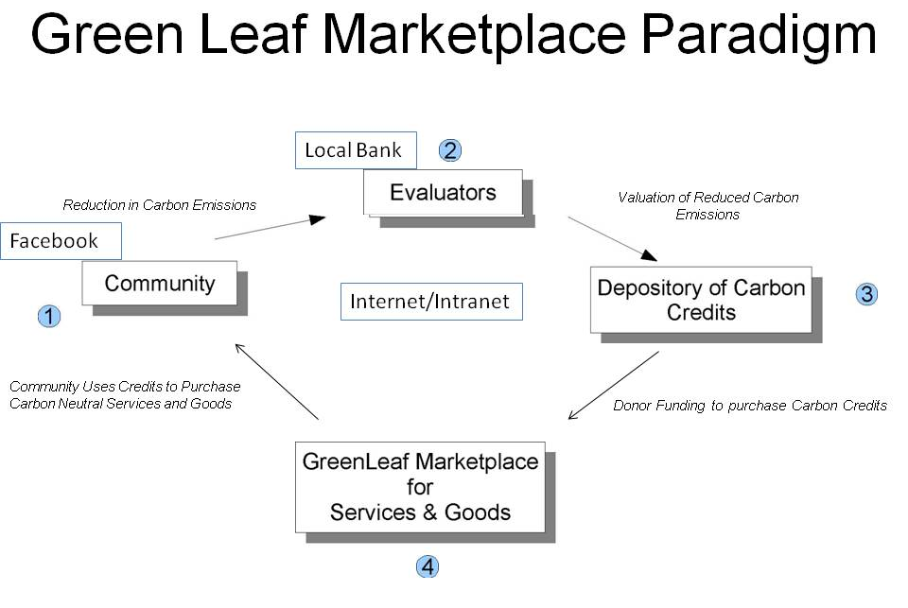
Conclusion
Climate change has had a significant impact upon the world's oceans, including changes in weather patterns, ocean ecosystems, human health and disease, and fisheries. However, actions can be taken to positively affect these situations, such as sustainable management of fisheries, improved energy efficiency individually and corporately, judicious land-use, public education programs, and thorough data research and data collection. The use of statistical analysis and predictive modelling including actuarial analysis of climate change effects on ocean productivity, pollution, food security, and forecasting the economic and social impacts of natural disasters must be part of the solution set identified.

Application of ocean engineering solutions can aid the resiliency of land-ocean ecosystem productivity through improved fertilizer content design (recommended or regulated), aquaculture guidelines, coastal restoration policies, and wastewater treatment parameters. Oceanic health can be improved increasing productivity for coastal communities to achieve food and ecosystem security and contribute to the global knowledge of the ocean with carefully regulated carbon dioxide offsets being an important financial tool to make this process sustainable.

Engagement at every level of society is needed to lead the way towards a sustainable and profitable future.

Sincerely yours in conservation and education,
Leonard Sonnenschein
President
World Aquarium and Conservation for the Oceans Foundation
701 North 15th Street, 2nd Floor
St. Louis, Missouri 63103 USA
office: 314-647-6011
fax: 314-647-7874
mobile: 314-609-2798
web sites: www.worldaquarium.org
www.CFTO.org

