- Worldview Mission (WM) NGO, member of United Nations CSO-NET (ECOSOC CIVIL Society Network NGO Branch, New York.
Worldview Mission (WM) is an dynamic platform for young adult and looking into your aims and objectives all tie with the Millennium Development Goals which is our principal mission and vision.
Our volunteer members are here to work with rural communities and much work has already been done by some of the youth groups showing positive outcomes in communities .
We strongly believe, this shall enable us understand cultural diversity, lifestyles and how to implement or communicate with underpriviledged youths and
difficult to reach out children for example access recent technologies and opportunities.
Reason being that Worldview Mission, is an initiative made of volunteers and with your target we believe volunteerism shall be enhanced after Programme.
Worldview Mission volunteer discription
Describtion role of our organisation group in projects.
We shall keep to the ethical values and contribute in the following ways :
-Ensure a better outreach and understanding of young people during the project by belonging to one of the Working Groups to ease implementation and collaboration within the project.
-Bring some past or recent activities promoted or carried in various countries to share and see how we could recommend hence forth for a better future .
-Additionally, this shall give us the opportunity introduce some of our various dialects to other participants giving them a better understanding of cultural diversity.
-Finally, looking into the aspect of volunteerism, (Worldview Mission) has always been a good standard for such thematic because we are highly represented across the global meaning differents behaviors , languages and style of living .
Worldview Mission (WM) members have been successful to ensure this barrier between the vulnerables and underprivileged is being resolved because our members work fully in promote areas as volunteers. http://unpan1.un.org/intradoc/groups/public/documents/un/unpan000160.pdf
http://www.eramet.com/sites/default/files/publications/pdf/eramet_ethics_charter.pdf

Mission Statement
- “A sustainable world for the future generations.”
- Eradicate poverty in our communities and provide a safe haven for those in need.
- Provide a comprehensive program of personal growth and development.
- Youth Development empowerment to build the finest facility where young people get the feeling that they belong to a loving society.
- Create an environment and use activities that foster mutual respect, resilience, self-esteem, self-regulation, self-efficacy and leadership.
- Promote awareness and acceptance of diversity.

Vision Statement
- “To improve the quality of life for the people living in poverty helping them to become self-sufficient”, and to facillitate global effort in meeting the United Millenium Development Goals.
Millennium Development Goals
- Worldview Mission (WM) is working to achieve the UN goals for a sustainable world for the future generations.
- The United Nations Millennium Development Goals (MDG’s) are 8 international Development goals that 192 UN member states and at least 23 International organizations have agreed to achieve by the year 2015.http://www.un.org/millennium/declaration/ares552e.htm
- http://bcove.me/9xtf8mgb
- http://undesadspd.org/Family/InternationalObservances/InternationalDayofFamilies.aspx
- http://www.bond.org.uk/advocacy/millennium-development-goals
- http://www.un.org/en/development/index.shtml
- http://mdgs.un.org/unsd/mdg/host.aspx?Content=indicators/officiallist.htm

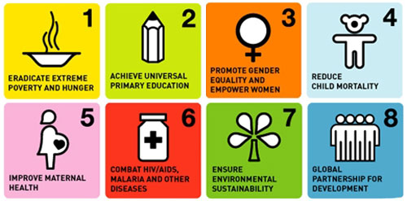

- http://www.bond.org.uk/advocacy/millennium-development-goals

- http://www.un.org/en/development/index.shtml

- http://mdgs.un.org/unsd/mdg/host.aspx?Content=indicators/officiallist.htm

