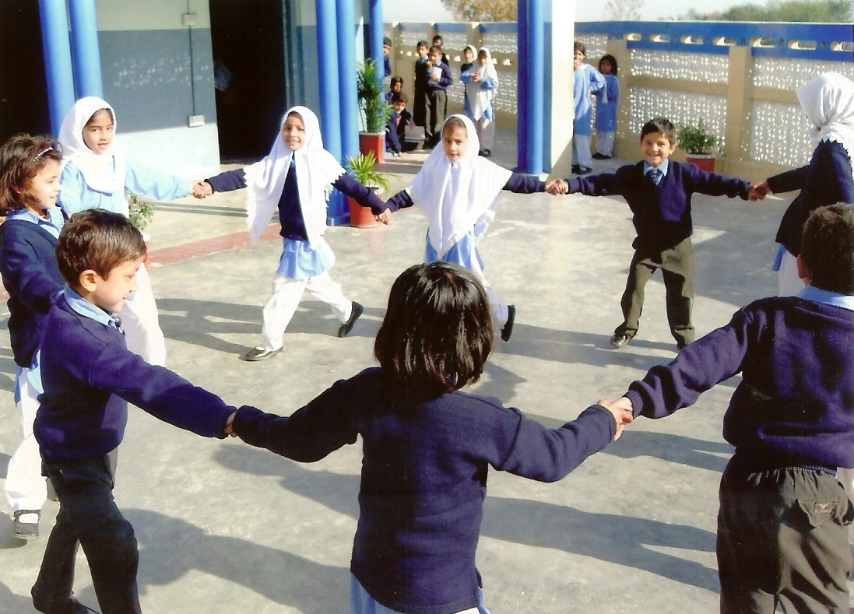

86244



**World Bank Policy Paper Series on Pakistan**

**PK 08/12**

**June 2012**

**Human Opportunity Index (HOI) – National**

**Equality of Children’s Opportunities in Pakistan**

***John Newman***

_______________________________________________

This publication is a product of the South Asia Poverty Reduction and Economic Management Sector Unit. It is part of a larger effort by the World Bank to provide open access to its research and make a contribution to development policy discussions in Pakistan and around the world. Policy Working Papers are also posted on the Web at http://econ.worldbank.org. The authors may be contacted at Jnewman@worldbank.org.

**Abstract**

This paper complements the World Bank’s recent report on poverty by providing some additional information on inequality. In contrast to reports that analyze measures of inequality of income or wealth (such as the Gini), this paper focuses on equality of opportunities of children, where "opportunities" refer to access to basic services and goods (access to education, health conditions and basic infrastructure) that improve the likelihood of children to maximize their human potential. It introduces a new metric to Pakistan–the Human Opportunities Index (HOI) that combines the overall coverage rate of the opportunity with a “penalty” for the share of access to opportunities that are distributed in an unequal fashion. The Human Opportunity Index was developed recently at the World Bank and has been estimated now for over 20 countries in Latin America and Africa.

The Policy Working Paper Series disseminates the findings of work in progress to encourage the exchange of ideas about development issues. An objective of the series is to get the findings out quickly, even if the presentations are less than fully polished. The papers carry the names of the authors and should be cited accordingly. The findings, interpretations, and conclusions expressed in this paper are entirely those of the authors. They do not necessarily represent the views of the International Bank for Reconstruction and Development / World Bank and its affiliated organizations, or those of the Executive Directors of the World Bank or the governments they represent.

**Human Opportunity Index (HOI) – National**

**Equality of Children’s Opportunities in Pakistan**

**John Newman**

This paper was motivated by World Bank’s extensive support to the design of the new Framework for Economic Growth of Pakistan. These first two sections describing the HOI draws heavily on the description in the World Bank Report entitled, “Opportunities for Children in a Post-Conflict Country: the Case of Liberia”, prepared by Ana Abras, Jose Cuesta, Ambar Narayan and Alejandro Hoyos (Poverty Reduction & Equity, PREM Network).

**Executive Summary**

1. This paper presents information on quality of children’s opportunities in Pakistan for two points in time (1998-99 and 2007-08) to illustrate the extent of progress over roughly a decade. The analysis is conducted at the national level. Particular attention was paid to documenting the current situation and the recent changes at the national level, given that Pakistan is embarking on devolution of responsibilities to the provinces with the implementation of the 18th Amendment. While the results are presented only up to 2007-08, there will soon be data available for 2010-11 that could be analyzed in exactly the same fashion to provide an excellent baseline for the current status of the distribution of opportunities for children. The approach could then be used with future household surveys to monitor how equality of opportunities evolves over time and, importantly, whether any corrective actions need to be taken if greater inequality emerges as a problem.
2. The results presented in this paper are preliminary and should be considered suggestive, rather than definitive. The results show that there has been an improvement in both coverage and equality for education, basic infrastructure and immunization rates in Pakistan between 1998-99 and 2007-08. There is improvement in coverage in maternal health, but an increase in inequality. The international comparisons show that the changes in HOI for education compare favorably to those obtained in other countries, but the level of HOI for education is still low relative to all Latin American countries and many African countries. In basic infrastructure, both the change and the level of the HOI compares well to Latin America and the level is far above that of African countries.
3. Some additional benefits would be expected from extending the work in different dimensions. One task is to consider additional opportunities or indicators for analysis. For example, it would be possible to define service quality standards—for the social sectors and infrastructure—and then determine how equitable the access to public services of a particular standard is. It would also be possible to deepen the analysis at the provincial level, by drilling down to look at opportunities at the district level and analyzing whether differences in equality of opportunities are related to differential patterns of public expenditure or targeting of policy. Finally, the expected benefit of the approach could be enhanced if care is taken in the upcoming surveys to be carried out at the provincial and district levels to capture both the opportunities and circumstances that would be important to consider helping ensure greater equality of opportunity for all children in Pakistan.

**Introduction**

1. To a large extent, the poverty and inequalities that one observes in Pakistan today are rooted in opportunities that were available to children when they were growing up. If poverty and inequality are to be reduced in the future, there must be greater equality in opportunities to children today. The idea that there should be equality in opportunities for children is a concept that is typically embraced by all—in contrast to the more contentious positions that are taken with respect to inequality of income or consumption. While some may be in favor of equalizing incomes or consumption, others may point out the negative effects this may have on individual incentives and economic growth. However, few would disagree with a guiding principle that there should be equality of opportunity—the "circumstances" a person is born into (e.g. gender, location, parental and economic background) should not determine the individual’s access to opportunities.

1. While analyzing inequality of income or consumption can be done using measures such as the Gini, capturing the notion of equality of opportunity requires a different approach and a different metric. A large body of social science literature has been concerned with equality of opportunity for some time. Amartya Sen has been deeply influential in arguing for an equitable distribution of “capabilities,” which essentially amount to an individual’s ability and effort to convert resources into outcomes they have reason to enjoy. John Roemer’s (1998) work “Equality of Opportunity” was the first to formalize an equality of opportunity principle and remains the most relevant piece of academic literature underpinning the analysis described in this paper for Pakistan and other, similar work that the World Bank has been doing on the Equality of Opportunity in Latin America and Africa.[1] Roemer argues that policy should work to equalize opportunities *independent* of circumstances and that outcomes should depend only on effort.
2. The World Bank’s 2006 World Development Report “Equity and Development” argues that inequality of opportunity, both within and among nations, results in wasted human potential and weakens prospects for overall prosperity. Conducting an analysis of inequality of opportunity, however, requires a measure or a set of measures that provide a practical way to track a country’s progress towards equalizing opportunities for all its citizens. To be useful to analysts and policymakers alike, such a measure must combine a few attractive properties: intuitive appeal, simplicity, practicality (especially in relatively data scarce environments) and sound microeconomic foundations to ensure that it has an interpretation that is consistent with its objective.
3. Much of the empirical work in developing countries till recent times has focused mainly on measuring (and comparing) average rates of access to goods or services in health and education for the population and different subgroups within. What has been lacking for the most part is an intuitive and unified framework to address a range of questions across different types of opportunities, such as: How far away is a country from universalizing each type of opportunity? How unequally are available opportunities distributed across different sub-groups of the population? How important are circumstances to which an individual is born into in determining access to opportunities? Which are the circumstances that matter for access, and in that sense, contribute the most to inequality in access? What would it take, in terms of resources, to reduce inequality in opportunities, when providing universal access is clearly not possible in the near term?
4. These questions have been especially relevant for Pakistan for quite some time. Many observers, both within and outside the country, have noted how poor social indicators have been in Pakistan and, historically, how poor has been the pace of change in the social indicators given its rate of GDP per-capita growth over time. Easterly (2003) calls it “growth without development”. While Easterly noted that there had not been much progress in social indicators over the 1990s despite the expenditure and effort of the Social Action Program, the results for the decade of the 2000s appear to be better. Certainly, there has been a considerable push for expanding education, especially female education, and there is evidence of an increasing demand for education as evident from the growth in private schooling—even in rural areas.[2] The question of what has happened to the equality of opportunities and what is likely to happen to opportunities in the future becomes increasingly important as the country begins to implement the 18th amendment. One of the important motivations for the decentralization is to improve delivery of public services, by bringing the government closer to the people and increasing accountability. But there are also risks of exacerbating existing differences, as a result of differences in access to resources, management and implementation capability across provinces and a diminished role of the national government, which otherwise might be called on to carry out needed redistribution so as to equalize opportunities. As opportunities could become either more or less equally distributed, it will be important to track what actually happens over time.
5. World Bank staff and external researchers in recent years have made significant progress in addressing questions such as above in a simple and intuitive framework, as demonstrated by Barros and Ferreira (2009). The report introduced a new metric, the Human Opportunity Index (HOI), which measures how far a society is from universal provision of basic services and goods, such as sanitation, clean water, education, and the extent to which those goods and services are unevenly distributed.[3] A key feature of HOI is that it not only takes into account the overall coverage rates of these services, but also how equally the coverage is distributed—by measuring the extent to which those without coverage are concentrated in groups with particular circumstances (e.g. economic status, gender, parental education, ethnicity and so on), which are conditions a child is typically born into.
6. The 2009 report computed HOI for five indicators: access to clean water, sanitation and electricity, completing sixth grade on time, and attending school from age 10 to 14. The analysis focused on children because unlike adults, children cannot be expected to make the efforts needed to access these goods and services, implying that these indicators can be considered as proxies for opportunities available to a child. The report, and the updated 2010 version, “Do Our Children Have a Chance?” analyzed these five indicators for 19 Latin American Countries using the HOI measure, exploring both changes over time within countries and comparisons across countries.
7. This paper introduces the use of the new metric “HOI” for Pakistan. It presents estimates at the national level of the HOI for a set of key opportunities, calculated from the 1998-99 and 2007-08 Pakistan Social and Living Standards Measurement (PSLM) surveys. Where internationally comparable data exist, a comparison is made of the progress in Pakistan with the progress over a similar ten-year period in several countries in Latin America and Africa. Besides simply tracking how the HOI for different opportunities have changed over time, the paper also analyzes what circumstances appear to be important in explaining the inequality of opportunities and how the relative weight of the different circumstances in explaining inequality has changed over time. The paper does not, however, go into the very important issue of how policies and programs might have influenced these trends. That type of analysis is best carried out by sectoral experts and lies beyond the scope of this paper. Such analyses could be useful complements to the type of work carried out in Economic and Sector Work by the World Bank and in studies conducted by other institutions and independent analysts. The paper concludes with some suggestions on how the use of HOI estimates might be employed to help monitor changes in equality of opportunities as Pakistan implements the 18th Amendment. As suggested above, it will be important to monitor what happens to inequality of opportunities to allow for timely, corrective action to be taken if needed.

**Calculation and Interpretation of HOI**

1. The HOI provides an inequality-sensitive coverage rate of opportunities. An opportunity is defined to be a good or service that is sufficiently important for a child’s future welfare that society considers that it should be available to all children, regardless of their background. In most societies, basic education, health and infrastructure services would be considered opportunities. An opportunity is said to be distributed according to a principle of equality of opportunity if circumstances exogenous to the individual, such as birthplace, gender, ethnicity, income and education level of the parents, have no bearing on how the opportunity is distributed in the population.
2. The HOI is defined as the difference between two components:
3. the overall coverage rate of the opportunity (C) ; and
4. a “penalty” for the share of access to opportunities that are distributed in violation of the equality of opportunity principle (P).
5. To get an intuitive understanding of how the HOI captures this penalty associated with outcomes that are distributed in violation of the equality of opportunity principle, it is useful to go through an example. Box 1 outlines a simple example of how HOI is measured, in a hypothetical situation with two countries with identical populations of children and average coverage rates of primary school enrollment. The example demonstrates how HOI is sensitive to inequality in coverage and how it would change in response to an increase in overall coverage or reallocation favoring the more disadvantaged group.

**A Simple and Intuitive Example of HOI**

**Box 1**

Consider two countries, A and B, each with a total population of 100 children. Each country has two groups of children, I and II, which consist of the top 50 percent and bottom 50 percent by per capita income, respectively. The coverage rate of school enrollment (or the average enrollment rate) for both countries is 0.6, i.e. 60 children attend school in each country. The table below shows the number of children going to school in each group for each country.

Given the total coverage rate, the principle of equality of opportunity will hold true for each country if each of the 2 groups in each country has the same rate of coverage, i.e. if each group has 30 children going to school. But in reality Group II has 20 enrollments in country A and 25 in country B. This suggests that firstly, opportunities are unequally distributed, and secondly, inequality of opportunities is higher in country A. The D-index is the share of total enrollments that is “misallocated”, namely 10/60 and 5/60 for A and B, respectively.

|  |  |  |
| --- | --- | --- |
| Groups by circumstance (e.g. income) | **No. of children aged 6 to 10 years enrolled in school** | |
| **Country A**  **(100 children)** | **Country B**  **(100 children)** |
| Group I  (top 50% by income) | 40 | 35 |
| Group II  (bottom 50% by income) | 20 | 25 |
| **Total** | **60** | **60** |

Therefore,

HOIA = CA (1-DA) = 0.6 * (1-10/60) = 0.50 and

PA = CA*DA = 0.6 * (10/60) = 0.10;

HOIB = CB (1-DB) = 0.6 * (1-5/60) = 0.55 and

PB = CB * DB = 0.6 * (5/60) = 0.05

Thus even though both countries have equal coverage rates for enrollment, the higher inequality of opportunity in country A leads to the D-index being higher for A than for B, and HOI being higher for B than for A. It is also easy to see that HOI will increase in a country if: (i) the number of enrollments in each group increases equally (in proportionate or absolute terms); (ii) if enrollment for any group increases without decreasing the coverage rates of the other group; and, (iii) enrollment for Group II increases, keeping the total number of children enrolled unchanged (implying enrollment in Group I reduces by an equivalent amount). These three features relate to the “scale”, “Pareto improvement” and “redistribution” properties of HOI, respectively—properties that are intuitively appealing.

1. In this simple example with only one circumstance, the dissimilarity index and the penalty could be calculated by hand. More generally, when there are multiple circumstances, this is not possible and the Dissimilarity Index must be calculated econometrically. Thus, more generally, the HOI is defined as:

HOI = C (1 - D)

Or, equivalently:

HOI = C - P

Where:

P = C*D

C is the average coverage

D is the Dissimilarity Index, formally defined as:



The term  is the predicted coverage rate of individual i. It is obtained from a logit model using the circumstances as independent variables.[4] C is the average coverage rate in the population and is the weight.

1. The HOI has a number of attractive features as an index. For example, the HOI is sensitive to:
2. the overall coverage: when the coverage for all groups increases by factor k the HOI increases by the same factor;
3. Pareto improvements: when the coverage for one group increases without decreasing the coverage rates of other groups, the HOI increases; and,
4. redistribution of opportunities: when the coverage rate of a vulnerable group increases for a constant overall coverage rate there is decrease in inequality and an increase in the HOI.

**Selection of Opportunities and Circumstances for the Analysis**

1. Ideally, the selection of opportunities and circumstances to be monitored would reflect a consensus within the country of what opportunities should be considered universal and what circumstances are sufficiently important to identify to ensure that those who differ in circumstances do not differ in their access to opportunities. Since the objective of this paper is simply to introduce the possibility that the HOI approach could be useful in Pakistan, some common measures for opportunities and circumstances are selected that have been considered in other countries and for which data are available from household surveys in Pakistan.
2. The analysis will make use of data from the 1998-99 and 2007-08 Pakistan Social and Living Standards Measurement (PSLM) Surveys. These two surveys were chosen because they provide observations over roughly a decade, which should be long enough to detect progress. Moreover, HOI calculations have been made for Latin America and Africa over a ten-year period, to facilitate comparisons. Choosing the 1998-99 and 2007-08 surveys also allows for the inclusion of real per-capita consumption as one of the circumstances to consider. Not all of the PSLM surveys have consumption data.[5]
3. Other opportunities could and should be chosen. For example the selected opportunities capture only enrollments and completion rates. They do not capture dimensions of quality of school. If the educational system is willing to define a measure of what constitutes adequate quality, it would be possible to use the approach to determine the extent to which there is equality in achieving adequate quality schooling. Similarly, the measure of basic infrastructure only captures whether a child is at a home with a connection. It does not reflect whether there is electricity available 24 hours a day. But this is simply a question of availability of data. If the appropriate data were available, this approach could be used to capture the equality in the availability of service.
4. A final point relates to the question of what is considered to be an opportunity. Should the government be content with simply providing a supply of the service and pay no attention to whether the parents take steps to make that service available to their children? This involves considering what it means to supply the service. A service may be “available” but the cost of accessing that may be prohibitive. If a society truly cares about children receiving equal opportunities, this may require going beyond asking whether a service is provided to a particular quality standard to a question of what is happening to the utilization of that service. But both concepts can be important. Society may be interested in having equality in primary completion rates and may also want to know whether one of the reasons for why there is inequality in primary completion rates is because there is inequality (or appropriately compensatory investment) in the use of public funds. Looking at both aspects of the problem could be fruitful. Table 1 presents the opportunities considered in the analysis and Table 2 presents the circumstances used in the analysis at the national level.

**Definition of Opportunities Used in the HOI Analysis for Pakistan**

**Table 1**

|  | **Opportunities** |
| --- | --- |
| **Education** | 1. Enrollment of children aged 6-10 2. Enrollment of children aged 11-15 3. Primary completion among children aged 15-19 4. Secondary completion among children aged 20-24 |
| **Health** | 1. Did not have diarrhea in the last 30 days for children less than 5 2. Ever received immunization 3. Received full immunization according to a record in a health card or a self-response of the mother 4. Received full immunization as recorded on a health card 5. Received adequate prenatal care, defined as at least 3 prenatal care visits with the first one occurring before the fourth month of pregnancy 6. Received any postnatal care within 6 weeks after birth 7. Attended by some traditional or formal birth attendant (defined as traditional birth attendant, trained *dai*, doctor, lady health visitor, lady health worker, nurse etc.) 8. Attended by formal birth attendant (defined as doctor, lady health visitor, lady health worker, nurse etc.) 9. Institutional birth (defined as being at a government or private hospital/clinic) |
| **Infrastructure** | 1. Having improved sanitation (defined as improved if from flush to public sewage, flush to pit or pit latrine, unimproved if flush to open drain, raised latrine or no toilet) for children aged 0-16 2. Having improved water (defined as improved if from pipe, hand pump, tube well or closed well, unimproved if from open well, pond, river, spring or other) for children aged 0-16 3. Having an electricity connection for children aged 0-16 4. Having a gas connection for children aged 0-16 5. Having a telephone connection for children aged 0-16 |

**List of Circumstances Used in HOI Analysis at National Level**

**Table 2**

|  |  |  |
| --- | --- | --- |
|  | **Circumstances** | |
| National Estimates | 1. Gender[6] 2. Urban 3. Household size 4. Real Per Capita Consumption 5. Highest Education Level of Household Head 6. Gender of Household Head 7. Dummy =1 if family lives in Sindh 8. Dummy=1 if family lives in KP 9. Dummy=1 if family lives in Balochistan | 1. Gender 2. Urban 3. Household size 4. Real Per Capita Consumption 5. Highest Education Level of Household Head 6. Dummy = 1 if family lives in Karachi 7. Dummy=1 if family lives in Sindh, outside of Karachi 8. Dummy = 1 if family lives in KP 9. Dummy=1 if family lives in Balochistan |

**HOI Results at the National Level**

1. Figure 1 presents estimates of the Coverage Rates, Human Opportunity Index (HOI) and Penalty for the key educational opportunities. The difference between Coverage estimate and the HOI estimate is the Penalty, which is the share of access to opportunities that is not distributed according to the principle of equality of opportunities. The results indicate that there has been considerable and statistically significant improvement in Coverage Rates and HOI in the two enrollment rates and the two completion rates. As revealed by the change in the penalty rates, there has been some statistically significant improvement in equality in primary enrollment and somewhat lower (but still statistically significant) improvement in secondary enrollment. There has been no statistically significant change in the penalty in completing primary or secondary school. There has been a well documented effort by the government to promote primary education and reduce inequality in primary school enrollments and these results reflect the success of those efforts.[7] These results are discussed in more detail in later section. As the completion rates are measured at ages 15-19 and 20-24 (to facilitate international comparisons), it may take some time for the impact of recent government efforts to be revealed in the completion rates. If current results just reflect a delay and not the existence of some impediments to achieving greater equality in the completion rates, then an improvement should be visible once the 2010-11 data are analyzed.

**Coverage Rates and HOI for Key Education Indicators in Pakistan**

**Figure 1**

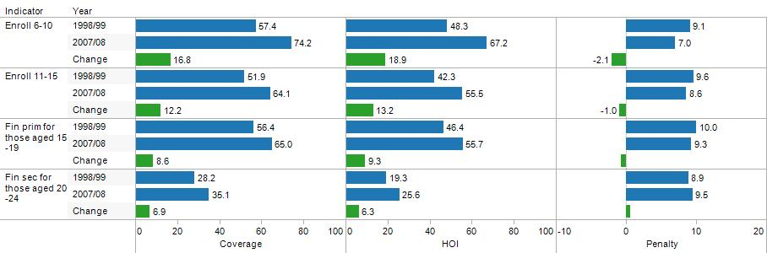

Note: For the change in the indicator, the values are reported only if the change is significant at the 95% level. 95% Confidence Intervals are reported in Annexure 3.

1. Figure 2 illustrates the results for key health indicators in Pakistan. The indicator of the incidence of diarrhea does not strictly reflect a health intervention, but it is a good indicator of overall environmental health conditions. Around 12 per cent of children less than 5 were found to have diarrhea within the last 30 days, but the small difference between the Coverage and HOI estimates indicates that there was not much inequality across the population in the incidence of diarrhea. There may, of course, be considerable differences in how that diarrhea is treated. There was also no improvement over time in the incidence of diarrhea (in fact, there was a very small increase).
2. There were large increases in the immunization rates over this period, with larger increases in full immunization rates than whether children were immunized at all. While for all three immunization variables, the direction of change was towards greater equality, only for being immunized at all was the change in the penalty statistically significant. It is perhaps not surprising that there is greater equality apparent in whether a child received any immunization than whether a child received full immunization. Receiving full immunization requires more follow-up on part of the parents and more educated parents are more likely to follow up.
3. One of the most noteworthy results is the low level of health care related to births that still prevails—even after most of the values of the related indicators doubled over the 10 year period. That illustrates at what a dire level the indicators were in 1998-99. In addition to having a low level of coverage, the size of the penalty is relatively high for the level of coverage. Moreover, for all but the case of traditional and formal skilled birth attendants, there has been an increase in inequality with the improvement in coverage. This may reflect a difficulty in expanding coverage when achieving the coverage requires a behavioral change on part of the families. As will be seen, with most of the infrastructure variables, an expansion of coverage was accompanied by an improvement in equality.

**Coverage Rates and HOI for Key Health Indicators in Pakistan**

**Figure 2**

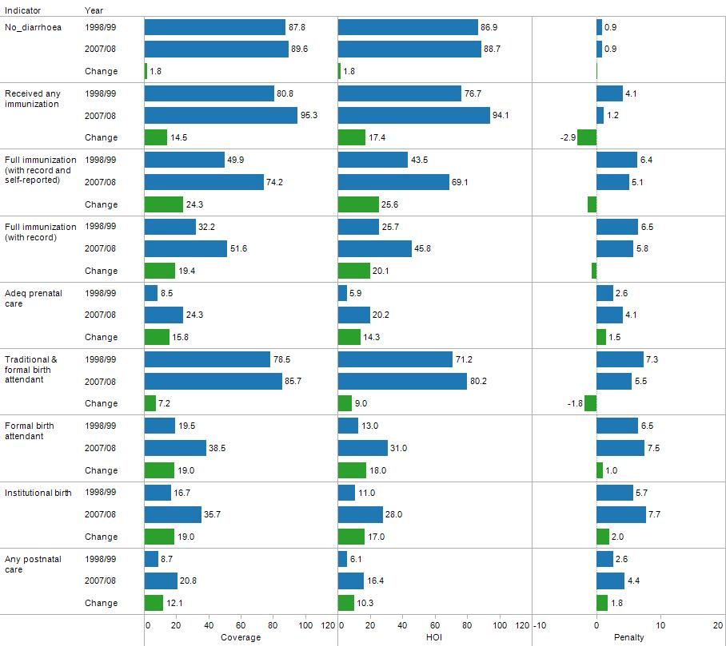

Note: For the change in the indicator, the values are reported only if the change is significant at the 95% level. 95% Confidence Intervals are reported in Annexure 3.

1. Figure 3 presents information on key infrastructure indicators in Pakistan. Note that these measures refer to the coverage for children aged 16 or less, not for the availability of the infrastructure service for the population at large. There were considerable improvements in access to improved water sources, improved sanitation and electricity. The change in the penalty indicates that there has been a considerable (and statistically significant) improvement in equality in the provision of these services. However, it should be pointed out that these indicators refer to connections only. They do not capture how many hours a day those with piped water may be receiving water. And the electricity variable only indicates whether the households have a connection–not how many hours a day they have electricity. Power shortages are a very serious issue in Pakistan and, going forward, it would be useful if the household surveys would collect information on hours of use. If one is willing to define what constitutes adequate hours of electricity a day, it would be possible to calculate a HOI estimate for adequacy of electricity in a similar fashion to the calculation of the HOI estimate of access to electricity defined by having a connection.

**Coverage Rates and HOI for Key Infrastructure Indicators in Pakistan**

**Figure 3**

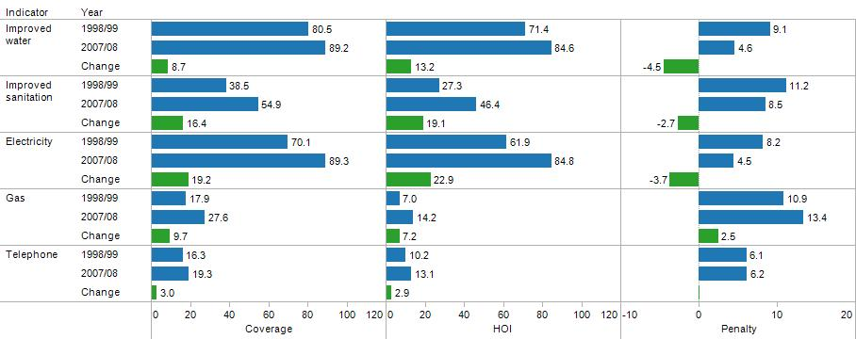

Note: For the change in the indicator, the values are reported only if the change is significant at the 95% level. 95% Confidence Intervals are reported in Annexure 3.

1. Coverage rates for gas and telephone services are considerably lower than for other services; although it is not clear that the questionnaire has adequately captured the use of cell phones. As other sources of information suggest an explosion in the use of cell phones, these measures for telephone usage are much less reliable than the measures for the other infrastructure services.

**International Comparisons**

1. It is difficult to judge whether the progress in the HOI observed in Pakistan is good, bad or indifferent without placing it in some context. As the World Bank has now carried out HOI analyses for several countries in Africa and Latin America, it is possible to draw some comparisons of the progress that Pakistan has achieved over roughly 10 years with that of other countries over a similar ten-year period. However, this is only possible to do for a few opportunities and the comparisons are close but not entirely the same. Still, they do provide some useful context.
2. Figure 4 compares changes in coverage and changes in penalties in primary enrollment rates for Pakistan and several countries in Africa. Results for Latin America are not presented for primary enrollment because primary enrollment is already universal. The end-of-period HOI is represented by the size of the circle. To make it easier to judge the relative position of Pakistan, countries with the end-of-period HOI that are just above and just below that of Pakistan are highlighted. In terms of the change in coverage and improvement in equality (reduction in the penalty), Pakistan compares favorably with other countries. However, it is evident that in terms of the overall level of the HOI, there are quite a few countries in sub-Saharan Africa that are more advanced than Pakistan (Rwanda, Uganda, Malawi, Madagascar, Ghana, Kenya, Cameroon and Namibia).

**International Comparisons of Changes in Coverage, Penalty & Primary Enrollment Rates**

**Figure 4**

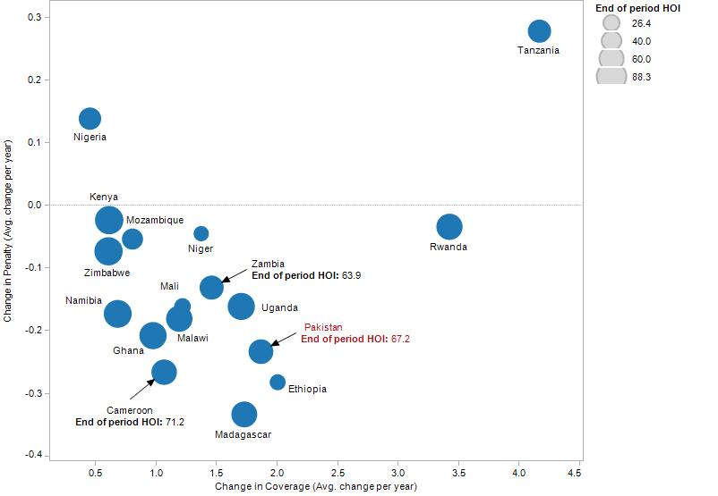

1. Figure 5 presents the results for changes in coverage and penalties for secondary school enrollments, with the end-of-period HOI for secondary enrollment represented by the size of the circle. In this comparison, both Latin American and African countries are represented. As in the previous case, the performance of Pakistan in terms of the change in coverage and improvement in inequality compares favorably to other countries. However, it is also apparent that in terms of the end-of-period HOI, Pakistan still lags behind many other countries in Africa and Latin America (this is seen by comparing the size of the circles). This reflects the very poor initial conditions in schooling that Pakistan has had.

**International Comparisons of Changes in Coverage, Penalty & Secondary Enrollment Rates**

**Figure 5**

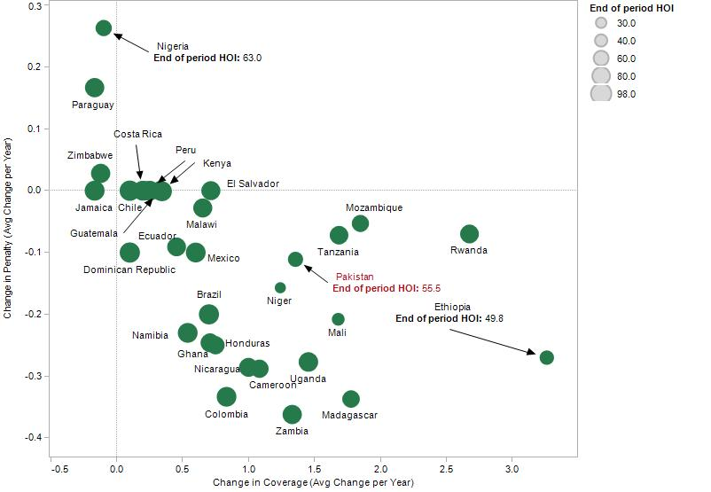

1. Figures 6 and 7 present information on the changes in Coverage and Penalties (reflecting changes in inequality) for access to improved water and electricity.[8] In both of these opportunities, Pakistan not only shows considerable improvement over the decade, but its end-of-period values of the HOI compare favorably to countries in Latin America. Again, it is important to take note of the caveat that these indicators measure only connections and not adequacy of service throughout the day. It is likely that Pakistan would not compare as favorably to Latin America if the opportunity took note of effective hours of service of water and electricity. The African countries are not included in the comparison, because the results for Pakistan far exceed those of the African countries.
2. Thus, leaving aside questions of service availability throughout the day, what is striking about the international comparisons is that Pakistan appears to be close to Latin American countries in infrastructure (far above African countries), but is actually below many African countries in educational opportunities afforded to children. It was not possible to make comparisons for the health opportunities using HOI, but based on Coverage, Pakistan would be towards the low end of the distribution.

**International Comparisons of Changes in Coverage, Penalty & Access to Improved Water**

**Figure 6**

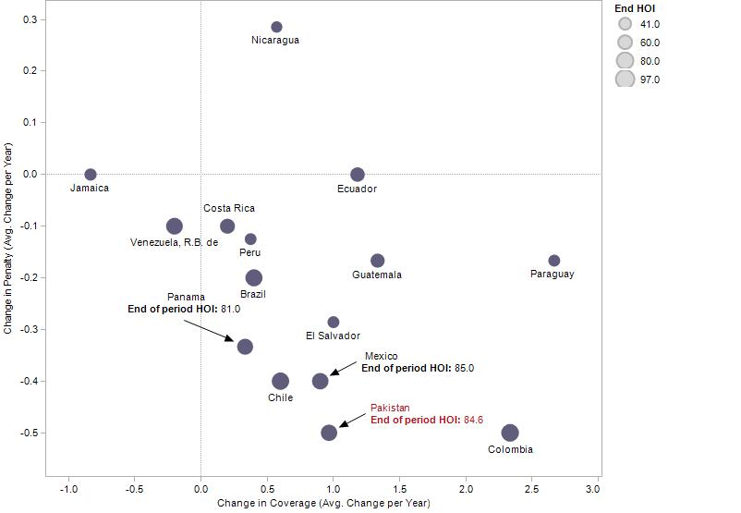

**International Comparisons of Changes in Coverage, Penalty & Access to Electricity**

**Figure 7**

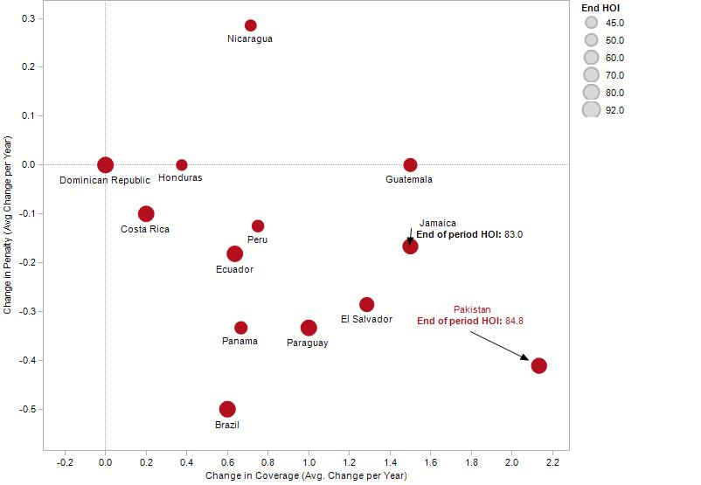

**Conclusion**

1. This paper has introduced to Pakistan a new metric for measuring equality of opportunities in several dimensions of education, health and infrastructure. While the paper selected opportunities that could be readily calculated from the existing PSLM, the approach is capable of being used on a variety of opportunities and indicators that could be important for policy-makers. For example, one could define adequacy of test scores by specifying a specific threshold and, by identifying specific circumstances–gender, location, etc.—one could determine how close the country is approaching a goal of having equal opportunity in the measure of quality of education, not just physical coverage. Similarly, one could define access to electricity by an acceptable number of hours of availability, not just whether a family has a connection. Then, one could carry out the same type of analysis that was carried out in this paper.
2. This suggests that the Human Opportunity Index approach would be an ideal approach to monitor what happens to equality of opportunities as the country begins to implement the 18th Amendment. There is some concern within the country that there could be a risk of greater inequality as the provinces begin to operate with more autonomy and with different levels of investment in the social sectors. Several observers have stressed the importance of monitoring what happens to social outcomes and the use of the HOI would seem to be an ideal metric, given the concerns. It would be important for the monitoring to be carried out by the government, rather than the World Bank. One possible institution to carry out the analysis might be a technical secretariat of the Council of Common Interests or the Planning Commission. It is also possible for the Provincial Governments to track their own HOIs, but given the concern about overall equity in the country, it would be useful to have some oversight taking place at the national level. The HOI is relatively simple to estimate from survey data and the World Bank has prepared canned programs to carry out the analysis which can be shared with government.
3. Besides the task of monitoring, it would be useful for the government to begin to consider instruments that could be used to bring about greater equality of opportunities if the monitoring indicates that a problem is emerging. As the provinces will have considerable autonomy, it is likely that the national government would have to consider instruments that provide incentives for the provincial governments to make investments that would bring about greater equality of opportunities. A natural instrument to consider would be matching grants. Provincial government might be induced to leverage their funds with matching federal funds, with the matching rate set so as to create incentives. For example, provinces might have to put in only 20% of the cost for investments in nutrition if it is felt that there is underinvestment in the provincial governments in nutrition and that this is contributing to greater inequality of opportunities.
4. It would also be possible to create an incentive for results by providing a rebate on the amount of matching funds that the provincial government provides–as long as the province delivers results. The HOI, itself, could be used as a metric to measure results, with the rebate of the matching grant dependent on the improvement in the HOI. This could be an effective metric as, being a calculated measure from a household survey, it is difficult to manipulate.

**Annexure 1[9]**

**Computing the Human Opportunity Index from Household Survey Data**

In order to construct the HOI, we need to obtain the conditional probabilities of access to opportunities for each child based on their circumstances. In order to do so, one can estimate a logistic model, linear in the parameters β, where the event I corresponds to accessing the opportunity (e.g. access to clean water), and x the set of circumstances, (e.g. gender of the child, education and gender of the head of the household, etc).[10] We fit the logistic regression using survey data:



where *xk* denotes the row vector of variables representing the *k*-dimension of circumstances, hence,  and  a corresponding column vector of parameters. From the estimation of this logistic regression one obtains estimates of the parameters  to be denoted by  where *n* denotes the sample size.

Given the estimated coefficients, one can obtain for each individual in the sample his/her predicted probability of access to the opportunity in consideration:



Finally, compute the overall coverage rate, C, the D-Index, the penalty, P, and the HOI using the predicted probability and sampling weights, *w*:

 

; and 

**Shapley Decomposition: identifying how each circumstance “contributes” to inequality[11]**

Following Barros et al. (2009) we can measure inequality of opportunities by the penalty (P) or by the dissimilarity index (D), as defined in expressions (1) and (3) above. The value of these two measures–where P is just a scalar transformation of D–is dependent on the set of circumstances considered. Moreover, they have the important property that adding more circumstances always increases the value of P and D. If we have two sets of circumstances A and B, and set A and B do not overlap, then $HOI\left(A,B\right)≤HOI(A)$; and alternatively, $D\left(A,B\right)≥D(A)$. The impact of adding a circumstance A is given by:

$$D_{A}=\sum_{S⊆N\backslash \{A\} }{\frac{\left|S\right|!\left(n-\left|S\right|-1\right)!}{n!}} \left[D\left(S∪\left\{A\right\}\right)-D\left(S\right)\right] (4)$$

Where *N* is the set of all circumstances, which includes *n* circumstances in total; *S* is a subset of *N* that does not contain the particular circumstance *A*. *D(S)* is the dissimilarity index estimated with the set of circumstances *S*. $D\left(S∪\left\{A\right\}\right)$ is the dissimilarity index calculated with set of circumstances *S* *and* the circumstance *A*.

We can define the contribution of circumstance A to the dissimilarity index as:

$$M_{A}=\frac{D_{A}}{D\left(N\right)} (5)$$

$$where \sum_{i∈N}{M_{i}}=1$$

**Annexure 2**

**Recent Household Surveys Conducted in Pakistan**

**PSLM—FBS**

2004-05 Provincial as well as district level survey. In this round for provincial level survey income data was not collected in detailed format as usually collected in the consumption and income module of PSLM.

2005-06 Provincial level including income and consumption module

2006-07     District level

2007-08     Provincial level including income and consumption module

2008-09     District Level

2009-10     No survey conducted however, as per schedule, FBS was supposed to carry out provincial level survey.

2010-11     Provincial as well as district level surveys are being carried out. The field operations will finish by end of June. The data are expected to be available by end of the year.

During first half of 2010, FBS carried out PSLM Panel survey covering 8,000 households for the Jan-March and April-June quarters of 2007-08 PSLM. This Panel survey was carried out for the World Bank.

**Labor Force Survey (LFS)—FBS**

The LFS were carried out in the years 2003-04, 2005-06, 2006-07, 2007-08, 2008-09 and 2009-10.

**Pakistan Demographic Survey (PDS)—FBS**

The PDS were carried out during 2003, 2005, 2006 and 2007

**MICS—Provincial Bureaus**

The MICS have been carried by provincial Bureaus of Statistics with the technical support of FBS and UNICEF. The first round of MICS was carried out during 2000-04 and the second round was conducted during 2007-09. All MICS are district based but provinces have conducted them in different periods. In the second round Punjab has carried out MICS at Tehsil level which is further down administrative level within a district.

**PDHS—NIPS**

PDHS was carried out by National Institute of Population Studies (NIPS) for 2006-07 with the technical support of FBS.

**Education Census- FBS/Ministry of Education**

In 2005 FBS conducted the first ever Education Census in the entire country covering all types of educational institutions. The census was carried out on behalf of Ministry of Education.

**Pakistan Panel Household Survey—Pakistan Institute of Development Economics( PIDE**)

PIDE has carried out a panel survey with the technical/financial support of the World Bank in sixteen districts of the country covering approximately 4000 households. The first round was conducted in 2001, the second in 2004 and the last round was carried out in 2010. This survey collected broad range of data on education, health, employment, agriculture & livestock, expenditure & consumption, migration, crises & shocks etc. This survey also collected data on anthropometrics variables.

**Annexure 3**

In all the following tables, the numbers are highlighted in red when the changes between 1998-99 and 2007-08 are statistically significant at the 95% level.

|  |  |  |  |  |  |
| --- | --- | --- | --- | --- | --- |
| **Table A3.1 Education Indicators – National Level**  **95 Percent Confidence Intervals for Estimates in Figures Presented in Main Body** | | | | | |
|  | | **1998-99** | | **2007-08** | |
|  |  | **Lower Bound** | **Upper Bound** | **Lower Bound** | **Upper Bound** |
| **Enrollment Aged 6-10** | **Coverage** | **56.59** | **58.29** | **73.42** | **74.96** |
| **HOI** | **47.34** | **49.26** | **66.33** | **68.17** |
| **Penalty** | **8.79** | **9.48** | **6.62** | **7.26** |
| **Enrollment Aged 11-15** | **Coverage** | **50.99** | **52.85** | **63.12** | **64.99** |
| **HOI** | **41.28** | **43.35** | **54.47** | **56.58** |
| **Penalty** | **9.22** | **10.00** | **8.12** | **8.94** |
| **Finished Primary Aged 15-19** | **Coverage** | **55.44** | **57.41** | **64.04** | **65.92** |
| **HOI** | **45.321** | **47.57** | **54.57** | **56.75** |
| **Penalty** | **9.57** | **10.38** | **8.91** | **9.73** |
| **Finished Secondary Aged 20-24** | **Coverage** | **27.20** | **29.21** | **34.04** | **36.21** |
| **HOI** | **18.35** | **20.25** | **24.58** | **26.71** |
| **Penalty** | **8.46** | **9.36** | **8.99** | **9.96** |
| **HOI** | **23.38** | **27.24** | **28.00** | **32.07** |
| **Penalty** | **9.06** | **10.78** | **9.72** | **11.38** |

|  |  |  |  |  |  |
| --- | --- | --- | --- | --- | --- |
| **Table A3.2 Health Indicators – National Level**  **95 Percent Confidence Intervals for Estimates in Figures Presented in Main Body** | | | | | |
|  | | **1998-99** | | **2007-08** | |
|  |  | **Lower Bound** | **Upper Bound** | **Lower Bound** | **Upper Bound** |
| **No diarrhoea** | **Coverage** | **87.15** | **88.36** | **88.88** | **90.33** |
| **HOI** | **86.16** | **87.57** | **87.79** | **89.61** |
| **Penalty** | **0.64** | **1.13** | **0.62** | **1.20** |
| **Immunized at all** | **Coverage** | **80.11** | **81.55** | **94.92** | **95.74** |
| **HOI** | **75.83** | **77.58** | **93.57** | **94.61** |
| **Penalty** | **3.81** | **4.40** | **1.08** | **1.41** |
| **Full Immunization(self-reported and with record)** | **Coverage** | **47.52** | **52.24** | **72.10** | **76.33** |
| **HOI** | **40.95** | **46.05** | **60.66** | **71.58** |
| **Penalty** | **5.48** | **7.28** | **4.24** | **5.95** |
| **Full Immunization**  **(with record)** | **Coverage** | **30.06** | **34.25** | **48.99** | **54.29** |
| **HOI** | **23.71** | **27.64** | **43.14** | **48.41** |
| **Penalty** | **5.68** | **7.27** | **4.79** | **6.93** |
| **Adequate prenatal care** | **Coverage** | **7.76** | **9.15** | **23.05** | **25.63** |
| **HOI** | **5.31** | **6.55** | **18.92** | **21.38** |
| **Penalty** | **2.18** | **2.86** | **3.65** | **4.73** |
| **Skilled Birth Attendant (Traditional and formal)** | **Coverage** | **77.59** | **79.48** | **84.73** | **86.64** |
| **HOI** | **69.96** | **72.35** | **79.12** | **81.32** |
| **Penalty** | **6.90** | **7.87** | **5.06** | **5.88** |
| **Skilled Birth Attendant (Formal)** | **Coverage** | **18.55** | **20.36** | **37.16** | **39.93** |
| **HOI** | **12.11** | **13.80** | **29.57** | **32.39** |
| **Penalty** | **6.08** | **6.92** | **6.97** | **8.15** |
| **Institutional birth** | **Coverage** | **15.86** | **17.59** | **34.35** | **37.08** |
| **HOI** | **10.28** | **11.87** | **26.59** | **29.34** |
| **Penalty** | **5.23** | **6.07** | **7.21** | **8.29** |
| **Any post-natal care** | **Coverage** | **7.99** | **9.38** | **19.50** | **22.16** |
| **HOI** | **5.49** | **6.69** | **15.13** | **17.59** |
| **Penalty** | **2.27** | **2.91** | **3.92** | **5.01** |

|  |  |  |  |  |  |
| --- | --- | --- | --- | --- | --- |
| **Table A3.3 Infrastructure Indicators – National Level**  **95 Percent Confidence Intervals for Estimates in Figures Presented in Main Body** | | | | | |
|  |  | **Lower Bound** | **Upper Bound** | **Lower Bound** | **Upper Bound** |
| **Improved sanitation** | **Coverage** | **38.03** | **38.91** | **54.40** | **55.43** |
| **HOI** | **26.80** | **27.73** | **45.81** | **46.94** |
| **Penalty** | **11.03** | **11.38** | **8.34** | **8.73** |
| **Improved water** | **Coverage** | **80.20** | **80.86** | **88.88** | **89.44** |
| **HOI** | **71.02** | **71.93** | **84.28** | **85.01** |
| **Penalty** | **8.87** | **9.23** | **4.37** | **4.66** |
| **Electricity** | **Coverage** | **69.67** | **70.59** | **89.00** | **89.61** |
| **HOI** | **61.34** | **62.50** | **84.33** | **85.19** |
| **Penalty** | **10.78** | **11.13** | **13.24** | **13.63** |
| **Gas** | **Coverage** | **17.65** | **18.19** | **27.10** | **28.08** |
| **HOI** | **6.78** | **7.14** | **13.61** | **14.69** |
| **Penalty** | **10.78** | **11.13** | **13.24** | **13.63** |
| **Telephone** | **Coverage** | **16.01** | **16.67** | **18.86** | **19.71** |
| **HOI** | **9.93** | **10.54** | **12.73** | **13.42** |
| **Penalty** | **5.94** | **6.27** | **6.01** | **6.41** |

**References**

Abras, Ana, Jose Cuesta, Ambar Narayan, and Alejandro Hoyos. 2011. “Opportunities for Children in a Post-Conflict Country: the Case of Liberia.” Background paper prepared for Liberia Poverty Assessment. PREM discussion paper. Washington D.C.: The World Bank.

Andrabi, Tahir, Jishnu Das and Asim I. Khwaja. 2006. “A Dime a Day: The Possibilities and Limits of Private Schooling in Pakistan.” *World Bank Policy Research Working Paper* 4066.

Barros, R., Jose Molinas Vega and Jaime Saavedra. 2010. “Measuring Progress toward Basic Opportunities for All”. *Brazilian Review of Econometrics*. Vol. 30(2)

Barros, R. and Jose Molinas Vega. 2010. Human Opportunities for Children in Brazil: An Assessment with the Human Opportunity Index. *Manuscript*.

Barros R. and Francisco Ferreira. 2009. “Measuring Inequality of Opportunities in Latin America and the Caribbean.” Washington D.C.: World Bank.

Easterly, William. 2003. “The Political Economy of Growth Without Development: A Case Study of Pakistan” in Dani Rodrik, 2003, *In Search of Prosperity: Analytic Narratives on Economic Growth*. Princeton: Princeton University Press.

Government of Pakistan. 2008. “Education for All: Mid Decade Assessment.” Ministry of Education. Islamabad.

Hoyos, Alejandro, and Ambar Narayan. 2011. “Inequalities of Opportunities among Children: How Much Does Gender Matter?” *World Development Report 2012, Gender Equality and Development*. Washington D.C.: World Bank.

Molinas, Jose R., Ricardo Paes de Barros, Jaime Saavedra and Marcelo Guigale. 2010. “Do Our Children Have A Chance? The 2010 Human Opportunity Report for Latin America and the Caribbean.” Washington D.C.: The World Bank.

Roemer, J. (1998). *Equality of Opportunity.* Cambridge, MA: Harvard University Press

World Bank. 2006. “World Development Report: Equity and Development.” Washington D.C.

World Bank. Independent Evaluation Group Report. Washington D.C.

1. For a discussion on different definitions of equal opportunities see Abras et al. (2011).
2. See the discussion of educational actions and results in the “Education for All: Mid Decade Assessment” (Government of Pakistan, 2008). For documentation on the growth of private schools see Andrabi et al. (2006).
3. This discussion draws from three sources: Barros and Ferreira (2009), Barros et al. (2010) and Molinas et al. (2010).
4. The calculation of D from a logit model is described in more detail in Annexure 1
5. While having a good combination of data for both opportunities and circumstances (including consumption) is the main reason for selecting the particular PSLM surveys, this sort of analysis could be done with any of the household surveys. It could be interesting to do the analysis with the Multiple Indicator Cluster Surveys (MICS) as they allow for greater disaggregation. A listing of the available household surveys in Pakistan is given in Annexure 2.
6. Note: for estimates of Prenatal care, Traditional or Formal Birth Attendant, Formal Birth Attendant, Institutional Births and Postnatal Care, there was no separate information available on gender so it was not included as a circumstance in that case.
7. Much of this work has been supported by the World Bank. See WB Independent Evaluation Group (IEG) report
8. The comparisons have been limited to Latin American countries that had coverage rates for electricity below 95 percent. Those countries that already had extremely high coverage rates would be constrained in the improvement they could make and would present a misleading comparison.
9. This is reproduced from the World Bank Report entitled, “Opportunities for Children in a Post-Conflict Country: the Case of Liberia”, prepared by Ana Abras, Jose Cuesta, Ambar Narayan and Alejandro Hoyos (Poverty Reduction & Equity, PREM Network).
10. Because the value of the HOI depends upon the circumstances chosen, there is not a unique HOI since there is no fixed set of circumstances. As the number of included circumstances is increased, the HOI can only decrease in value. Thus, the computed HOI can always be interpreted as an upper bound of the HOI, subject to the addition of more circumstances.
11. The initial idea of carrying out a Shapley decomposition of the HOI is due to Javier Escobal, Ambar Narayan, Alejandro Hoyoos Suarez and Jaime Saavedra. It was first implemented in a background paper prepared for the WDR 2012 (2011) by Alejandro Hoyos Suarez and Ambar Narayan entitled “Inequality of opportunities among children: how much does gender matter?”