YOUTH MILLENNIUM DEVELOPMENT AMBASSADORS BOARD MEMBERS
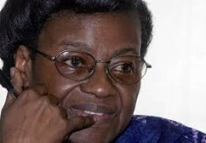
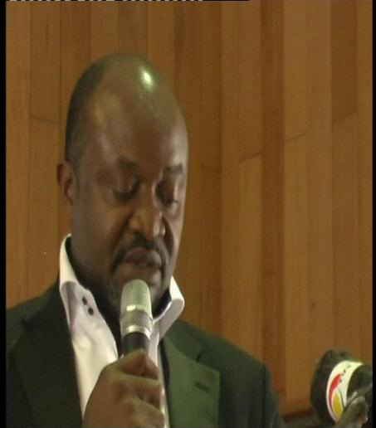
His Excellency, Ambassador Chief Justin Ibezim Agudosi is the pioneer President of the Millennium Development Ambassadors Council, a deliberative organ of the Millennium Development Ambassadors Initiative, which is a non-profit initiative dedicated to advancing the realization of the UN Millennium Development Goals in local communities.
Ambassador Agudosi Justin has been involved in several initiatives for human development and also has been very focused with private endeavours. He has furthered his educational pursuit to the Canterbury University, United Kingdom, where he bagged the Bachelor of Business Administration in Applied management (B.sc) and furthered his Master of Business of Administration in Management (M.Sc.).

Dr. Christiana Thorpe is the current chief of the Sierra Leone National Electoral Commission, an independent agency created by the Sierra Leone government, and is in charge of organizing and supervising .

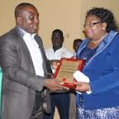

Raphael Oko (Nigeria ) has enabled thousands of teachers to access
professional development programs; provided access to computers for the disabled; established Teaching and Learning Centers; opened a school in a displaced persons’ camp; created peace curriculum materials, and conducted HIV-AIDS courses. Raphael is noteworthy dedicated teacher with Teachers Without Borders. His newest projects, the Millennium Development Ambassadors Program (teaching leaders about the Millennium Development Goals) and the training of National Youth Service Corps members (new graduates of Nigeria’s universities) have the potential of large-scale educational transformation.

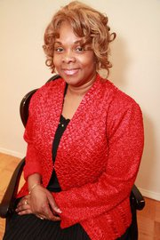
Hélène H. Oord was born in Suriname, lived and studied in the Netherlands. Since 2007 networking with organizations connected to the United Nations such as UN/NGO’s, UN Agencies and UN Ambassadors. Participates with Organizations connected to the United Nations with Status of Economic & Social Council (ECOSOC) She is an Ordained Evangelist. Pastor John H. Boyd Sr., New Greater Bethel Ministries, Queens NY, is her pastor and overseer. www.ngbm.org

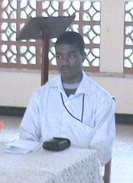

Paul Lengar, 22, decided to become an educator and youth activist in Sierra Leone because he wants all young people in his country to receive the benefits of education. His educational background is in Human Resource Development and Project Management, and he has a strong passion for working with at-risk youth.
Paul was first introduced to Teachers Without Borders when he visited Nigeria in 2010 to attend a workshop organized by Youth Service Africa, where he received the Certificate of Teaching Mastery. As a National Youth Coordinator in Sierra Leone, he introduced the TWB Peace Education Program to the national Forum on Attitudinal and Behavioural Change of the Intersecondary Schools Leadership Council, reaching hundreds of young people interested in bringing about change through peacebuilding. Paul has a strong interest in promoting Peace Education in Sierra Leone and continues to volunteer his time with Teachers Without Borders to bring the Peace Education program to even larger numbers of students and educators.

