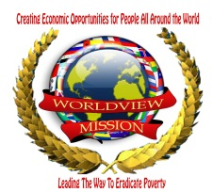WORLDVIEW MISSION * 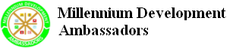

http://www.worldviewmission.org http://www.mdgambassadors.org

Youth Ambassadors
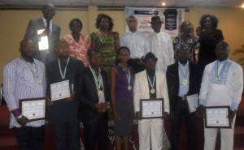
The Youth Millennium Development Ambassadors (YMDAs) program is an emerging youth led initiative designed to inspire, empower, connect and celebrate outstanding Youth Leaders to take local and practical steps to work towards the realization of the eight United Nations Millennium Development Goals.
Launched on August 12, 2011 in Sierra Leone with the support of the organizationsGLOBAL EDUCATORS FOR ALL INITIATIVE, MILLENNIUM DEVELOPMENT AMBASSADORS AND INTER SECONDARY SCHOOLS LEADERSHIP COUNCIL (ISSL COUNCIL), the YMDAs empower youth leaders to bridge the global development divide and facilitate the emergence of a world without borders where all individuals have the right to education and sustainable development. They work as volunteers to localize the global MDGs in their local communities and are mentored by current Millennium Development Ambassadors.
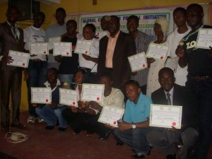
Join us !!, in this effort by nominating outstanding youth leaders from around the world, particularly in Africa, to be commissioned as Youth Millennium Development Ambassadors.
Nominated candidates will be required to submit a brief description of their work which may be published on our website.
All Youth Millennium Development Ambassadors shall undergo introductory lectures on the UN MDGs and shall affirm and make a commitment to facilitating the goals in
WORLDVIEW MISSION

their communities and nation.
Stay tuned for more information on this initiative.
To nominate a youth leader or for more information, please send us a message
E-mail: isslcouncil2@gmail.com / info@mdgambassadors.org |worldview.mission@gmail.com /
E-mail: info@worldviewmission.org / Join Our Forum

Appointment & Certification Process
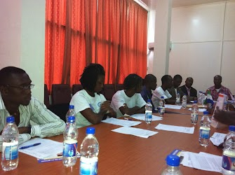
1. Applicants must be nominated to our office by a former/current MDA, community leader, or professional reference.
2. Applicants are required to submit CVs/resume highlighting their work and experience.
3. Recognition is given to the past and present efforts of the nominee. Most importantly, it is a new commission and commitment to improve the world for all.
4. Nominees approved by the Millennium Development Ambassadors Council will receive a letter of approval and will be invited to join the network of MDAs.*
5. Nominees will be invited to the MDAs Awards Ceremony honoring their extraordinary effort and leadership in creating global peace.**
6. Appointees will participate in a mandatory introductory seminar on the MDGs and will endorse the vision of the UN Millennium Declaration and affirm their commitment to realizing the MDGs.
WORLDVIEW MISSION

7. MDAs officially serve for one (1) year and can renew their membership after approval of an annual report highlighting their projects success.
* There is a fee of $200USD which covers administrative costs and a contribution to an ongoing project developed by the current Millennium Development Ambassadors.
** Local Sierra Leonean residents will participate in MDAS Awards Ceremony. All others that cannot attend the ceremony will be issued their award via postal mail.
Register to be considered for commissioning as Millennium Development Ambassador

WORLDVIEW MISSION

Some Ambassadors
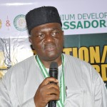
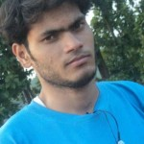
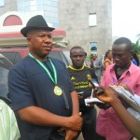
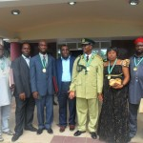
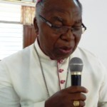
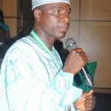
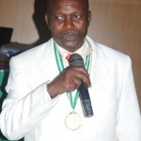
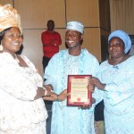
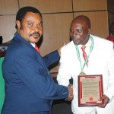
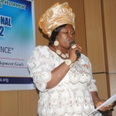
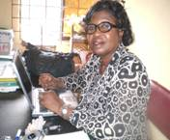
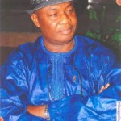

WORLDVIEW MISSION

Benefits
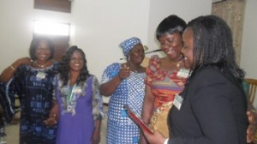
Benefits
1. Membership of Millennium Development Councils and Committees. Opportunities to engage and utilize the services of other Ambassadors and Volunteers.
2. The opportunity to network with other teachers, educators, and leaders in multiple fields.
3. A periodic newsletter, providing up to date news on successes and challenges others meet in their work as MDAs.
4. Invitations to local, national, and international conferences, seminars and meetings.
5. Access to Capacity Building Workshops and development courses.
6. Special MDA Identification card.

WORLDVIEW MISSION

Responsibilities
Responsibilities Programme workshops activities of becoming an Ambassador to comply with the UN MDGL’s by: 2015
Eradicate extreme poverty and hunger
Achieve universal primary education
Promote gender equality and empower women
Reduce child mortality
Improve maternal health
Combat HIV/AIDS, malaria and other diseases
Ensure environmental stability
Develop a global partnership for development

Millennium Development Ambassadors are required to become facilitators and champions of the realization of the MDGs in their local communities. Ambassadors may carry out one or several activities at multiple levels of society, from the individual to the international. All activities should be based on the Six Fundamental Values and dedicated to achieving the Eight Millennium Development Goals.
As an MDA, members are expected to join MDG Committees; attend meetings, seminars, and conferences; collaborate with other Ambassadors; and support other initiatives in furthering the MDGS.
MDAs will be required to focus on the following:
1. Membership: Recruiting or encouraging others with abilities and resources to join us.
2. Partnership: Creating partnership with governments, CSOs, intergovernmental organizations, businesses, etc., to engage our members and deploy our programs
3. Programs: Activities/projects dedicated to the realization of the 8 goals of the MDGs
4. Funds: Raising funds to support programs and activities.
5. Reporting/Evaluation: Reporting of activities and evaluation
WORLDVIEW MISSION

PLEASE JOIN

Worldview Mission in Partnership with Youth Millennium Development Ambassadors Initiative

Office: 89 Fort Street, off circular Road, Freetown, Sierra Leone (West Africa)
Tel: +23278442956, +232 88 602606, +31(0)6 3610-8563
Contact person: Mr. PAUL LENARD (SIERRALEONE)
Email: info@mdgambassadors.org , ambassadorlengar@yahoo.com ,
http://www.mdgambassadors.org , http://isslcouncil-sl.blogspot.com

Worldview Mission (EU/NL ) Holland
Office Headquarter:
Contact Person: Chair & Founder
Ms. Hélène H. Oord
Worldview Mission / Beemsterhoek 14, 2905XA, Capelle A/D IJssel (EU/NL) Holland
E-mail: info@worldviewmission.org / worldview.mission@gmail.org
Site: http://www.worldviewmission.org /

