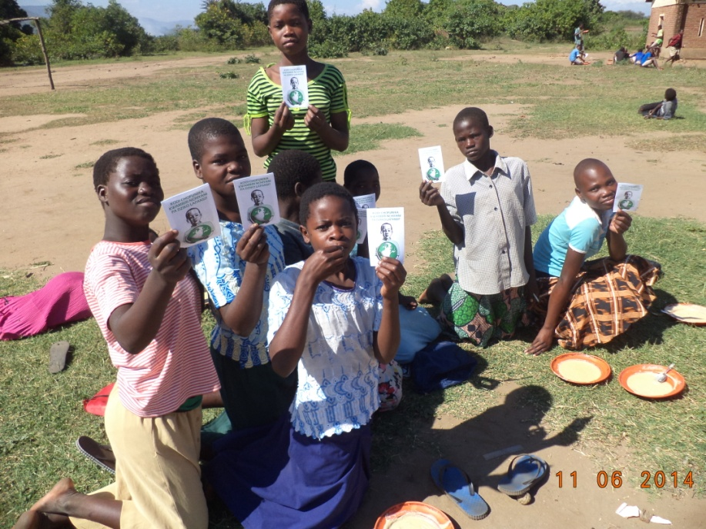

DEAR BROTHER RICHARD MURPHY,

THANK YOU VERY MUCH FOR YOUR SUPPORT TO OUR WORK WITH FREE GOSPEL LITERATURE HERE IN CHIKHWAWA IN MALAWI.

I WOULD LIKE TO SEND YOU THE ATTACHED PHOTOS FOR YOU TO SEE HOW YOUR LITERATURE IS REACHING CHILDREN HERE IN CHIKHWAWA IN MALAWI.I WOULD LIKE TO REPORT TO YOU THAT THERE IS A VERY BIG CRY FOR THE WORD HERE IN CHIKHWAWA IN MALAWI.

PLEASE SEND US MORE AND MORE LITERATURE HERE TO MALAWI.BROTHER RICHARD,CAN YOU MANAGE TO DO ME A FAVOR,PLEASE ASK SOME PEOPLE THERE WHO CAN SUPPORT ME TO HAVE A LAPTOP FOR SOME WORK ON EVANGELISM HERE IN CHIKHWAWA IN MALAWI.PLEASE SEE ME ON THE PHOTO AMONG THE CHILDREN AND ON THE TABLE AT NJEREZA PRIMARY SCHOOL WHERE TEACHERS ARE LOOKING FOR SPOONS FOR THESE CHILDREN TO BE USING FOR EATING PORRIDGE.THE SCHOOL HAVE 1054 CHILDREN ,14 TEACHERS BUT WITH OUT AN ADMINISTRATION BLOCK FOR MORE THAN 10 YEARS NOW.THE PORRIDGE IS SUPPLIED BY WORLD FOOD PROGRAMME IN COLLABORATION WITH THE MALAWI GOVERNMENT.PLEASE PARTNER US NOW.

PEACE AND GRACE,

APOSTLE FRANCIS ANANDA CHIPUKUNYA
SUPPORT FOR CHANGE INITIATIVE MINISTRIES
P.O BOX 113 ,CHIKHWAWA ,MALAWI.
