A TALE OF TWO CONQUERORS
Jesus and Alexander died at thirty-three!
One lived and died for self; one died for you and me.
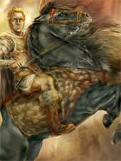
The Greek died on a throne; Christ died on a cross;
One’s life a triumph seemed; the other but a loss.
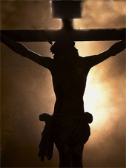
One led vast armies forth, the other walked alone;
One shed a whole world’s blood; the other gave His own.
One won the world in life and lost it all in death;
The other lost His life, to win a whole world’s faith.
Jesus and Alexander died at thirty-three.
One died in Babylon, and one on Calvary.
One gained all for himself; and one Himself gave.
One died to conquer, and one the world to save.
The one made himself God; and God made Himself less;
The one lived but to blast; the other but to bless.
When died the Greek, forever fell his throne of swords;
But Jesus died to live forever, King of Kings and Lord of Lords.
Jesus and Alexander died at thirty-three!
The Greek made all men slaves; Christ made all men free!
One built a throne on blood; the other built on love.
The one was born of earth; the other from above.
One conquered all the earth, to lose all earth and heaven;
The other gave up all, that all to Him be given.
The Greek forever died; Christ forever lives!
He loses all who gets, and wins all things who give!

