THE MONTHLY REPORT FOR WORLDVIEW MISSION (WM) CHIKHWAWA DEVELOPMENT CENTRE FOR JUNE 2013.

FROM:
APOSTLE FRANCIS ANANDA CHIPUKUNYA
PROJECT LEADER AND FOUNDER,SUPPORT FOR CHANGE INITIATIVE [SOFUCI]
P.O BOX 113 CHIKHWAWA ,MALAWI –AFRICA
TEL :+265 0 882 452 580
SKYPE:francis.chipukunya
EMAIL:mchikkwawa@yahoo.com

TO :
MISS HELENE H. OORD
FOUNDER & CHAIR,WORLDVIEW MISION INTERNATIONAL
EMAIL :worldview.mission@gmail.com
SKYPE:helene.oord21
Website: www.worldviewmission.nl

DATE :JUNE 28, 2013.

BACKGROUND INFORMATION
As WM Chikhwawa development centre, our vision is to create a unique society of information ,skills ,wisdom and knowledge for universal development. We focus at bringing holistic information upon people fro change . we focus mostly people in rural areas . we target the youth,women, the elderly ,the disabled ,orphans ,and girls. We would like to provide people with information ,skills ,wisdom and knowledge for change.
For all what we did in the month of june please see the photos below.
We did the following;
=meeting local leaders
=visiting our site
=meeting officials at Chikhwawa district council
=Meeting teachers at njereza primary school
=conducting a sports day at njereza primary school
=composing a fund raising flyer
=visiting mwalija cbccc
BUDGET ;we spend about $110.00
CHALLENGES;
=lack of funds
=lack of staff
REQUEST TO WM HEADQUARTERS;
=project vehicle
=air time
=project leader allowances
=camera and laptop computer
=office daily running costs
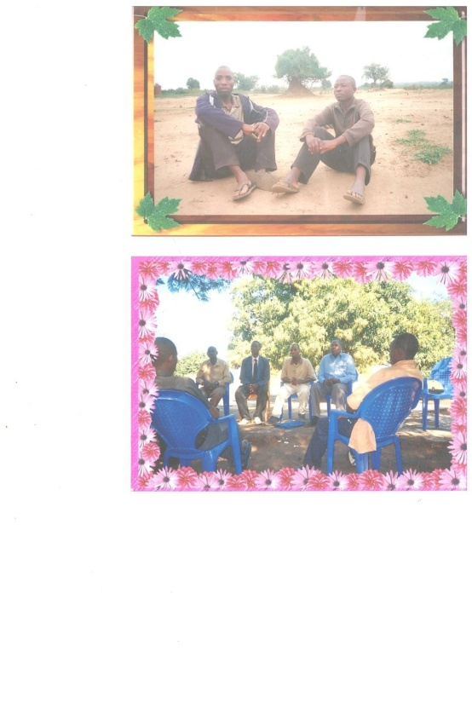

Apostle francis ananda chipukunya with pastor lucius segwa at the Worldview Mission chikhwawa development centre site in the area of gvh kabvalo of t/a kasisi in chikhwawa in Malawi .the second photo is apostle francis ananda chipukunya with teachers at njereza primary school in Chikhwawa in Malawi. This school need partners to partner us in order to rehabilitate the school to have a library ,office and classrooms. The teachers were requesting francis to ask the worldview mission in the Netherlands to think it twice to support the school.

It was the wish and desire of the local community to see the school being transformed . it was also a wish with francis too to see the school in new walls.people in rural areas needs children to learn in good places.
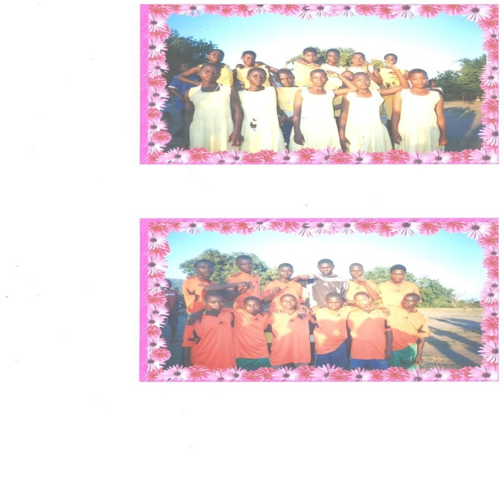

These are two sports teams at njreza primary school where worldview mission under francis went to work with children in netball and football. The school need sports attire and equipments from well wishers to support them.

Teachers and people in the communities around the school need the initiatives that are coming to see their children be equipped well in everything. We need support for the global world to work with us in order for us to reach out many youth with our program
These are girls at the same school in a photo to set that they need a good future for them to reach out their goals in life . girls like these needs empowerment.

URGENT CALLING;
We call upon all people to work with our rural community in Chikhwawa in Malawi.

