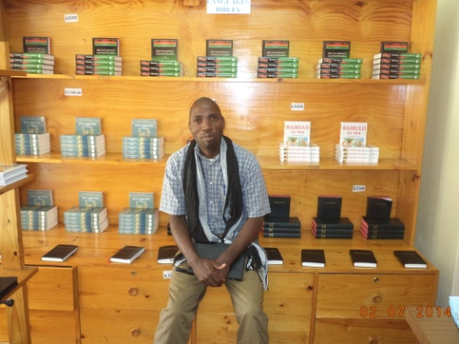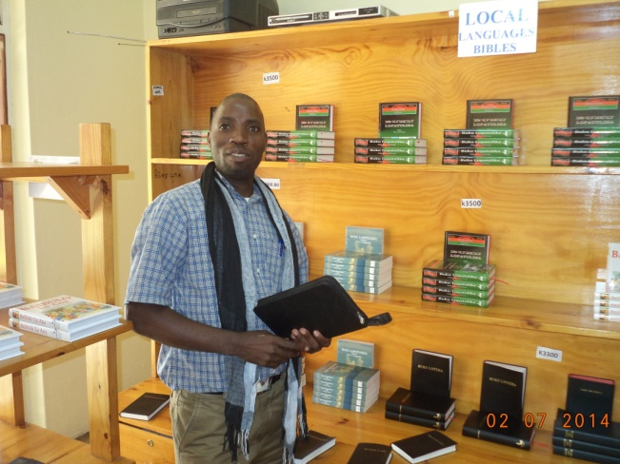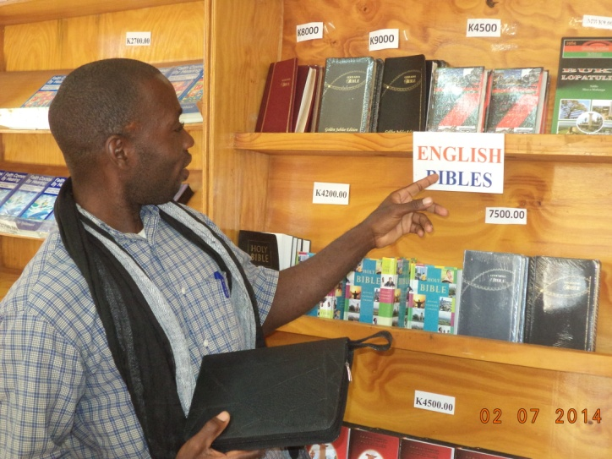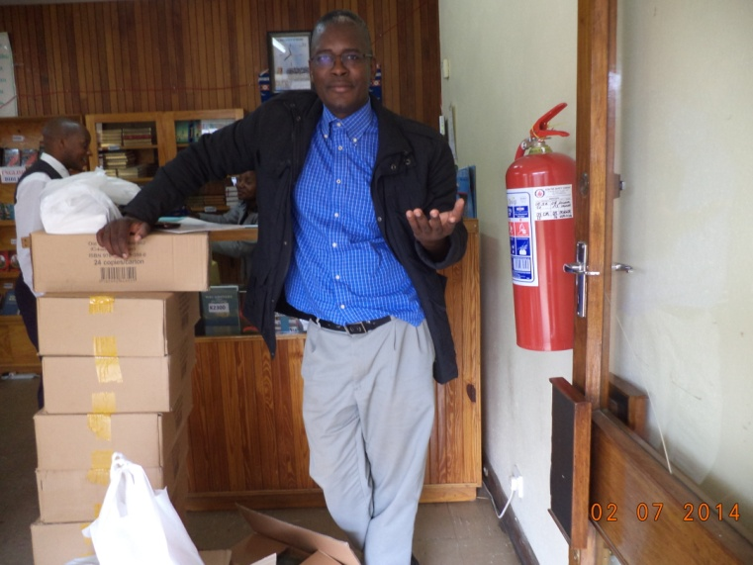

DEAR GEORGE,

I would like to report to you in a very humble and cordial manner that I reported at the Bibles society of Malawi office today and collect the Bibles.I would like to report to you that I have collected about 230 Bibles in CHICHEWA and 28 large bible covers.I thank you for the doors opened for you to be able to support us in this way.

I would like to humbly welcome one of your friends to come and see how this big donation will work to some local pastors here in chikhwawa in Malawi.I welcome the one whom you shall send to visit us.We shall keep some Bibles for him/her to see how the work is done here in chikhwawa in Malawi.

Many people are looking for the Bibles in local languages here.This help from you have come at a right time as we receive many call for free Bibles daily from people.

Thank you.
PLEASE SEE THE ATTACHED PHOTO FOR THIS .

Peace and Grace,

APOSTLE FRANCIS ANANDA CHIPUKUNYA

