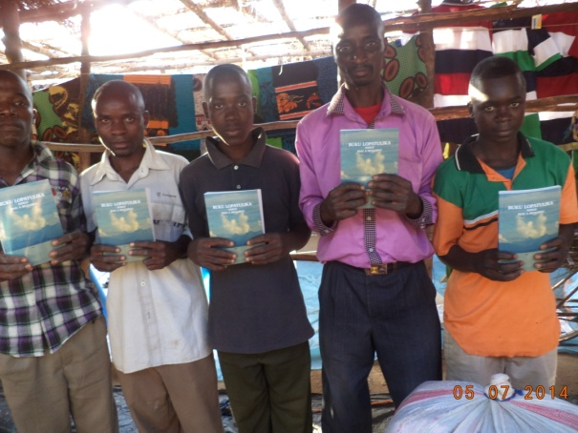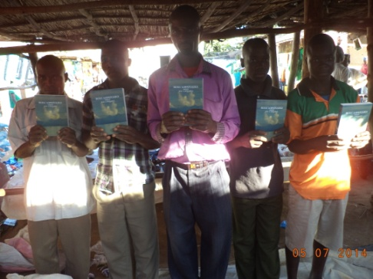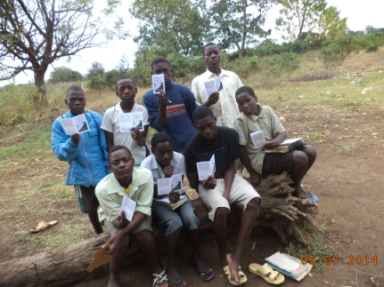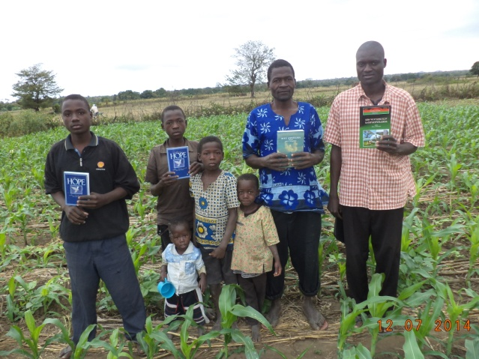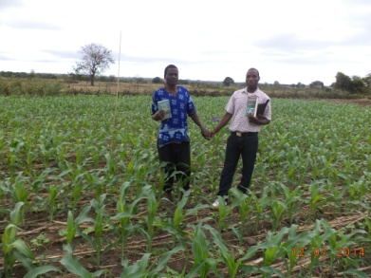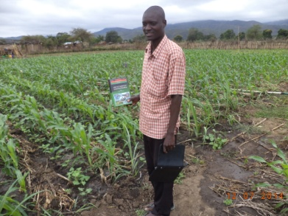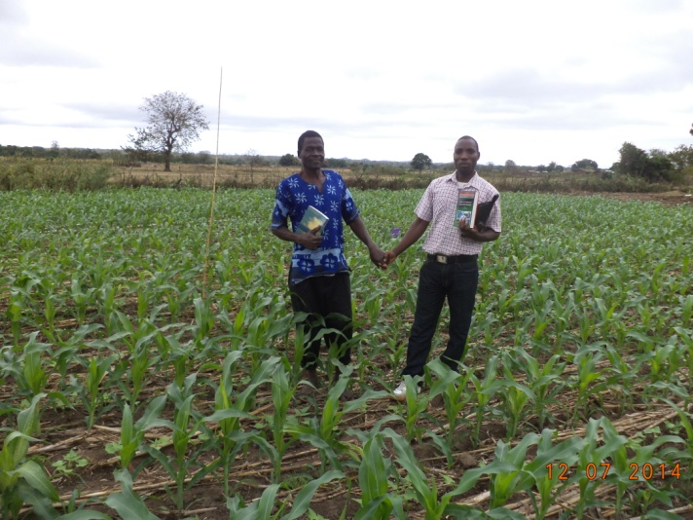

12 juli 2014 12:48
Report in photos

DEAR HELENE,

THANK YOU VERY MUCH FOR YOUR SUPPORT TO OUR WORK IN CHIKHWAWA IN MALAWI.

Please see the attached photos in order for you to see what are are really doing for the Lord our God here in chikhwawa in malawi.

APOSTLE FRANCIS ANANDA CHIPUKUNYA

