Business Plan: Hélène H. Oord Ministries International Dept. Eldoret Kenya
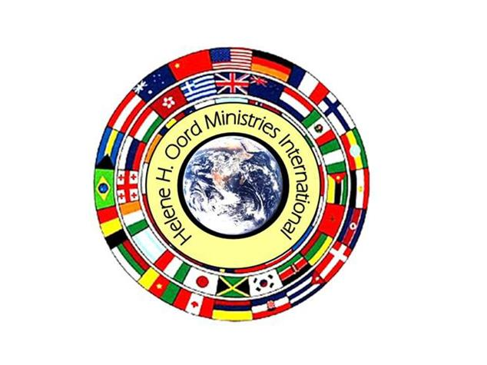

Founder: Rev Hélène H. Oord
Manager:
PASTOR ANTONY WABUGE WANJALA

City Kenya-Eldoret
Phone:+25472157573
Email: wabawan7@gmail.com

PASTOR ANTONY WABUGE WANJALA

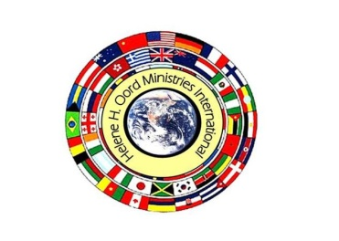

Founder of The Hélène H. Oord Ministries Int. Dept. Eldoret Kenya
Rev. Hélène H. Oord

Worldview Mission (WM)
Chair & Founder
Headquarter EU/HL (Netherland’s)

+31(0)636-108-563 Mob
+31(0) 637-140-758 Mob
+31(0)10-785-7863 Landline
Email: info@worldviewmission.org
Email: worldview.mission@gmail.com
Site: http://worldviewmission.nl/?page_id=21

Media Department ( Hélène H. Oord Min. Int’l )
http://helenehoordministriesint.wordpress.com/kingdom-projects/

15/12/2012

PASTOR ANTONY WABUGE WANJALA
Manager:+25472157573
Address: Kenya-Eldoret
Email: wabawan7@gmail.com

CONTENTS

INTRODUCTION OF THE GROUP…………………………………………………………………………………………….1

GROUPS MISSION, VISION & OBJECTIVE………………………………………………………………………………….2

PROPOSAL OBJECTIVES…………………………………………………………………………………………………………….3

BUDGET ALLOCATION……………………………………………………………………………………………………………….4

CONCLUSION……………………………………………………………………………………………………………………………5

PROPOSAL OBJECTIVES
The Proposal seeks to provide an office that is well equipped and full of furniture.
The following are the objectives of the OFFICE:
- To establish an outstanding office operation
- To have a pivot where people and officers on the ground will be reporting after work
- An office where there will be a source of vital information and data centre
- Have a strategic point of operation where we can establish diary centre
- Will be key to achieve the groups vision, mission and objectives
SUMMARY
Hélène H. Oord International is a group that wishes to improve the lives of the people on the ground. In doing so, it has immersed itself with several activities that are currently operational. Indeed, its presence has been felt by many and hopes to lift hands of the needy further in the village.
The Mission and vision for this proposal is to acquire an equipped office with all necessary facilities that will aid in development and achievement of the objectives of the organization and thus reciprocate improve the living standard of our people.
CONCLUSION
We dully accept and will to work progressively with Hélène H. Oord Ministries in order to better the lives of people on the ground. With much regard, we will highly appreciate the support that will be offered to us.
INTRODUCTION OF THE GROUP
Following the post election violence in 2007 and early 2008, many people were left vulnerable and infected with HIV/AIDS due to the merciless raping and violation of human right. Many children were left loitering and homeless. This brought the idea of formation of this group to fold and care for those infected or affected by the violence. Most of the victims were in Eldoret, Kenya where the group is currently strategically operating with the branding name of
Hélène H. Oord Ministries International Department, Kenya.
The group now has a total of 90 children with 13 voluntary members comprising of both women and men.
In addition, of Hélène H. Oord Ministries International will interview National and International diplomats, Ambassadors and VIPs persons to enlighten us with issues that affect their countries and the United States “about their burden for the people and the needs of the people”. Through these interviews they will then get to know about each other and find out how they can help and work together or share information, data and services.
- To connect ministries with organizations of all sorts by providing information about the concerns and goals of the organization and bring awareness of the current activities.
- To provide their needs and wants for the better understanding in our multicultural society.
- To promote, support and improve communication among civil organizations for rapid and effective coalition between people of the republic of Kenya.
- To ensure that violence will never occur again as experienced in the previous/past elections.
GROUPS VISION
- To inform the world through public forums, talks and public speaking, television, radio and other necessary available means of communication that people will care about each other regardless of race, tribe, religion or nationality.
- To build coherent peace globally
- To reach out worldwide and supply the appropriate information to all people, in different languages, for better understanding of the needs in our multicultural society.
GOALS & OBJECTIVES OF THE GROUP
- To create a harmonious functioning information exchange unit
- To make contributions to the needed programmers’ in our society for the better.
- Bring in all groups performing same functions in order to avoid duplication of duties and work as one block.

STAFF OF THE GROUP Hélène H. Oord Ministries Int. department Kenya-Eldoret
The group is headed by:
Manager: Pastor Antony Wabuge Wanjala……………………………………………………..+25472157573
Pastor Antony Wabuge Wanjala……………………….programmer Coordinator + 254721575573
Madam.Lynette,Wechuli………………………………………………………………Treasurer.,+ 25472197882
Madam Salome Rotich………………………………………………………………….Secretary +254723501893

GROUPS ACTIVIES INCLUDE
- Youth and women activities
- Training and empowerment
- HIV and AIDS awareness
- Micro enterprise and Micro Finance establishment
- Entrepreneurship

BUDGET by: request

ITEM DESCRIPTION | QUALITY | EACH COST | TOTAL COST

Pictures of Family PASTOR ANTONY WABUGE WANJALA Kenya

